Building capacity and resilience against diseases transmitted via water
under
climate perturbations and extreme weather stress

Shubha Sathyendranath^{1,2}, Anas Abdulaziz³, Nandini Menon⁴, Grinson George⁵, Hayley Evers-King¹, Gemma Kulk¹, Rita Colwell⁶, Antarpreet Jutla⁷, Trevor Platt¹
¹ Plymouth Marine Laboratory, Plymouth, UK
² National Centre for Earth Observation, Plymouth Marine Laboratory, Plymouth, UK
³ National Institute of Oceanography, Kochi, India
⁴ Nansen Environmental Research Centre (India), Kochi, India
⁵ Central Marine Fisheries Research Institute, Kochi, India
⁶ University of Maryland, Applied Environmental Health
⁷ West Virginia University, Civil and Environmental Engineering.

The human population is under threat from a suite of environmental perturbations, including global warming; shifts in global-scale distributions of precipitation and drought; population growth and the resulting increased stress on the environment; and increased threats from diseases transmitted via water (either fresh, brackish or salt). Against these multiple-stresses, there arises an imperative for human resilience to minimise risk. Building resilience is a priority to mitigate environmental damage that will be exacerbated by population pressure and poor sanitation conditions. In this chapter, we provide a perspective on demonstrated and potential capabilities of remote sensing to build capacity and resilience against water-borne and vector-borne diseases. Although the role of remote sensing in this context has been well demonstrated in some regions, it is as yet unexplored as a global public health tool. Earth observation data from satellites are increasingly available at the global scale in real time, with free, open and timely access. This resource enhances the potential for developing cost-effective methods to build a capacity to monitor risks to human health from water-borne diseases. Indeed, the problem is global, but its manifestations may be sporadic and regional in scope. With global warming and changing environmental conditions, geographic regions under threat are evolving and expanding, and so the need for both capacity and awareness building is not limited to developing countries in the tropical belt where such threats are currently more acute.
This chapter addresses effects of water-borne diseases impacting humans at the coastal fringe. A significant proportion of the world’s population is at risk to such diseases, and the potential effects are severe, encapsulated in the United Nations Sustainable Development Goal 3 (Health) Target 3.3 “By 2030, end the epidemic…. of malaria and neglected tropical diseases and combat hepatitis, water-borne disease and other communicable disease”, and in Target 3.d to “Strengthen the capacity of all countries, in particular developing countries, for early warning, risk reduction and management of national and global health risks”. Given the influence of a changing climate on distribution and intensity of outbreaks of water-associated diseases, it is relevant to SDG13 (climate), Target 13.3 to “improve education, awareness-raising and human institutional capacity on climate change mitigation, adaptation, impact reduction and early warning”. In the decade of the 2020s, incidence of waterborne diseases will, increasingly, be a major threat to low and middle-income countries (LMIC), notably India, where a major shortage of drinking water is predicted by 2030. Approximately 15% of the population of India lives within a 100 km periphery of a 7500 km long coastal line, and therefore is significantly vulnerable to water-associated diseases. Several diarrheal diseases (e.g., cholera, shigella, rotavirus) are frequently reported to occur in coastal regions of the developing world (Figure 1). The chapter is also relevant to SDG 14 (Life below water). Coastal and maritime tourism rely on healthy marine ecosystems. Tourism development must be a part of Integrated Coastal Zone Management to help conserve and preserve fragile marine ecosystems and to serve as a vehicle to promote a blue economy, contributing to the sustainable use of marine resources. This perspective also highlights the relevance of this chapter to SDG 10 (Reduced inequalities). Tourism can be a powerful tool for reducing inequalities if it engages local populations and all key stakeholders in its development. Tourism can contribute to urban renewal and rural development by giving people the opportunity to prosper in their place of origin. Furthermore, tourism serves as an effective mean for economic integration and diversification.

Figure 1Population distribution and water-borne disease outbreak. Rectangles represent endemic diarrheal disease regions
Specific, recent metrics demonstrating a need in the context of water-borne diseases include 216 million cases of malaria reported worldwide, and 870,000 deaths associated with lack of safe drinking water, unsafe sanitation, and lack of hygiene in 2016; they were caused mainly by diarrhoeal diseases, but also by malnutrition and intestinal nematode infections. According to the World Health Organisation, some two billion people use faecally-contaminated drinking water, rendering them vulnerable to death or chronic poor health from water-borne infectious diseases such as cholera, dysentery, typhoid and polio. Provision of safe drinking water is hostage to the influence of extreme weather, including drought and flooding, the frequency of which is increasing, as a consequence of climate change.
Apart from fatalities, the effect of a chronic burden of low-grade infections associated with water-borne diseases is antagonistic to maintenance of a healthy work force and well-being of a society in general, as well as being detrimental to sustainable development. For example, cholera kills an estimated 95,000 people every year, but causes 2.9 million to become seriously ill with debilitating disease. The incidence of diarrhoea has been acknowledged as a major cause of morbidity in coastal states, hence a need to address the resilience of communities to perturbation of their supply of safe drinking water under extreme weather events associated with a changing climate.
For the purpose of this chapter, water-associated diseases include those diseases, such as diarrhoea and cholera, that can be transferred by oral-faecal routes through consuming contaminated food or water, or exposure to contaminated recreational beaches. The responsible agents may be various types of pathogenic bacteria or viruses. If we take the example of Vibrio bacteria (Baker-Austin et al. 2018), the genus includes Vibrio cholerae, responsible for cholera (of some 200 serotypes Vibrio cholerae, only two – O1 and O139 – are associated with cholera epidemics); V. alginolyticus that causes infections of wounds and ears exposed to contaminated water; V. parahaemolyticus, associated with food poisoning from consumption of seafood, causing acute gastroenteritis, with symptoms including cramps, diarrhoea, headache, fever and chills; and V. vulnificus, a food-borne pathogen known to cause wound infections, primary septicaemia and food-poisoning that can be fatal. Diseases carried by vectors, such as mosquitoes, which require (stagnant) water to complete parts of their life cycle, are also included in the family of water-associated diseases. Mosquitoes are known vectors for a host of diseases, including malaria, dengue fever, chikungunya and Zika. Fish and seafood can be sources of food-borne pathogens such as Salmonella, Listeria, Escherichia coli, and Campylobacter.
Here we focus largely on two contrasting case studies from coastal regions of the Indian subcontinent that are highly vulnerable to water-associated diseases: the Ganga Delta where seasonal outbreaks of cholera are routine, and which has been the subject of a number of studies demonstrating the applications of remote sensing; and Kerala in South India, also an area where cholera is endemic, but which presents quite different patterns of disease outbreaks. Mortality rates are comparatively low in Kerala owing probably, and at least in part, to the high standard of personal hygiene and health facilities. Global implications of regional problems are also touched upon.
Dealing with water-associated diseases requires a whole-ecosystem approach to management, including: monitoring the pathogen load in the environment; identifying its reservoirs, routes of transmission, and conditions for proliferation; optimization and validation of tools such as remote sensing; ecosystem models for early warning of disease incidence; and designing strategies to involve people in understanding the causes of disease occurrence and mitigate them.
Within the armoury that might be mobilised against water-associated diseases, remote sensing is proving to be of increasing utility. To characterise the ocean, space-borne sensors use radiometric signals from various parts of the electromagnetic spectrum (visible, infra-red and microwave) to yield data at regional to global scales with fine local resolution (one kilometre or better) and temporal resolution (nominally one day) on a variety of environmental properties, including sea surface temperature, phytoplankton abundance indexed as concentration of chlorophyll, and sea surface height.
For illustration of the concepts and for identifying the priorities in future work, we turn next to two case studies.

The Ganga Delta Region
The Ganga Delta region, straddling India and Bangladesh, covers an area of over 100,000 km², making it the largest delta in the world. It is the drainage basin for many rivers, the most important being the Ganga and the Brahmaputra. It is a highly fertile region, and an important fishing zone. Over a 100 million people live in the delta. It is exposed periodically to flooding during the monsoon season, and to droughts in summer. Akanda et al. (2018) classify cholera as epidemic, mixed-mode, and endemic. All three types are reported to occur in the Ganga Delta, and typically there are two seasonal outbreaks of cholera in the region every year. Several authors have reported the use of environmental data in general and satellite data in particular, to understand and predict outbreaks of cholera in the region. There is a wealth of clinical and environmental data related to cholera from the Ganga Delta region; it has been the subject of various studies on the relationships between environmental conditions and disease outbreaks; and various methods have been proposed to forecast risks of disease outbreaks in the region (Table 1).
Mutreja et al. (2011) employed molecular techniques to study the bacteria responsible for the seventh pandemic of cholera and concluded that the pandemic occurred globally over the years, from a source in the Bay of Bengal area, primarily through human-to-human transmission. However, it has been established that the cholera bacterium, Vibrio cholerae is autochthonous to aquatic environment (Colwell, 1996). Thus, when exploring regional disease outbreaks, it is important not to overlook the global distribution of this bacterium.
Table 1 A few selected publications that have reported relationships between environmental conditions, environmental cholera and cholera outbreaks in the Ganga Delta region. When satellite data are used, the names of the satellites or sensors, and the products are noted. A list of the acronyms used and their expansions are provided at the end of the chapter. Note that ocean colour (remote sensing reflectances at various spectral bands in the visible domain can be used to retrieve chlorophyll concentration and indicators of water clarity (diffuse attenuation coefficient).
Environmental Variables Studied | Remarks | Reference
Landsat: NDVI, Land Use  MODIS/MERIS: SST, Ocean Colour  SWOT (planned): River discharge  SMAP: Soil moisture  GRACE: Water storage, River discharge  TRMM/GPM: Precipitation  TOPEX/Poseidon/JASON: Sea Surface Height  AVHRR: SST | A consortium of satellite sensors used to predict cholera, with models and data used varying according to whether epidemic, mixed-mode endemic or endemic cholera is being studied. Reports on the use of cell phones to survey the local population and to disseminate advisories. | Akanda et al. (2018)
GRACE: Terrestrial Water Storage | Region of study: the Bengal Delta. GRACE data used to study anomalies in terrestrial water storage in relation to cholera outbreaks. Predictive model. | Jutla et al. (2015)
Chlorophyll, River Discharge | Regions of study: Bangladesh, Mozambique. Chlorophyll concentration is used as a proxy for plankton abundance, since cholera bacteria are known to attach themselves to plankton. | Jutla et al. (2010)
Ocean-colour reflectances at 412 and 555 nm | Predictive model for Bengal Delta and Mozambique. Proposes a “satellite water marker” based on the ocean colour signal at two wavelengths, which is then used in predictive model for cholera incidence. | Jutla et al. (2013)
Climate variability (El Niño southern oscillation) and flooding | A multidimensional inhomogeneous  Markov chain Model used. Predictive model with 11 month lead time. | Reiner et al. (2012)
SST, SSH and chlorophyll | Region of study: Bangladesh. Demonstrates link between cholera epidemics and regional climate, using time series of satellite data. | Lobitz et al. (2010)
Chlorophyll concentration, Rainfall, SST | Regions of study: Kolkatta (India) and Matlab (Bangladesh). Predictive models developed showed differences between the two sites, highlighting the importance of local information. | De Magny et al. (2008)
Water temperature, water depth, rainfall, conductivity, and copepod counts | Four isolated sites in Bangladesh studied. Predictive model proposed using water temperature (lag, 6 weeks), ctx gene probe count (lag, 0 weeks), conductivity (lag, 0 weeks), and rainfall (lag, 8 weeks). “Occurrence of cholera correlates with biological parameters, e.g., plankton  population blooms” | Huq et al. (2005)
pH, temperature, iron, salinity, copepods, diatoms, dinoflagellates | Region of focus: Bangladesh. One of the earliest papers to demonstrate the use of satellite data to illustrate the link between cholera and climate. | Colwell (1996)

Vembanad Lake in Kerala, India
Vembanad Lake, along with its neighbouring wetlands and coastal waters of Kerala in India provides a contrasting study area, although from a hydrological perspective, it mimics many aspects of the Ganga Delta, but at a much smaller scale. The lake, which straddles the districts of Alappuzha, Kottayam and Kochi in Kerala (India), is the largest lake in South India. With a total length of approximately 100 km, it is also the longest lake in all India. It forms part of the Vembanad-Kol wetland system, recognized internationally under the Ramsar Convention for conservation and sustainable use of wetlands. Some ten rivers flow into the lake. Its drainage area is estimated to be 40% of the entire state of Kerala, and 1.6 million people live on its shores. The lives of the people are intimately linked to the lake: it is used for bathing, washing, and cooking, and is an important means of local transport. Kuttanad region on the southern part of the lake, often referred to as the rice bowl of Kerala, is one of the few places in the world where rice is cultivated below sea level (1 to 3 m below mean sea level). Because of its “biosaline farming”, the Kuttanad farming system is recognized by FAO as a Globally Important Agricultural Heritage System.
A cultural icon, and a location of exceptional natural beauty, Vembanad Lake is considered a “safe” tourist destination that brings much needed revenue to the region: according to the 2017 Kerala tourist statistics, the income to Kerala from tourism in 2017 was INR 33,383.68 crores (or approximately 3.8 billion GBP), an increase of 13% over the previous year, and was responsible for 23% of the total employment in the state. Vembanad Lake is central to the industry, with thousands of house boats plying the waters of the lake during the tourist season.
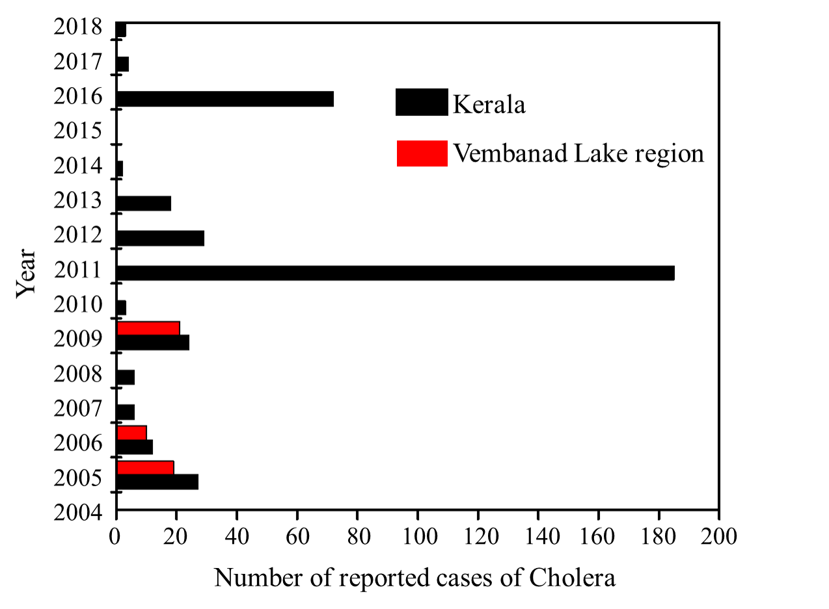
Yet, all is not well in “God’s own country” (the tag line of Kerala Tourism). The lake is now highly polluted: pressure from the high population density around the lake, growing prosperity of the state with associated construction work on the banks of the river, increasing tourism, all of which contribute to the overall problem. Various industrial units on the estuarine stretches of Vembanad Lake utilise water from the lake for routine operations and discharge effluent back to the lake. Biodiversity and fisheries are on the decline, and invasive species, notably water hyacinth (Eichhornia crassipes), water moss (Salvinia molesta) and water lettuce (Pistia stratiotes), are particularly problematic. From a health perspective, the incidence of water-associated diseases such as chikungunya and dengue fever, once unheard of in the region, are now on the increase. Malaria, previously eradicated, is making a comeback (but Kerala is still considered low risk for malaria). The lake and the surrounding low-lying regions are subject to frequent flooding, especially during the monsoon season. The Kerala floods of 2018 were exceptionally catastrophic, with up to a million people displaced, a reported death toll close to 400, and widespread damage to public infrastructure, private homes and natural ecosystems. The region around Vembanad Lake felt the brunt of the devastation.
Figure 2 Reported cases of Cholera in recent years from the Vembanad Lake area (study area) and all Kerala.

Cholera (for which the causative agent is the bacterium Vibrio cholerae) is endemic to the region (Ali et al. 2018), but the number of reported incidence is low (237 cases reported in Kerala during 2010-2015, compared with 5914 in West Bengal). According to Ali et al. (2018), there is a strong negative correlation between literacy rate and risk of cholera, and Kerala is a state claiming a literacy rate of 100%, which could be a contributing factor to the lower incidence of the disease in Kerala. Outbreaks of cholera in Vembanad Lake study area and in the whole state of Kerala are shown here in Figure 2 (Kerala Directorate of Health Services Report on “Epidemiological Situation of Communicable Diseases in Kerala, 2006-2010”). Kanungo et al. (WHO 2010) synthesise the data on cholera in India for the period 1997 to 2006. They report a total of 1463 confirmed cases of cholera in Kerala during the period, and emphasise that this figure does not cover all clinical cases: “even if outbreaks were identified, the number of individuals affected was often underestimated”. Often, health departments tend to report probable cases of cholera simply as dysentery, fever and diarrhoea. In addition to Vibrio cholerae, other Vibrio species occurring in Vembanad Lake cause debilitating illness involving many lost work days. A study organized by Cochin University of Science and Technology India, in collaboration with Northumbria University, reported the prevalence of morbidity among rural populations of Alappuzha (part of study area) due to Vibrio cholerae. The report also ranked diarrheal disease as the second most important cause of working days lost through illness. Kerala is a relatively wealthy state, attracting migrant workers from the rest of India, and some of the reported cases of cholera in 2017 were traced to a worker from outside the state. Antibiotic resistance is a serious issue. Previous studies from NIO Kochi (Vijayan et al. 2015, Proceedings, 4th National Conference of Ocean Society of India) have also shown that antibiotic and metal resistance are prevalent among bacteria isolated from the study area. Hence there is an urgency to find a solution to the problem of water-borne diseases in the area, particularly cholera.
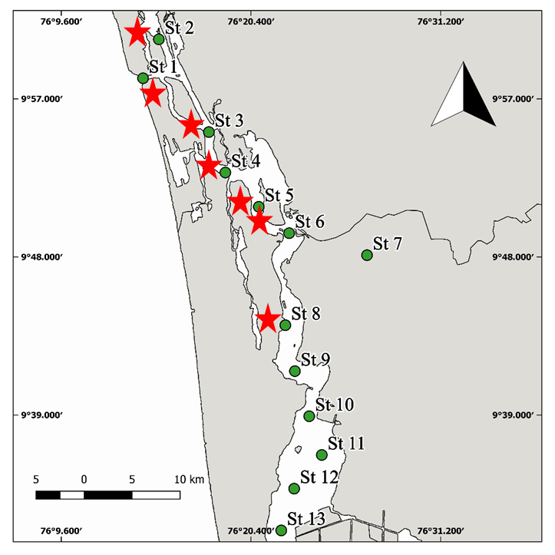
The study area presents paradoxes begging explanations. The data available from the Integrated Disease Surveillance Program (IDSP) of Government of India on cholerae incidence in Kerala during the last decade, show that outbreaks occur in both dry and wet seasons. However, the region remained stubbornly free of water-borne diseases after the devastating floods of 2018, even though our own sampling showed wide-spread contamination of well-water and lake water by E. coli, and the presence of pathogenic Vibrio cholerae bacteria in the northern part of the lake (Figure 3), in the vicinity of Kochi Municipal Corporation, the most densely-populated locality on the banks of the lake system.
Figure 3 Map of Vembanad Lake showing sampling stations as green dots. Red Asterisks indicate locations where pathogenic cholera bacteria were found at least once during the sampling period (April - November 2018). High correlation was observed between presence/absence of pathogenic cholera bacteria and E. coli in the samples.
A partial explanation for the absence of outbreaks of water-borne diseases in 2018 is perhaps the literate and well-informed inhabitants of the area, who are prepared to listen to scientists, especially in times of crisis. During the 2018 floods, scientists and volunteers worked with government ministers, health departments, municipal corporations, NGOs and international organisations to test water quality and bring awareness of water contamination to the fore. Some of the authors of this chapter (AA, NM and GG) took the lead to put in place “water clinics” and reported to the authorities on the level of contamination of well water in various localities around the Lake, and classified the wells according to distance from septic tanks and levels of water clarity. Government advisories exhorted the population to use only boiled water for drinking and cooking, demonstrating that the population and the authorities are predisposed to the concepts enshrined in Water, Sanitation and Hygiene (WASH).
Vembanad Lake and the surrounding areas constitute a natural laboratory of manageable size to study the epidemiology and ecology of cholera bacteria and the factors that influence their distribution: it is an aquatic system that contains elements of fresh lake water, brackish estuarine water and saline coastal water that can be treated as a prototypical tropical system with a densely populated shoreline and a community vulnerable to periodic flooding and consequent deterioration of the local sanitary conditions, and hence to exposure to water-borne diseases. Strong seasonality, punctuated by dry summers followed by heavy rains during monsoons, leads to strong seasonal variability in flushing rates, salinity levels, temperature and pH. River discharges into the lake also show strong seasonality: sluggish in summer, they become torrents during the rainy season. The Pampa river, which flows past a famous pilgrimage site in the neighbouring mountains of the Western Ghats, is suspected to be an important point source of bacterial pollution where the river enters the lake, but only during the pilgrimage season which follows the monsoons. In addition, the voluntary scientific work that was carried out by our team during these floods established excellent credentials, and high-level contacts in various departments of government, which, by positive feedback, will be particularly beneficial when the team addresses societal elements of the cholera problem.
No comprehensive studies have been undertaken to explore the use of remote sensing to predict and prevent outbreaks of infectious diseases in this region. Transposition of knowledge from the Ganga Delta region to the Vembanad Lake region is not always straightforward. Simple matters such as differences in scale complicate incorporation of algorithms from the Ganga region to the Vembanad Lake region. Satellite sensors with a footprint size of ~1 km are acceptable for the Ganga Delta region, but such resolution is too coarse for Vembanad Lake because of its small size and elongated, indented shape. Instruments designed for land applications, such as those on board Landsat and Sentinel-2, provide the required high spatial resolution of order 10 m, but those instruments are not optimised for quantitative estimation of water quality. Innovative approaches are needed to optimise algorithms that extract maximum information from these sensors for aquatic applications.
During the 2018 floods, local newspapers reported on the use of Synthetic Aperture Radar (SAR) on board Sentinel-1 to map the extent of floods. This is an important service, since dynamic maps of flood extent allow authorities to select the most vulnerable localities for targeted rescue missions and for prioritising health care to avoid outbreaks of diseases. But Sentinel-1 provides repeat temporal coverage only every 10 days or so, and it is desirable to consider the potential for other sensors such as the Multi-Spectral Instrument (MSI, on board the Sentinel-2 satellite, part of the European Union Copernicus Programme) for mapping the extent of water. Although MSI has no cloud-penetrating capability, unlike the SAR sensor, even partial images under cloud-free conditions can provide additional information on flood conditions on days when SAR images are not available (Figure 4).
Figure 4. Sentinel-2 images processed to show the extent of water in excess of a baseline, before, during, and after the 2018 floods in Kerala, India. Preliminary results. Note that "floods" as mapped by satellites may at times indicate paddy fields that are flooded as part of the cultivation cycle. Local information is essential to interpret and refine the results.
Algorithms such as the floating algal index (FAI) can be used to map floating macrophytes (Fig. 5) in Vembanad Lake. The image shows Sentinel-2 data processed using ACOLYTE software (Vanhellemont, 2019). Further work is needed to separate floating algae from rice paddies and other forms of vegetation – an essential step, given that S2 is a relatively new sensor in providing this capacity. Once such algorithms are validated and, if necessary, improved they can be used to study the dynamics of invasive floating vegetation and their relationship with proliferation of disease-bearing mosquitoes. Blocking of sunlight by these algae results in an increase in Biological Oxygen Demand caused by their decay and is thought to be responsible for decreasing fish yields. Further, anoxia in the saline stretches are often aggravated by organic-rich effluents released from urban settlements and industries. Some of the invasive species in Vembanad Lake are vulnerable to salinity, which leads to the question of whether flushing rates in the lake should be increased to destroy the species (the potential exists for changing the times when Thannermukkam Bund, which divides the northern and southern parts of the lake is opened or closed. The bund was built in 1974 to control incursion of salt water into the southern part of Vembanad Lake, and hence facilitate paddy cultivation).
More generally, satellites can serve a role in testing the effectiveness of remedial measures to eradicate invasive species in the lake, not an easy task according to previous attempts.

Implications for capacity building

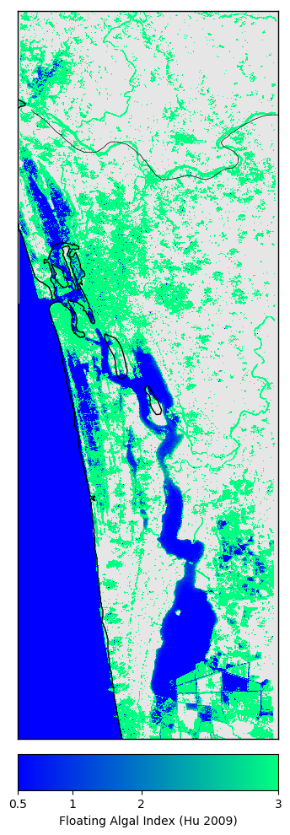
What can be learned from this brief comparison between the situation in the Bengal Delta Region and the state of Kerala? First, in building resilience against epidemics of water-associated diseases, there is a premium on education of all social classes, and strategies adopted to achieve this goal must include engagement with schools and community centres. Equally important is credibility of the scientific advice made available as a preventive measure and also the possible rapidly-evolving advice released during potential emergencies, for example during flooding. The public will heed advice given by relevant specialists, if the required credibility has been built up patiently in advance. If the entire community is engaged in, the foundation of resilience, already strong, will be further strengthened.
Figure 5 Example of the Floating Algal Index of Hu et al. (2009) applied to Sentinel-2 data from Vembanad Lake area for 25 March, 2018. Preliminary, unvalidated results.
However, more can be done, especially engagement of citizens in regular scientific observations and in prompt dissemination of results will be invaluable in helping to identify possible development of conditions conducive to disease outbreaks. For example, epidemiological models exist to simulate the dynamics of bacterial pathogens, including the cholera Vibrio. But the models require parameters, which in general are not constant. Rather, they change with time as environmental conditions change. Consider the scheme depicted in Figure 6. Here, citizen science can help in two ways. The first is to quantify ambient conditions in so far as they affect the growth rate of the cholera pathogen, for example water temperature in the lake. The next is to characterise the effect on local sanitary conditions that occur following damage to water infrastructure caused by flooding. Prompt collection and dissemination of data on a regular basis is vital to implement the epidemiological model and update local risk forecast models in a timely fashion. The models could even be implemented locally and regularly by the general public, using information collected on essential parameters. Typically, the models can be run on personal laptop computers. With the use of open-source web applications, one may anticipate that such models might be run using smart phones. In the case that the model results indicated risk of a disease outbreak, scientific authorities should be alerted for checking and further action, as required. Modern technologies, such as cell phones, can play a very helpful role in engaging communities and to collect and disseminate data (Akanda et al. 2018). Finger et al. (2016) used cell phone geo-location information to track people travelling from an area suffering from a cholera outbreak to unaffected regions, and used the information to predict the spread of the disease. We envisage that a cell-phone based approach could be developed to establish dynamic, regional sanitation maps that could facilitate targeted remedial action at governmental level in periods of high risk of disease outbreak, and could also serve as a communication tool to inform population at risk of changes in risk levels.

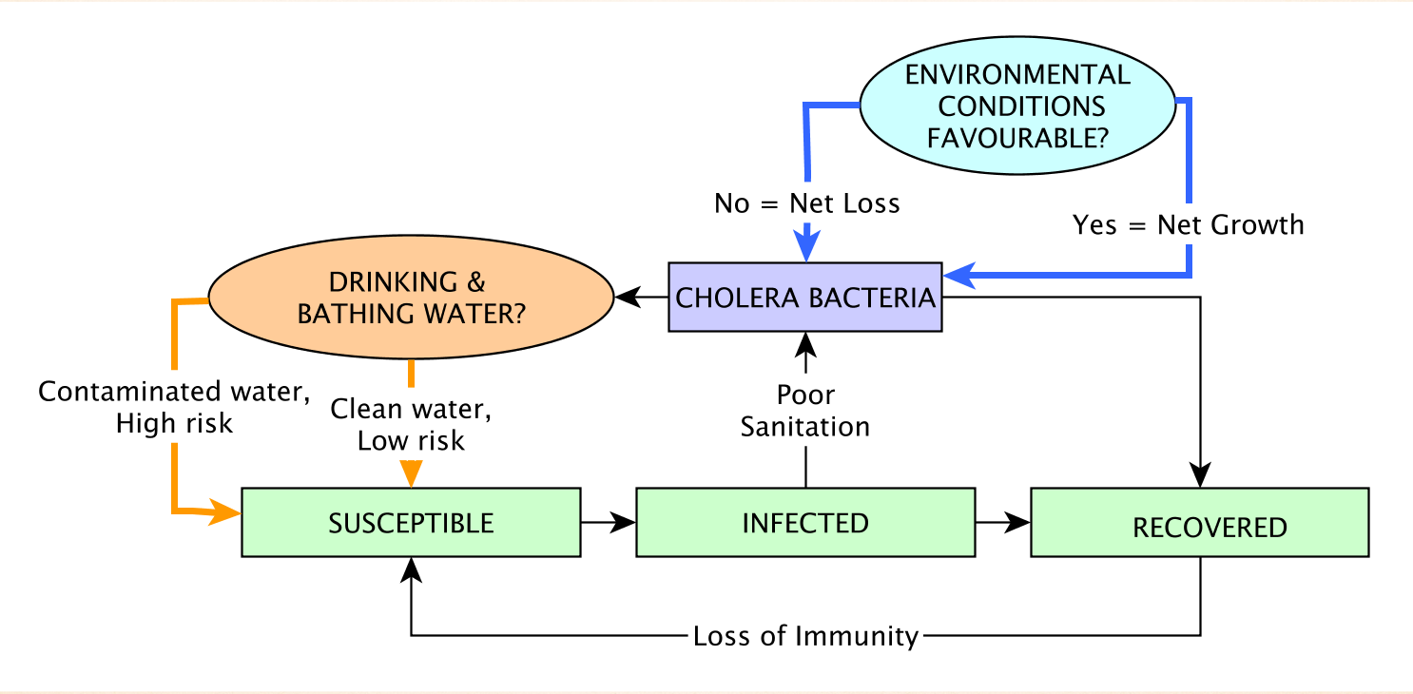
Figure 6. Schematic Diagram showing an epidemiological model developed for Vembanad Lake Region
A central pillar of building resilience against possible epidemics is forecasting, early warning, and risk mapping of water-associated diseases using remote sensing, in situ observations, and modelling. A suitable vision would be to enable cost-effective, regularly updated, geo-referenced and timely warning for areas vulnerable to water-associated diseases, which in turn would enable preventive measures to be deployed in an optimal manner to minimise the probability of epidemics. The environmental data provided by remote sensing will have large spatial extent (regional) and high resolution on the ground (1 km or better). The long-term target would be to establish a system applicable in a variety of localities and for a variety of diseases. By combining information acquired from intensive in situ sampling with data from the regional scale (such as can be collected by remote sensing), it should be possible to address geo-referenced risk of exposure to water-associated diseases in a more complete and penetrating procedure. Because the environmental component of disease risk is subject to control by fluctuations in climate, the issue of resilience to climate change must also be considered, addressable by employing modelling, using results obtained for risk forecasting, together with expected changes in intensity and frequency of extreme weather events. In application of the results to real-life situations, capacity building would benefit from complementary citizen science programmes; available and utilisable operation manuals and sanitation brochures to explain the high relevance and value of maintaining hygiene and, at the same time, protecting the ecosystem; modern tools such as smart phones and social media could be used to disseminate information regarding risk status.
To date, efforts by scientists to address water-associated diseases remain fragmented, in the sense that efforts are often focussed on a particular region, to address a specific outbreak. The problem is that different scientific disciplines (microbiology, molecular genetics, modelling, remote sensing, epidemiology, clinical research, social scientists) explore different aspects of a complex problem such as water-borne diseases. Furthermore, different stakeholder communities, not just scientists but including health workers, medical practitioners, social workers, NGOs, government authorities, international organisations, the community of vulnerable people exposed to the threat, hold different parts of the puzzle. Networking and collaboration across scientific disciplines and across relevant communities is essential to ensure that the benefits of scientific advances reach the communities at risk, and on a global scale. To promote networking, “open innovation” approaches, which exploit multiple external sources to drive innovation, could be invoked for stakeholder engagement and knowledge sharing (via open platforms such as wikiversity, for example).
There is ample evidence (Martinez-Urtaza et al.2018, Escobar et al. 2015, Jutla et al. 2010) that climate change and climate variability and associated changes conditions of the world oceans can alter geographic areas under high risk. Jutla et al. (2010) suggested that ocean corridors might guide the transmission of cholera bacteria in tropical regions, and Martinez-Urtaza et al. (2016) provided evidence to support the suggestion that the ocean corridors might be altered during El Niño Southern Oscillation (ENSO) events. Escobar et al. (2015) used climate projections, along with an ecological niche model of cholera, to illustrate how oceanic conditions favourable for cholera bacteria might expand to higher latitudes, with changing climate. Nasr et al. (2015, 2016) provided one of the first studies to link global climate change models with cholera in the Bengal Delta, The use of artificial intelligence (such as support vector and neural networks) can provide an unparalleled opportunity to understand emergence of water-related diseases under various climate change scenarios. This will aid in development of new models (and understanding) and facilitate decision making under deep uncertainty. There is no time to be lost before collective and innovative action be taken to build resilience in the human population worldwide, against the broad and extensive threats from diseases that will be exacerbated by altered environmental conditions.

Concluding Remarks
Here, we have suggested a powerful role for remote sensing in building resilience against outbreaks of water-associated diseases. We illustrated the problem by comparing situations in two locations: the Bengal Delta Region (Bangladesh) and Vembabad Lake region in Kerala state in India. We envision a whole-ecosystem approach including monitoring pathogen load in the environment, identifying its reservoirs, routes of transmission, conditions for proliferation, optimization and validation of tools including remote sensing and ecosystem-simulation models for early warning of disease incidence and designing strategies to involve the world community so that it can understand disease occurrence and its causes, thereby being empowered to mitigate them. The global patterns of disease outbreaks are likely to be modified with climate change, adding to the imperative to understand better the underlying causes of disease outbreak, so we can be better prepared to deal with changing patterns of outbreaks. The importance of various communities working together to implement solutions cannot be exaggerated.

Acknowledgement: This work is a contribution to the REVIVAL (REhabilitation of Vibrio Infested waters of VembanAd Lake: pollution and solution) Project, jointly funded by NERC (UK) and DST (India).

List of Acronyms Used:
AVHRR: Advanced, Very High Resolution Radiometer
CNES: Centre National d’Études Spatiales (National Centre for Space Studies)
ESA: European Space Agency
FAI: Floating Algal Index
GPM: Global Precipitation Measurement (NASA and JAXA Mission)
GRACE: Gravity Recovery and Climate Experiment
JASON: Joint Altimetry Satellite Oceanography Network (NASA and CNES Joint Mission)
JAXA: Japan Aerospace Exploration Agency
MERIS: Medium Resolution Imaging Spectrometer (Sensor on board the ESA Envisat satellite)
MODIS: Moderate Resolution Imaging Spectroradiometer
MSI: Multi-Spectral Instrument on Board Sentinel-2. European Mission. Part of the European Union Copernicus Programme
NASA: National Aeronautics and Space Administration
NDVI: Normalised Difference Vegetation Index
Poseidon: Positioning, Ocean, Solid Earth, Ice Dynamics, Orbital Navigator (TOPEX/Poseidon was a joint NASA CNES Mission)
SWOT: Suface Water Ocean Topography (future satellite mission, jointly developed by NASA and CNES, launch planned for 2021)
TOPEX: Topography Experiment (TOPEX/Poseidon was a joint NASA CNES Mission)
TRMM: Tropical Rainfall Measuring Mission (NASA Mission)
TWS: Terrestrial Water Storage
SMAP: Soil Moisture Active Passive (NASA Mission)
SSH: Sea Surface Height
SST: Sea Surface Temperature

References

Akanda, AS, Aziz, S, Jutla, A, Huq, A, Alam, M, Ahsan, GU, Colwell, RR (2018) Satellites and cell phones form a cholera early-warning system. Eos, 99, https://doi.org/10.1029/2018EO094839. Published on 27 March 2018.
Baker-Austin, C, JoaquinTrinanes, J, Gonzalez-Escalona, N, Martinez-Urtaza, J (2018)
Colwell, RR (1996) Global Climate and Infectious Disease: The cholera paradigm. Science, 274: 2025-2031.
de Magny, GC, Murtugudde, R, Sapiano, MRP, Nizam, A, Brown, CW, Busalacchi, AJ, Yunus, M, Nair, GB, Gil, AI, Lanata, CF, Calkins, J, Manna, B, Rajendran, K, Bhattacharya, MK, Huq, A, Sack, RB, and Colwell, RR (2008) Environmental signatures associated with cholera epidemics. Proceedings of the National Academy of Science, 105(46): 17,676-17,681. www.pnas.orgcgidoi10.1073pnas.0809654105
Escobar, LE, Sadie J. Ryan, SJ, Stewart-Ibarra, AM, Finkelstein, JL, King, CA, Qiao, H, Polhemus, ME (2015) A global map of suitability for coastal Vibrio cholerae under current and future climate conditions. Acta Tropica, 149: 202–211.
Finger, F, Genolet, T, Mari, L, de Magny, GC, Manga, NM, Rinaldo, A, Bertuzzo, E, (2016) Mobile phone data highlights the role of mass gatherings in the spreading of cholera outbreaks. Proceedings of the National Academy of Sciences of the United States of America, 113 (23). pp. 6421-6. ISSN
0027-8424 DOI: https://doi.org/10.1073/pnas.1522305113 Hu, C (2009) A novel ocean color index to detect floating algae in the global oceans. Remote Sensing of Environment. 113. 2118-2129. 10.1016/j.rse.2009.05.012.
Huq, A, Sack, RB, Nizam, A, Longini, IM, Nair, GB, Ali, A, Morris, Jr., JG, Khan, MNH, Siddique, AK, Yunus, Albert, MJ, Sack, DA, and Rita R. Colwell1, RR (2005) Critical Factors Influencing the Occurrence of Vibrio cholerae in the Environment of Bangladesh. Applied and Environmental Microbiology, 71(8): 4645–4654. doi:10.1128/AEM.71.8.4645–4654.2005
Jutla, A, Akanda, AS, Islan, S (2010) Tracking cholera in coastal regions using satellite observations. J. Am. Watr Resour Assoc. 45(4): 651-662. doi:10.1111/j.1752-1688.2010.00448.x.
Jutla, A, Akanda, AS, Huq, A, Faruque, ASG, Colwell, R and Islam, S (2013) A water marker monitored by satellites to predict seasonal endemic cholera, Remote Sensing Letters, 4:8, 822-831, doi: 10.1080/2150704X.2013.802097
Jutla, A, Akanda, A, Unnikrishnan, A, Huq, A, Colwell, R (2015) Predictive time series analysis linking Bengal cholera with terrestrial water storage measured from Gravity Recovery and Climate Experimental Sensors. American Journal of Tropical Medicine and Hygiene. 93(6): 1179-1186.
Kanungo, S, Sah, BK, Lopez, AL, Sung, JS, Paisley, AM, Sur, D, Clemens, JD, Nair, GB (2010) Cholera in India: an analysis of reports, 1997-2006. (2010) Bull World Health Organ 2010;88:185–191 | doi:10.2471/BLT.09.073460
Lobitz, B, Beck, L, Huq, A, Wood, B, Fuchs, G, Faruque, ASG, Colwell, R (2000) Climate and infectious disease: Use of remote sensing for detection of Vibrio cholerae by indirect measurement. Proceedings of the National Academy of Sciences, 97(4): 1438-1443.
Martinez-Urtaza, J, Trinanes, J, Gonzalez-Escalona, N, Baker-Austin, C (2016) Is El Niño a long-distance corridor for waterborne disease? Nature Microbiology, Voume 1. Article Number: 16018, doi: 10.1038/NMICROBIOL.2016.18
Mutreja, A, Kim, DW, Thomson, NR, Connor, TR, Lee, JH, Kariuki, S, Croucher, NJ, Choi, SY, Harris, SR, Lebens, M, Niyogi, SK, Kim, EJ, Ramamurthy, T, Chun, J, Wood, JLN, Clemens, JD, Czerkinsky, C, G. Nair, GB, Holmgren, J, Parkhill, J, Dougan, G (2011) Nature, 477: 462-465. doi:10.1038/nature10392
Nasr, FA, Unnikrishnan, A, Akanda, A, Islam, S, Alam, M, Huq, A, Jutla, A, Colwell, R (2015). A framework for downscaling river discharge to access impacts of climate change on endemic cholera. Climate Research, doi: 10.3354/cr01310; 64: 257-274.
Nasr, F, Khan, R, Rahimikollu, J, Unnikrishnan, A, Akanda, A, Alam, A, Huq, A, Jutla, A, Colwell, R (2016) Hydroclimatic sustainability assessment of changing climate on cholera in the Ganges-Brahmaputra Basin. Advances in Water Resources, 10.106/j.advwaters.2016.11.018.
Vanhellemont, Q., 2019. Adaptation of the dark spectrum fitting atmospheric correction for aquatic applications of the Landsat and Sentinel-2 archives. Remote Sensing of Environment 225, 175–192. (https://doi.org/10.1016/j.rse.2019.03.010)

