Categorizing and Naming Marine Heatwaves

Alistair J. Hobday¹, Eric C. J. Oliver^{2,3}, Alex Sen Gupta⁴, Jessica A. Benthuysen⁵, Michael T. Burrows⁶, Markus G. Donat⁴, Neil J. Holbrook^{2,7}, Pippa J. Moore⁸, Mads S. Thomsen^{9,10}, Thomas Wernberg¹⁰, Dan A. Smale¹¹

- CSIRO Oceans and Atmosphere, Hobart, Tasmania, 7000, Australia
- Institute for Marine and Antarctic Studies, University of Tasmania, Hobart, Tasmania, Australia
- Department of Oceanography, Dalhousie University, Halifax, Nova Scotia, B3H 4R2, Canada
- Climate Change Research Centre and ARC Centre of Excellence for Climate System Science, University of New South Wales, Sydney, Australia, University of New South Wales, Sydney, Australia
- Australian Institute of Marine Science, Townsville, Queensland, 4810, Australia
- Department of Ecology, Scottish Association for Marine Science, Scottish Marine Institute, Oban, Argyll, PA37 1QA, Scotland, UK
- ARC Centre of Excellence for Climate System Science, University of Tasmania, Hobart, Tasmania, Australia
- Institute of Biological, Environmental and Rural Sciences, Aberystwyth University, Aberystwyth. SY23 3DA, United Kingdom
- Marine Ecology Research Group, School of Biological Sciences, University of Canterbury, Private Bag 4800, Christchurch, New Zealand
- UWA Oceans Institute & School of Biological Sciences, Crawley Western Australia 6009, Australia
- Marine Biological Association of the United Kingdom, The Laboratory, Citadel Hill, Plymouth, UK

Version: April 23, 2018

Journal: Oceanography

2 tables
5 figures
7410 words from start of abstract to end of references

Abstract
Considerable attention has been directed at understanding the consequences and impacts of long-term anthropogenic climate change. Discrete, climatically extreme events such as cyclones, floods, and heatwaves can also cause considerable impacts on regional environments, species, and humans – climate change is expected to exacerbate these effects. Climatic extremes also occur in the ocean, and recent decades have seen many high-impact marine heatwaves (MHWs) – anomalously warm water events that may last many months and extend over thousands of square kilometres. A range of biological, economic and political impacts have been associated with the more intense MHWs, and measuring the severity of these phenomena is becoming more important. Progress in understanding and public awareness will be facilitated by consistent description of these events. Here, we propose a detailed categorization scheme for MHWs that builds on a recently published classification, combining elements from schemes that describe atmospheric heatwaves and hurricanes. Category I, II, III, and IV MHWs are defined based on the degree to which temperatures exceed the local climatology and illustrated for ten MHWs. While there is a long-term increase in the occurrence frequency of all MHW categories, the largest trend is a 24% increase in the area of the ocean experiencing strong (Category II) MHWs. Use of this scheme can help explain why biological impacts associated with different MHWs can vary widely and provides a consistent way to compare events. We also propose a simple naming convention based on geography and year that would further enhance scientific and public awareness of these events.

- The rising awareness of extreme events

Extreme weather events are generally defined as rare and severe environmental events (e.g. Herring et al. 2015). Often, extreme events can be formally defined based on the frequency distribution of observations recorded at a location, and defined as lying in the upper or lower tail of the probability distribution (with various thresholds for ‘extremeness’ commonly based on different high or low percentiles) (Perkins and Alexander 2013). Examples include meteorological, hydrological and oceanographic events such as storms, cyclones, floods, droughts, and terrestrial and marine heatwaves (Herring et al. 2015). Extreme events can cause considerable impacts to both natural systems and human societies, and thus have an important place in history and social consciousness, ranging from societal collapse due to earthquakes, famine resulting from droughts, and loss of life from tsunamis (Zhang et al. 2011; Herring et al. 2015). Recent insurance records indicate that the frequency of economic loss events has more than doubled globally since the early 1980s, from about 350 to around 1,000 events per year, mostly due to the increase of weather and climate-related events (Munich Re 2016). Over this period the inflation-corrected losses have increased from ~ US$50bn to ~ US$200bn, and the payout for insured losses from less than US$5bn to over US$30bn per year (Munich Re 2016).

Oceanic extreme events have received less attention than terrestrial events, yet still lead to major biological and economic impacts. These extremes include periods of intense upwelling (Feely et al. 2008; Yang et al. 2012; Evans et al. 2015; Benthuysen et al. 2016), deoxygenation events (Diaz and Rosenberg 2008; Stramma et al. 2011) and unusually warm (Wernberg et al. 2013; Di Lorenzo and Mantua 2016) and cold ocean temperatures (Crisp 1964; Firth et al. 2011). Extreme temperatures, in particular, exert a strong influence on biological systems and a variety of impacts have been associated with these anomalous events, including shifts in species ranges and local extinctions (Crisp and Southward, 1963; Garrabou et al. 2009; Wernberg et al. 2016), and economic impacts on aquaculture (Oliver et al. 2017) and seafood industries through declines in important fishery species (Mills et al. 2013; Caputi et al. 2016; Hobday et al. 2016). While sustained periods of above average temperatures are sometimes associated with different phases of large-scale climate modes, such as the El Niño Southern Oscillation (ENSO) (Salinger et al. 2016), extreme events with significant environmental impacts often occur over shorter time periods as well (Hobday et al. 2016).

Extreme warm ocean temperature events have been observed around the world and been termed marine heatwaves (MHWs). Following atmospheric conventions, a MHW is defined as a “prolonged discrete anomalously warm water event that can be described by its duration, intensity, rate of evolution, and spatial extent” (Hobday et al. 2016). While MHW events have occurred in the past, there is increased scientific (Figure 1) and public interest in a range of recent MHWs. Furthermore, analysis of historical data (Zhang et al. 2017; Oliver et al. 2018) show trends in MHW intensity and frequency as a result of anthropogenic climate change. Research around the world is showing that MHWs, while not as dramatic as earthquakes and cyclones, have a range of important biological impacts such as habitat loss (Wernberg et al. 2016), coral bleaching (Hughes et al. 2017), and mass seabird mortality (Jones et al. 2018). These biological impacts can in turn disrupt dependent human systems (Mills et al. 2013; Frölicher and Laufkötter 2018) such that understanding and prediction of events has considerable public and management interest.

There is a long tradition of categorizing extreme events according to some intensity measure, and/or to name them following certain conventions. Categorization enables comparison of events across different regions, and facilitates comparison of the different events in a globally consistent framework. Naming provides a unique and unambiguous identifier of each event in a certain period, which greatly facilitates communication among experts as well as to the general public (Nairn and Fawcett 2013). While categorization or naming is commonly applied to a range of extreme environmental events such as tropical cyclones, earthquakes or atmospheric heatwaves, it is not currently used consistently for MHWs. One notable exception is ‘The Blob’, a north-west Pacific MHW that appeared between 2014 and 2016 (Bond et al. 2015; Di Lorenzo and Mantua 2016). Overall, an increasing global occurrence of and interest in MHWs strengthens the potential benefits that will arise from the development of categorization and naming schemes.

Our aim here is to present a detailed categorization scheme for MHWs that (a) enhances the existing binary classification (Hobday et al. 2016), (b) provides a consistent way to compare such events, and (c) enhances scientific and public awareness of these important events. More specifically, we describe Category I, II, III, and IV MHWs based on the degree to which temperatures exceed the local climatology. Finally, we demonstrate how the use of this new scheme can help explain variation in biological impacts associated with different MHWs.

- Naming and measuring extreme events

A range of extreme events and natural disasters have been identified by formal and informal naming systems, and measured on some kind of scale (Table 1). Providing names and measurements of intensity has a number of benefits, including clarity when discussing historical events, which aids identification and communication with the general public (Nairn and Fawcett 2013). The familiarity that names provide also builds public awareness regarding these events away from their impact region, and enhances risk awareness regarding future events. Scientists also benefit from naming and categorization, via improved meta-analyses (events can be clearly recognized in published literature) and in retrospective studies that seek to relate the magnitude of an event to some observed impact. For example, hurricanes and cyclones are given names from pre-determined lists to aid communication between forecasters and the general public regarding forecasts and warnings. For other extreme events, naming is more informal and may be based on the time of the event or the region, such as the Black Saturday, Black Friday, Ash Wednesday and Black Tuesday bushfires in Australia, the ‘Godzilla’ El Niño of 2016, the 2017 Lucifer heatwave in Europe, or the Australian Federation and Millennium droughts). In some cases, the informal naming approach will soon run out of options (e.g. only seven days of the week for “Black” bushfires in Australia) while other names provide little identifying information.

In addition to naming extreme events, measurement of these events can also provide a range of benefits with regard to communication and comparison. The best-known examples have been the development of magnitude scales for earthquakes (Richter scale) and hurricanes (Saffir-Simpson scale) (Table 1). Lesser known magnitude scales have also been developed for other types of extreme events, including for droughts in the USA (Palmer drought severity index), and fire risk in Australia (e.g. McArthur Forest Fire Danger Index).

- Categories of marine heatwaves

The only current quantitative definition of MHWs is primarily binary: once an upper locally determined threshold (90th percentile relative to the local long-term climatology) is exceeded for a five-day period with no more than two non-MHW days between a contiguous event, a location is classified as experiencing a MHW (Hobday et al. 2016). As more regional studies are completed in areas experiencing MHWs, scientists have recognized that biological impacts can vary dramatically and appear to be context dependent. For example, both eastern Tasmania and the northern and central Great Barrier Reef (GBR) experienced a MHW in 2015/16, with the temperature anomaly on the GBR (+2°C) being two thirds of that experienced off eastern Tasmania (+3°C). Despite this temperature difference, the reported biological impacts were only moderate for the Tasmanian MHW (Oliver et al. 2017) compared to the widespread and dramatic coral bleaching recently experienced in the GBR MHW that resulted in an overall coral mortality of ~22% (Hughes et al. 2017).

These differences in the apparent biological and socio-economic impacts of MHWs suggest that the metrics proposed by Hobday et al. (2016) may be extended to further understand these apparent differences. In addition, with long-term anthropogenic warming, the binary threshold used to define MHWs may be permanently exceeded at some time in the future. The Hobday et al. (2016) MHW definition offers several potential metrics that may be useful in constructing a categorization scheme. There are several design criteria that are important to ensure the MHW categorization scheme is useful for communication and extension as well as for post-event studies. These criteria are as follows:
- The category should be able to be described and updated as a MHW progresses. Based on this criterion, MHW duration, mean intensity, rate of onset and rate of decline are not suitable measures, as they are not known until the MHW has concluded. Hence, real-time reporting would not be possible.
- The category should reflect local thermal impact. The same MHW may have a stronger impact in some locations than in others, and this is important to recognize when undertaking impact assessment, especially for spatially extensive events. Thus, MHW area is not a suitable measure, as it would apply singularly to all locations identified within the boundary of the MHW in question.
- The category should be able to change in time, as events strengthen and weaken, just as for cyclone categorization. Thus, measures related to MHW intensity, such as ‘I’, ‘I_{cum’} and ‘I_{max’} are all suitable candidates (see below for details).
- The metric should not be overly complicated to aid simplicity of communication and to facilitate wide adoption.

We propose a MHW categorization scheme based on intensity (I), which is the sea surface temperature anomaly (SSTA) from the long-term climatology for a location (Hobday et al. 2016). After an event has concluded, the maximum intensity (I_{max}) can be used to categorize the overall event, as for tropical cyclones. Measures of cumulative intensity (I_{cum}) were considered based on use of a moving sum, in a similar fashion to measures of degree-heating weeks used by coral reef bleaching programs (e.g. Maynard et al. 2009). However, use of the moving sum is more complicated and there is no single definition that is used by all coral reef biologists (e.g. Selig et al. 2010). More comprehensive approaches, based on combinations of other MHW metrics may be required to further describe events, as in Hobday et al (2016).

The thresholds that define MHW categories could be based on percentiles of the historical distribution of SST values in a region (e.g. 90th, 95th, 98th, etc), which is consistent with the 90th percentile definition for a MHW (Hobday et al. 2016). However, unless the baseline period is adjusted, this measure will saturate with additional ocean warming, meaning that all days in a year might be classified as heatwave days, as this definition is bounded by a maximum value at the 100th percentile of the observed distribution.

Here we propose that categories of MHWs, identified as described above, be based on multiples of the value represented by the local difference between the climatological mean and the climatological 90th percentile, which is the threshold used to identify MHWs (Figure 2). This anomaly differs by location and time of the year (Hobday et al. 2016). Multiples of this local difference will describe different categories of MHWs. Descriptors of magnitude of scale, defined as moderate (1-2×, Category I), strong (2-3×, Category II), severe (3-4×, Category III) and extreme (>4×, Category IV) can be allocated at each point in space and time of a MHW event, based on the intensity (I) measure (Figure 2). We also recommend that the baseline period for determining these thresholds should be fixed, as otherwise baseline updates as the world warms will change the categories for past events. Unfortunately, the length of the period for which data are available will vary between observations, satellite data, and model output. Where possible, we suggest a 30 year baseline period 1983-2012, as used here, based on first availability of global satellite sea surface temperature in the NOAA OISST data set (Reynolds et al. 2007). Minor differences in MHW statistics may arise if different historical baselines are used (e.g. the Tasman Sea MHW was based on the baseline used in Oliver et al. 2017). We also acknowledge that different baseline periods might be appropriate for different study motivations. For example, if in future defining heatwaves as “unusual” for the time, rather than as the new normal, was desired, a moving 30-year climatology might be appropriate. This would capture unusually warm events through time relative to conditions that are based on a recent historical period (i.e. the previous 30 years) that will shape ecosystem response and human perceptions of the severity of the event. In the following sections, we examine the patterns in these categories, and explore the use of the categorization with a range of case studies (Table 2).

- Example marine heatwaves

Numerous MHWs have been reported in recent decades along with a range of biological impacts (see Table 2 for examples). Our proposed categorization scheme reveals the relative intensity of these events, and the duration in each category. Notably, these MHWs have occurred across all seasons. The benefit of using an instantaneous measure of MHW categorization is also illustrated, as like hurricanes, MHWs can intensify and dissipate over their “lifetime”. Real-time reporting on current events can thus reflect the current classification, and the post-event reporting refers to the maximum classification, as with hurricanes. We present ten well-known examples in each of the categories from Moderate (Category I) to Extreme (Category IV) based on analysis of the NOAA OISST V2 dataset, and the reported impacts.

A) Mediterranean Sea 1999 – Category I Moderate
A number of studies examined the impacts of the Mediterranean Sea 1999 MHW, which based on our original classification (Hobday et al. 2016) had a maximum intensity of 1.92°C and lasted 8 days in autumn (Table 2; Figure 3A). Despite being classified as a ‘moderate’ MHW in our new classification system, most of these studies documented significant impacts on different temperate corals, in particular octocorals and red corals (Cerrano et al. 2000; Garrabou et al. 2001; Linares et al. 2005; Coma et al. 2009). For example, the proportion of dead colonies varied from 26-62% (mean of 46%) of the population across sites around the island of Menorca (Spain) for the octocoral Eunicella singularis following the MHW. There was also evidence to suggest that seagrass growth was reduced and leaf mortality increased during this warm period (Diaz-Almela et al. 2007). These examples highlight that even moderate MHWs can have severe biological effects, particularly for organisms that live near their upper thermal tolerances.

B) Mediterranean Sea 2003– Category II Strong
A variety of biological impacts were attributed to the Mediterranean Sea 2003 MHW which was classified as Category II for 42% of the 31-day duration, with maximum intensity of 4.38°C (Table 2; Figure 3B). For example, a massive bloom of mucilage (largely composed of brown filamentous alga) covered much of the shallow-water habitats around Portofino in the Ligurian Sea. However, damage to benthic organisms underneath the mucilage were short-lived as the mucilage was moved to deeper waters following a severe storm (Schiaparelli et al. 2007). Similar to the 1999 MHW in this region, temperate benthic invertebrates were significantly affected with local mass bleaching and mortality (Garrabou et al. 2009; Crisci et al. 2011) and seagrass growth was reduced during the warm anomaly (Diaz-Almela et al. 2007). Finally, only subtle community changes were observed for sedimentary infauna, for example animal assemblages switched from snail- to worm-dominated in shallow ponds in North eastern Italy (Munari 2011). These examples highlight that different types of organisms can respond very differently to the same MHW.

C) Mediterranean Sea 2006 Category II Strong
The Mediterranean Sea 2006 MHW was classified as strong for 21% of the 33-day duration, with an maximum intensity of 3.99°C (Table 2, Figure 3C). This event was linked with marked increases in shoot mortality in populations of the seagrass Posidonia oceania, which were subjected to water temperatures above 26.6°C (Marba and Duarte 2010). As for previous MHWs in the Mediterranean Sea, negative effects on temperate benthic invertebrates were reported (Kersting et al. 2013; Kružić et al. 2014), although impacts were less severe than for the 1999 and 2003 events (Bensouusan et al. 2010; Crisci et al. 2011).

D) Tasman Sea, Australia 2015 – Category II Strong
The Tasman Sea off southeast Australia exhibited its longest and most intense MHW ever recorded in 2015/16 (Oliver et al. 2017). The event lasted for 252 days and reached maximum intensity of 2.70 °C above the long-term climatology (Table 2; Figure 3I) and was dominated by anomalous convergence of heat linked to the southward flowing East Australian Current (Oliver et al. 2017). Ecosystem impacts ranged from new disease outbreaks in farmed shellfish, mortality of wild abalone and out-of-range observations of various fish species. Analysis based on global climate models revealed that the occurrence of a MHW of this duration and intensity in this region was respectively ≥330 times and ≥6.8 times as likely due to the influence of anthropogenic climate change (Oliver et al. 2017).

E) Great Barrier Reef 2016 – Category II Strong
Coral bleaching was widely reported in the northern Great Barrier Reef (Hughes et al. 2017) as a result of the summer 2016 MHW, which according to our definition lasted for 55 days was Category II for 45% of this period, and reached 2.15°C above the regional climatology average (Table 2, Figure 3D). This thermal stress disrupted the symbiotic relationship between corals and their algal symbionts (Symbiodinium spp.), causing the corals to lose their colour, which can lead to high levels of coral mortality. Extreme bleaching occurred on more than 40% of reefs, and only 8.9% of 1,156 surveyed reefs escaped with no bleaching (Hughes et al. 2017). Ongoing studies are likely to reveal secondary effects on coral reef fishes and other taxa.

F) Western Australia 1999 – Category III Severe
A MHW lasted for 132 days along the Australian west coast in 1999 (Figure 3E). It was briefly (2% of days) classified as Severe (Category 3), and was Moderate for 86% of its duration (Table 2). We were unable to locate any studies reporting biological impacts linked to this event. This may be due to absence of impacts, or absence of research.

G) Northwest Atlantic 2012 - Category III Severe
Several fisheries species were impacted by the 2012 MHW event in the northwest Atlantic, which lasted 132 days, and was classified as Severe for 2% of days, Strong for 23% with a maximum intensity of 4.30°C (Table 2; Figure 3F). During this winter-spring event, anomalously warm waters led to shifts in the phenology, distribution and population structure of longfin squid and American lobsters (Mills et al. 2013) and affected the catches and juvenile recruitment in the snow crab fishery (Zisserson and Cook 2017). Changes in the duration and location of the lobster fishing season and increased catch rates had significant economic implications, as the market value plummeted and tensions between the US and Canadian fishing industries escalated (Mills et al. 2013).

H) Northeast Pacific Blob 2015 – Category III severe
This severe Pacific MHW lasted several years (Di Lorenzo and Mantua 2016) and was classified as severe for 13% of the 711-day duration reaching a maximum intensity of 2.56°C (Table 2; Figure 3G) Although a very recent MHW event, emerging evidence suggests that the biological impacts of ‘The Blob’ were widespread and far-reaching (Cavole et al. 2016; McCabe 2016). Specifically, changes in oceanographic conditions led to altered patterns of phytoplankton production, changes in population dynamics and behaviour of fish species, shifts in the geographical distributions of zooplankton and mass mortalities of birds and mammals along an extensive stretch of Pacific coastline (Bond et al. 2015; Cavole et al. 2016; Jones et al. 2018).

I) Santa Barbara 2015 – Category III Severe
Off Santa Barbara, USA, the summer 2015 event had the largest intensity (5.10°C) of the examples here, however, it was still only classified as severe (13% of days) due to the large variability in this region (Table 2, Figure 3H). In the only published biological impact study associated with this MHW, Reed et al. (2016) found no strong effects on giant kelp Macrocystis pyrifera or the kelp-associated species. The lack of catastrophic effects, as expected from the severe warming and kelp vulnerability to high temperature (Reed et al. 2016), may be due to high levels of background natural variability in the region, associated primarily with ENSO events, the high adaptability of kelp to environmental fluctuations, as well as complex interactions with upwelling and local nutrient conditions. This MHW also occurred in the middle of the spatial distribution range for Macrocystis, thus the species is exposed to higher temperatures elsewhere in its range. The absence of major biological impacts may be related to the species’ thermal tolerance and the occurrence of the MHW relative to this tolerance or distribution.

J) Western Australia 2011 – Category IV Extreme
The Western Australia 2011 MHW lasted 66 days, with 12% of the days classified as Extreme, and 12%, 33% and 42% as Severe, Strong and Moderate, respectively (Table 2; Figure 3J). The peak intensity in the region was 4.89°C above the regional summer averages. Impacts were particularly severe near the northern range limit of the dominant habitat-forming seaweeds Scytohalia dorycarpa (Smale and Wernberg 2013) and Ecklonia radiata (Wernberg et al. 2013; Wernberg et al. 2016) as both became regionally extinct along >100 km of coastline. The biological implications were particularly dramatic for the latter extinction as extensive Ecklonia kelp forests were rapidly replaced by small turf forming algae, with wide ranging impacts on associated invertebrate and fish communities (Wernberg et al. 2013; Wernberg et al. 2016). Severe negative impacts have also been recorded for other foundation species, including seagrasses (Fraser et al. 2014; Thomson et al. 2015) and corals (Abdo et al. 2012; Moore et al. 2012) as well as on commercially important invertebrates, such as blue crabs and bay scallops (Caputi et al. 2016).

Consideration of these examples shows that MHWs classified as Severe (Category III) or Extreme (Category IV) generally had more dramatic biological impacts compared to moderate or strong MHWs. For example, the Extreme Western Australian 2011 MHW has had dramatic impacts on entire coastal temperate communities, as the thermal maxima of key habitat forming species were exceeded with wide ranging cascading effects (Wernberg et al. 2016). In contrast, only limited biological impacts have been reported from the events that were moderate and strong. There was still variation in biological impacts for events within the same MHW categories, which highlights that it is essential to consider the thermal tolerances of the impacted organisms as well as local hydrodynamic conditions. The different amount of time in each MHW category during an event may also be relevant to future biological impact studies, as might be the overall duration of the event. Additionally, biological impacts may also occur even as temperatures are above average but not classified as MHWs. Future studies are needed to better characterise these sensitivities and the different biological impacts of MHWs. Developing integrated measures of MHW impact that account for intensity, duration and area would also complement the categorization proposed here. Such a severity index - derived from maximum intensity and duration – has been used for atmospheric heatwaves (Russo et al. 2014) and proposed for MHW biological impact studies (Smale et al. in review).

Comparing all the MHWs experienced in the period 1982-2016 in each example region shows that the differing frequency of absolute sea surface temperature anomalies (Figure 4A) is scaled such that more equal proportions of events occur in each of the categories (Figure 4B). This scaling is similar to that proposed for atmospheric heatwaves (Nairn and Fawcett 2015) and recognises the higher variance in temperate waters compared to tropical waters. Thus, in this proposed MHW categorization, a maximum intensity of 5°C in the temperate ocean is approximately equivalent to a maximum intensity event of 2°C in tropical waters – both represent Category III (extreme) heatwaves. Some 80% of all MHWs across regions are Category I, with very few Category IV events. Comparisons between regions, based on categories rather than absolute values, may better reflect the sensitivity of biological systems in each region – an area for further work.

- Trends in marine heatwave categories

With ongoing anthropogenic warming, there is the expectation that MHWs will become more intense over time. To examine this trend over recent decades, we calculated the maximum severity of MHWs experienced in a given year across the global ocean. Over the 35-year satellite SST record (Reynolds et al. 2007), there was a ~33% reduction in the area of ocean that does not experience a MHW at any time during the year (based on a linear regression; p<0.01) (Figure 5A). While there is a long-term increase in the occurrence frequency of all MHW categories, the largest trend is towards more strong (Category II) MHWs – over the period there is a ~24% increase in the area experiencing these events (p<0.01). This is consistent with analysis that showed general marine heatwave frequency and duration increased by 34% and 17%, respectively, for the period 1925 to 2016, global average resulting in a 54% increase in annual marine heatwave days globally. (Oliver et al. 2018). It is also clear that the incidence of high severity MHWs is strongly modulated by ENSO. The area of the ocean experiencing strong, severe or extreme MHWs, clearly increases during periods of extreme El Niño (1982/83, 1997/98 and 2015/16) (Figure 5A). Spatial maps of maximum annual MHW category indicate that higher category MHWs are not confined to the tropical Pacific during El Niño years. Indeed during 2016, about 70% of the ocean surface experienced a strong or greater intensity MHW at some point during that year, with only 5% of the ocean not experiencing any class of MHW (Figure 5B). While our focus here has been on MHWs, our approach and definition has also been used to describe anomalously cold events (Schlegel et al. 2017), and the proposed categories could also be used for such events.

- Naming Marine Heatwaves

Comparison, communication and familiarity with MHWs can be improved with categorization, as proposed above. Categorization can be further enhanced with a naming convention. Some informal names have been applied to recent MHWs such as “The Blob” (Bond et al. 2015), “Ningaloo Niño” (Pearce and Feng 2013; Feng et al. 2013), and the “Tasman Sea MHW” (Oliver et al. 2017). This approach may work for a short time, until multiple events are experienced in the same region, at which time confusion will arise (e.g. multiple events have been described in the Mediterranean Sea), or when different names are used for the same event (Western Australia MHW, Ningaloo Niño, The 2011 MHW), or the name is also used to describe the general MHW phenomena in a region (e.g. Ningaloo Niño, Kataoka et al. 2014). While improvements to this ad-hoc naming approach can be made, we do not propose a cyclone-equivalent system in which a pre-approved list of names is used to name each event. The generic names provided for hurricanes and cyclones (e.g. Cyclone Tracey; Hurricane Katrina) also lack any geographic or temporal information which hampers communication. We considered using the dominant climate driver associated with the MHW (Holbrook et al. in review), but these dominant modes can vary over time in the same region, are not region-specific, and are too specialized to meet the communication need. We have experienced previous difficulties in providing real time assessment of MHW strength to media, fishers and managers seeking to understand an event while it is occurring, but testing this proposed classification scheme with media has received positive feedback.

Our general recommendation is for scientists working on MHWs to consider naming events based on co-occurrence with a geographic or oceanographic feature, accompanied by a year (e.g. Tasman Sea 2015; Northwest Atlantic 2012). This recommendation has several advantages, including promotion of ocean region understanding, it already has some precedence (e.g. Oliver et al. 2017), and can still be general enough to cover the region impacted by the different intensities of the MHW. The year should be ascribed based on the year that the maximum intensity was reached, such that an event that spanned 2015/16 would be termed a 2015 event if I_{max} was reached in 2015. We suggest, however, that researchers working on MHWs consider naming events only once they reach Category II (strong), to avoid too many named events (Figure 5).

- Conclusion
Naming and categorising marine heatwaves is an important step to improving comparative studies and enhancing awareness. The scheme proposed here to classify MHWs can be easily applied to new data in real time with an R-code package freely available and will help development of this new research area. This categorization will also facilitate public communication long into the future, as projections show that MHWs will occur year round as oceans warm. Thus, categorization will allow detection of an increase in Category IV events into the future. Since surface water temperatures are projected to increase further, additional Categories V or VI can be easily accommodated by extending the proposed scheme. We recommend that future studies of MHWs utilize this proposed scheme, alone, or in addition to other metrics, and apply a consistent naming convention.

Acknowledgements
The NOAA High Resolution SST data (OISST V2) was provided by the NOAA/OAR/ESRL PSD, Boulder, Colorado, USA, https://www.esrl.noaa.gov/psd/. We appreciate the comments from three reviewer and the editor that improved the clarity of arguments presented here. This study is an output of the Marine Heatwaves Working Group, was supported by a NERC International Opportunity Fund awarded to DAS (NE/N00678X/1), and makes contributions to the Australian Research Council (ARC) Centre of Excellence for Climate System Science (ARCCSS) and National Environmental Science Programme Earth Systems and Climate Change Hub (Project 2.3 component 2). EO was supported by ARCCSS grant no CE110001028, TW by ARC Discovery grant DP170100023 and MGD by ARC grant DE150100456.
References

Abdo, D.A., Bellchambers, L.M. & Evans, S.N. (2012). Turning up the heat: Increasing temperature and coral bleaching at the high latitude coral reefs of the Houtman Abrolhos Islands. PLoS One, 7, e43878.
Bensoussan, N., Romano, J. C., Harmelin, J. G., & Garrabou, J. (2010). High resolution characterization of northwest Mediterranean coastal waters thermal regimes: to better understand responses of benthic communities to climate change. Estuarine, Coastal and Shelf Science, 87(3), 431-441.
Benthuysen, J. A., Tonin, H., Brinkman, R., Herzfeld, M., & Steinberg, C. (2016). Intrusive upwelling in the central Great Barrier Reef. Journal of Geophysical Research: Oceans, 121(11), 8395-8416.
Bond, N. A., M. F. Cronin, H. Freeland and N. Mantua (2015). Causes and impacts of the 2014 warm anomaly in the NE Pacific. Geophysical Research Letters: 10.1002/2015GL063306.
Caputi, N., M. Kangas, A. Denham, M. Feng, A. Pearce, Y. Hetzel and A. Chandrapavan (2016). Management adaptation of invertebrate fisheries to an extreme marine heat wave event at a global warming hot spot. Ecology and Evolution, 16: 3583-3593 doi: 10.1002/ece3.2137.
Cavole, L.M., A.M. Demko, R.E. Diner, A. Giddings, I. Koester, C.M.L.S. Pagniello, M.-L. Paulsen, A. Ramirez-Valdez, S.M. Schwenck, N.K. Yen, and others. (2016). Biological impacts of the 2013–2015 warm-water anomaly in the Northeast Pacific: Winners, losers, and the future. Oceanography 29(2):273–285, http://dx.doi.org/10.5670/oceanog.2016.32.
Cerrano, C., Bavestrello, G., Bianchi, C.N., Cattaneo-vietti, R., Bava, S., Morganti, C. et al. (2000). A catastrophic mass-mortality episode of gorgonians and other organisms in the Ligurian Sea (North-western Mediterranean), summer 1999. Ecology Letters, 3: 284-293.
Coma, R., Ribes, M., Serrano, E., Jiménez, E., Salat, J. & Pascual, J. (2009). Global warming-enhanced stratification and mass mortality events in the Mediterranean. Proceedings of the National Academy of Sciences, 106: 6176-6181.
Crisci, C., Bensoussan, N., Romano, J.-C. & Garrabou, J. (2011). Temperature anomalies and mortality events in marine communities: Insights on factors behind differential mortality impacts in the NW Mediterranean. PLoS ONE, 6, e23814.
Crisp, D.J. (1964). The effects of the severe winter of 1962-63 on marine life in Britain. Journal of Animal Ecology 33:165–210.
Di Lorenzo, E. and N. Mantua (2016). Multi-year persistence of the 2014/15 North Pacific marine heatwave. Nature Climate Change: DOI: 10.1038/NCLIMATE3082.
Diaz, R. J. and R. Rosenberg (2008). Spreading dead zones and consequences for marine ecosystems. Science 321: 926-929.
Diaz-Almela, E., MarbÀ, N. & Duarte, C.M. (2007). Consequences of Mediterranean warming events in seagrass (Posidonia oceanica) flowering records. Global Change Biology, 13, 224-235.
Evans, W., B. Hales, P. G. Strutton, R. K. Shearman and J. A. Barth (2015). Failure to bloom: Intense upwelling results in negligible phytoplankton response and prolonged CO2 outgassing over the Oregon shelf. Journal of Geophysical Research: Oceans 120: 1446–1461, doi:10.1002/2014JC010580.
Feely, R. A., Sabine, C. L., Hernandez-Ayon, J. M., Ianson, D., & Hales, B. (2008). Evidence for upwelling of corrosive" acidified" water onto the continental shelf. Science, 320(5882), 1490-1492.
Feng, M., M. J. McPhaden, S.-P. Xie and J. Hafner (2013). La Niña forces unprecedented Leeuwin Current warming in 2011. Nature Scientific Reports 3: 1277 | DOI: 10.1038/srep01277.
Firth, L.B., Knights, A.M. & Bell, S. (2011). Air temperature and winter mortality: Implications for the persistence of the invasive mussel, Perna viridis in the intertidal zone of the south-eastern United States. Journal of Experimental Marine Biology and Ecology. 400: 250-256
Fraser, M.W., Kendrick, G.A., Statton, J., Hovey, R.K., Zavala‐Perez, A. & Walker, D.I. (2014). Extreme climate events lower resilience of foundation seagrass at edge of biogeographical range. Journal of Ecology, 102, 1528-1536.
Frölicher, T. L. and C. Laufkötter (2018). Emerging risks from marine heat waves. Nature Communications: DOI: 10.1038/s41467-41018-03163-41466.
Garrabou, J., Coma, R., Bensoussan, N., Bally, M., Chevaldonne, P., Cigliano, M. et al. (2009). Mass mortality in Northwestern Mediterranean rocky benthic communities: effects of the 2003 heat wave. Global Change Biology, 15, 1090-1103.
Garrabou, J., Perez, T., Sartoretto, S. & Harmelin, J.G. (2001). Mass mortality event in red coral Corallium rubrum populations in the Provence region (France, NW Mediterranean). Marine Ecology Progress Series, 217, 263-272.
Herring, S. C., M. P. Hoerling, J. P. Kossin, T. C. Peterson and P. A. Stott, (Eds). (2015). Explaining Extreme Events of 2014 from a Climate Perspective. Bulletin of the American Meteorological Society. 12: A1-S172
Hobday, A. J., L. V. Alexander, S. E. Perkins, D. A. Smale, S. C. Straub, E. C. J. Oliver, J. Benthuysen, M. T. Burrows, M. G. Donat, M. Feng, N. J. Holbrook, P. J. Moore, H. A. Scannell, A. Sen Gupta and T. Wernberg (2016). A hierarchical approach to defining marine heatwaves. Progress in Oceanography: doi:10.1016/j.pocean.2015.12.014.
Holbrook, N. J., H. A. Scannell, A. Sen Gupta, J. Benthuysen, M. Feng, E. C. J. Oliver, L. V. Alexander, M. T. Burrows, M. G. Donat, A, J. Hobday, P. J. Moore, S. E. Perkins, D. A. Smale, S. C. Straub, and T. Wernberg. (in review). A global assessment of marine heatwaves and their drivers.
Hughes, T. P., J. T. Kerry, M. Álvarez-Noriega, J. G. Álvarez-Romero, K. D. Anderson, A. H. Baird, R. C. Babcock, M. Beger, D. R. Bellwood, R. Berkelmans, T. C. Bridge, I. R. Butler, M. Byrne, N. E. Cantin, S. Comeau, S. R. Connolly, G. S. Cumming, S. J. Dalton, G. Diaz-Pulido, C. M. Eakin, W. F. Figueira, J. P. Gilmour, H. B. Harrison, S. F. Heron, A. S. Hoey, et al. (2017). Global warming and recurrent mass bleaching of corals. Nature 543: 373-377.
Jones, T., J. K. Parrish, W. T. Peterson, E. P. Bjorkstedt, N. A. Bond and L. T. Ballance (2018). Massive mortality of a planktivorous seabird in response to a marine heatwave. Geophysical Research Letters 45: https://doi.org/10.1002/2017GL076164.
Kataoka, T., Tozuka, T., Behera, S., & Yamagata, T. (2014). On the Ningaloo Niño/Niña. Climate Dynamics, 43(5-6), 1463-1482.
Kersting, D.K., Bensoussan, N. & Linares, C. (2013). Long-term responses of the endemic reef-builder Cladocora caespitosa to Mediterranean warming. PLoS One: 8, e70820.
Kružić, P., Lipej, L., Mavri, B. & Rodić, P. (2014). Impact of bleaching on the coral Cladocora caespitosa in the eastern Adriatic Sea. Marine Ecology Progress Series, 509, 193-202.
Linares, C., Coma, R., Diaz, D., Zabala, M., Hereu, B. & Dantart, L. (2005). Immediate and delayed effects of a mass mortality event on gorgonian population dynamics and benthic community structure in the NW Mediterranean Sea. Marine Ecology Progress Series, 305, 127-137.
Marba, N. & Duarte, C.M. (2010). Mediterranean warming triggers seagrass (Posidonia oceanica) shoot mortality. Global Change Biology, 16, 2366-2375.
Maynard, J., J. E. Johnson, P. A. Marshall, C. M. Eakin, G. Goby, H. Schuttenberg and C. M. Spillman (2009). A Strategic Framework for Responding to Coral Bleaching Events in a Changing Climate. Environmental Management 44: 1-11.
McCabe, R. M., Hickey, B. M., Kudela, R. M., Lefebvre, K. A., Adams, N. G., Bill, B. D., …& Trainer, V. L. (2016). An unprecedented coastwide toxic algal bloom linked to anomalous ocean conditions. Geophysical Research Letters, 43(19).
Mills, K. E., A. J. Pershing, C. J. Brown, Y. Chen, F.-S. Chiang, D. S. Holland, S. Lehuta, J. A. Nye, J. C. Sun, A. C. Thomas and R. A. Wahle (2013). Fisheries management in a changing climate: Lessons from the 2012 ocean heat wave in the Northwest Atlantic. Oceanography 26(2): 191-195.
Moore, J.A., Bellchambers, L.M., Depczynski, M.R., Evans, R.D., Evans, S.N., Field, S.N. et al. (2012). Unprecedented mass bleaching and loss of coral across 12 of latitude in Western Australia in 2010–11. PLoS One, 7, e51807.
Munari, C. (2011). Effects of the 2003 European heatwave on the benthic community of a severe transitional ecosystem (Comacchio Saltworks, Italy). Marine Pollution Bulletin, 62, 2761-2770.
Munich Re (2016), Topics Geo 2015, Natural catastrophes 2015 Analyses, assessments, positions 2016 issue, Münchener Rückversicherungs Gesellschaft, Munich, Germany, Order number 30208875 https://www.munichre.com/site/corporate/get/documents_E1576427756/mr/assetpool.shared/Documents/0_Corporate%20Website/_Publications/302-08875_en.pdf
Nairn, J. R., & Fawcett, R. G. (2013). Defining heatwaves: heatwave defined as a heat-impact event servicing all community and business sectors in Australia. 74 pp. Centre for Australian Weather and Climate Research Technical Report 60.
Nairn, J. R. and R. J. B. Fawcett (2015). The Excess Heat Factor: A Metric for Heatwave Intensity and Its Use in Classifying Heatwave Severity. International Journal of Environmental Research and Public Health 12: 227-253.
Oliver, E. C. J., J. A. Benthuysen, N. L. Bindoff, A. J. Hobday, N. J. Holbrook, C. N. Mundy and S. E. Perkins-Kirkpatrick (2017). The unprecedented 2015/16 Tasman Sea marine heatwave. Nature Communications 8: 16101. doi:16110.11038/ncomms16101.
Oliver, E. C. J., M. G. Donat, M. T. Burrows, P. J. Moore, D. A. Smale, L. V. Alexander, J. A. Benthuysen, M. Feng, A. Sen Gupta, A. J. Hobday, N. J. Holbrook, S. E. Perkins-Kirkpatrick, H. A. Scannell, S. C. Straub and T. Wernberg (2018). Ocean warming brings longer and more frequent marine heatwaves. Nature Communications 9: Article number: 1324 doi:10.1038/s41467-018-03732-9
Pearce, A. F. and M. Feng (2013). The rise and fall of the “marine heat wave” off Western Australia during the summer of 2010/2011. Journal of Marine Systems 111-112: 139-156.
Perkins, S. E. and L. V. Alexander (2013). On the Measurement of Heat Waves. Journal of Climate 26: 4500-4517.
Reed, D., L. Washburn, A. Rassweiler and T. B. S. H. Robert Miller (2016). Extreme warming challenges sentinel status of kelp forests as indicators of climate change. Nature Communications 7:13757 | DOI: 10.1038/ncomms13757
Reynolds, R. W., T. M. Smith, C. Liu, D. B. Chelton, K. S. Casey and M. G. Schlax (2007). Daily High-Resolution-Blended Analyses for Sea Surface Temperature. Journal of Climate 20: 5473–5496.
Russo, S., A. Dosio, R. G. Graversen, J. Sillmann, H. Carrao, M. B. Dunbar, A. Singleton, P. Montagna, P. Barbola and J. V. Vogt (2014). Magnitude of extreme heat waves in present climate and their projection in a warming world. Journal of Geophysical Research: Atmosphere 119: 12,500–512,512 doi:510.1002/2014JD022098.
Salinger, J., A. J. Hobday, R. J. Matear, T. J. O'Kane, J. S. Risbey, P. K. Dunstan, J. P. Eveson, E. A. Fulton, M. Feng, E. E. Plaganyi, E. S. Poloczanska, A. G. Marshall and P. A. Thompson (2016). Decadal-scale forecasting of climate drivers for marine applications. Advances in Marine Biology 74: 1-68. doi:10.1016/bs.amb.2016.1004.1002.
Schiaparelli, S., Castellano, M., Povero, P., Sartoni, G. & Cattaneo-Vietti, R. (2007). A benthic mucilage event in North-Western Mediterranean Sea and its possible relationships with the summer 2003 European heatwave: short term effects on littoral rocky assemblages. Marine Ecology, 28, 341-353.
Schlegel, R. W., E. C. J. Oliver, S. Perkins-Kirkpatrick, A. Kruger and A. J. Smit (2017). Predominant Atmospheric and Oceanic Patterns during Coastal Marine Heatwaves. Frontiers in Marine Science: doi: 10.3389/fmars.2017.00323.
Selig, E. R., K. S. Casey, and J. F. Bruno (2010). New insights into global patterns of ocean temperature anomalies: implications for coral reef health and management. Global Ecology and Biogeography 19:397-411.
Smale, D.A. & Wernberg, T. (2013). Extreme climatic event drives range contraction of a habitat-forming species. Proceedings of the Royal Society B-Biological Sciences, 280.
Stramma, L., S. Schmidtko, L. A. Levin and G. C. Johnson (2010). Ocean oxygen minima expansions and their biological impacts. Deep Sea Research I 57: 587-595.
Thomson, J.A., Burkholder, D.A., Heithaus, M.R., Fourqurean, J.W., Fraser, M.W., Statton, J. et al. (2015). Extreme temperatures, foundation species, and abrupt ecosystem change: an example from an iconic seagrass ecosystem. Global Change Biology, 21: 1463-1474.
Wernberg, T., D. A. Smale, F. Tuya, M. S. Thomsen, T. J. Langlois, T. de Bettignies, S. Bennett and C. S. Rousseaux (2012). An extreme climatic event alters marine ecosystem structure in a global biodiversity hotspot. Nature Climate Change: doi:10.1038/nclimate1627.
Wernberg, T., S. Bennett, R. C. Babcock, T. d. Bettignies, K. Cure, M. Depczynski, F. Dufois, J. Fromont, C. J. Fulton, R. K. Hovey, E. S. Harvey, T. H. Holmes, G. A. Kendrick, Ben Radford, J. Santana-Garcon, B. J. Saunders, D. A. Smale, M. S. Thomsen, C. A. Tuckett, F. Tuya, M. A. Vanderklift and S. Wilson (2016). Climate-driven regime shift of a temperate marine ecosystem. Science 353: 169-172.
Wernberg, T., Smale, D.A., Tuya, F., Thomsen, M.S., Langlois, T.J., de Bettignies, T. et al. (2013). An extreme climatic event alters marine ecosystem structure in a global biodiversity hotspot. Nature Climate Change, 3, 78-82.
Yang, D., Yin, B., Liu, Z., Bai, T., Qi, J., & Chen, H. (2012). Numerical study on the pattern and origins of Kuroshio branches in the bottom water of southern East China Sea in summer. Journal of Geophysical Research: Oceans, 117(C2).
Zhang, D. D., P. Brecke, H. F. Lee, Y.-Q. He and J. Zhang (2007). Global climate change, war, and population decline in recent human history. Proceedings of the National Academy of Sciences 104(49): 19214-19219.
Zisserson, B., & Cook, A. (2017). Impact of bottom water temperature change on the southernmost snow crab fishery in the Atlantic Ocean. Fisheries Research, 195:12-18.

Table 1. Examples of naming and categorization schemes used for extreme events and natural disasters. Single events may have attracted a name in popular media, without formal naming Editor: We could some illustrations here. E.g. a picture of a cyclone, storm, hail, flood. Notes may not be needed.
 | With formal naming | Without formal naming
With category/scale | Hurricanes (Saffir-Simpson scale¹ e.g. Katrina, Category 5)  Earthquakes (Richter scale² e.g. Kobe)  Storms (UK since 2015³, e.g. Abigail) | Atmospheric heatwaves (e.g. Heatwave index⁴), but European heatwave (2003)  Storms (e.g. Beaufort wind scale)  Droughts (e.g. Palmer drought severity index⁵)
Without category/scale | Fires (e.g. Black Saturday)  Droughts (e.g. Millennium Drought Australia, Dust Bowl USA) | Deoxygenation events  Hail storms  Floods (but for e.g. 1931 China Floods)  Acidification events  Marine heatwaves
Notes:
- http://www.nhc.noaa.gov/aboutsshws.php
- https://www.scientificamerican.com/article/how-was-the-richter-scale/
- Storms in the UK and Ireland have been named by the British Met Office since 2015. http://www.huffingtonpost.co.uk/entry/storm-doris-why-do-we-name-storms_uk_58aee990e4b057efdce96f50 while storms (associated with extra-tropical cyclones) in Europe do not get named e.g. https://en.wikipedia.org/wiki/European_windstorm
- http://www.bom.gov.au/weather-services/about/heatwave-forecast.shtml
- The Palmer drought severity index is a measurement of dryness based on recent precipitation and temperature https://en.wikipedia.org/wiki/Palmer_drought_index

Table 2. Examples of recent MHW classified into four categories of increasing severity and associated heatwave metrics (for event regions see Figure 3). For each event, listed is the date of peak intensity, the category and intensity (I_{max}, °C) on that date, the total duration of the event (days), the proportion (p, %) of time spent in each of the four MHW categories over the duration of the event, and the season in which the event occurred. Note that the proportions do not always add up to 100% due to the presence of “gap days” linking successive events (see Hobday et al. 2016), days which are not classified into any of the four categories. Events are abbreviated as Mediterranean Sea (Med); Great Barrier Reef (GBR); Western Australia (WA).
Event | Peak date | Category | I_{max} | Duration | p_{moderate} | p_{strong} | p_{severe} | p_{extreme} | Season | Biological Studies
Med. 1999 | 27/9/1999 | I Moderate | 1.92 | 8 | 100 | - | - | - | Autumn | Cerrano et al. 2000; Garrabou et al. 2001; Linares et al. 2005; Coma et al. 2009
Med. 2003 | 14/6/2003 | II Strong | 4.38 | 31 | 58 | 42 | - | - | Early Summer | Crisci et al. 2012
Med. 2006 | 26/7/2006 | II Strong | 3.99 | 33 | 76 | 21 | - | - | Summer | Kersting et al. 2013  Marba and Duarte 2010
Tasman Sea 2015 | 19/12/2015 | II Strong | 2.70 | 252 | 59 | 41 | - | - | Spring/Summer | Oliver et al. 2017
GBR 2016 | 11/3/2016 | II Strong | 2.15 | 55 | 55 | 45 | - | - | Summer/Autumn | Hughes et al. 2017
WA 1999 | 25/7/1999 | III Severe | 2.13 | 132 | 86 | 12 | 2 | - | Winter | None available
NW Atl. 2012 | 20/5/2012 | III Severe | 4.30 | 132 | 76 | 23 | 2 | - | Winter/Spring | Mills et al. 2013
NE Pacific (Blob) - 2015 | 13/7/2015 | III Severe | 2.56 | 711 | 44 | 43 | 13 | - | Year-round | Cavole et al. 2016; Bond et al. 2015; McCabe et al. 2016
Santa Barbara 2015 | 13/10/2015 | III Severe | 5.10 | 93 | 44 | 41 | 13 | - | Summer | Reed et al. 2016
WA 2011 | 20/5/2011 | IV Extreme | 4.89 | 66 | 42 | 33 | 12 | 12 | Summer | Wernberg et al. 2013

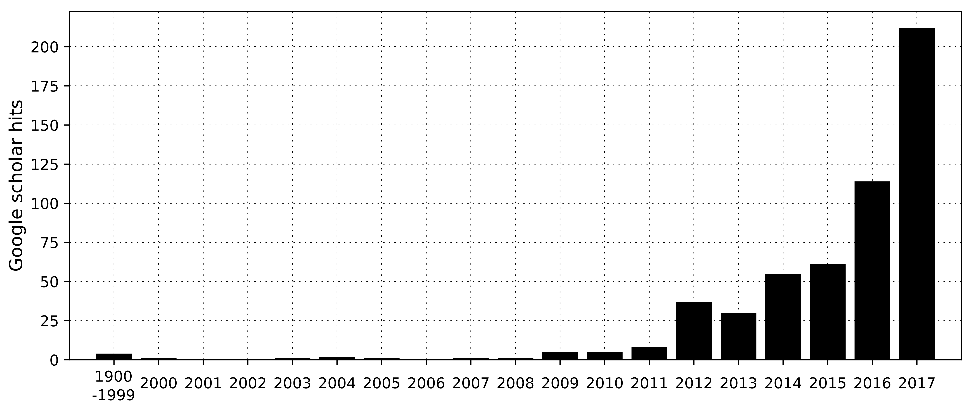

Figure 1. Frequency of publications returned from a Google Scholar search based on the search terms “marine heatwave*”, and “marine heat wave*”. Note the first bin (1999) contains all records for the period 1900-99.

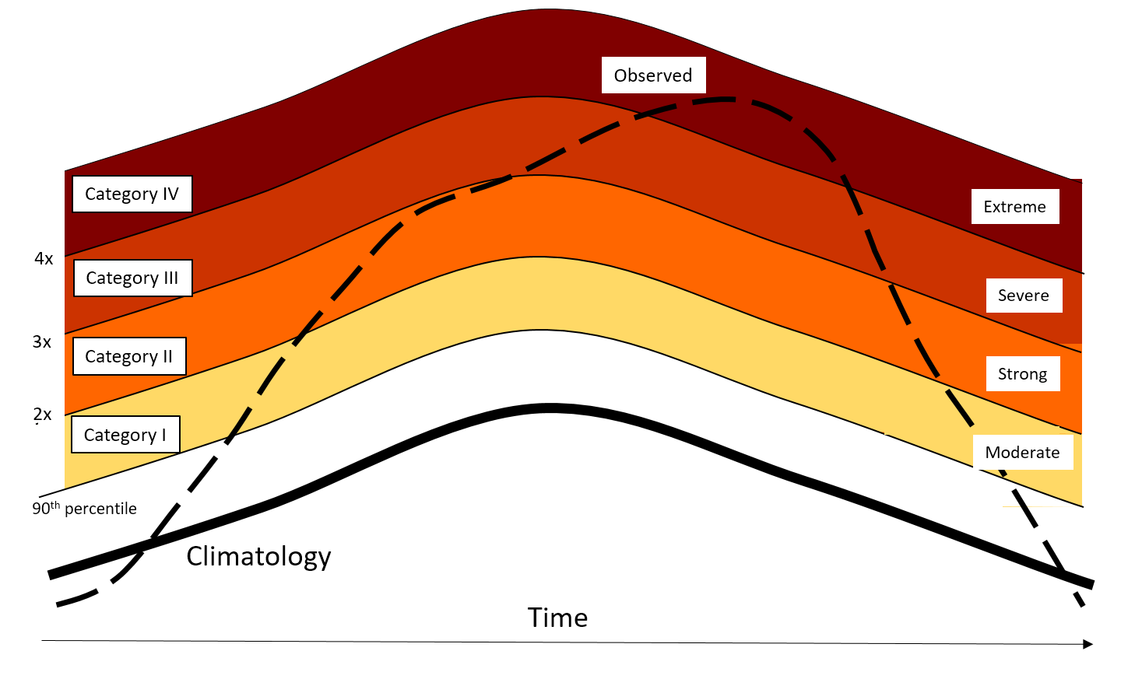
Figure 2. Categorization schematic for marine heatwaves (MHW) showing the observed temperature time series (dashed line), the long term regional climatology (bold line) and the 90th percentile climatology (thin line). Multiples of the 90th percentile difference (2x twice, 3x, three times, etc) from the mean climatology value define each of the categories I-IV, with corresponding descriptors from Moderate to Extreme. This example peaked as a Category IV (extreme) MHW.

A | 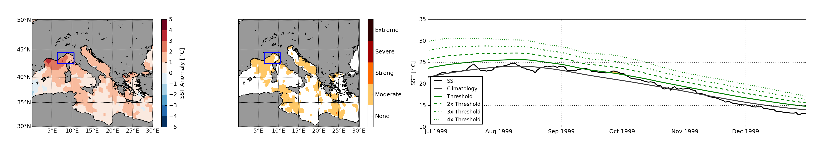
B | 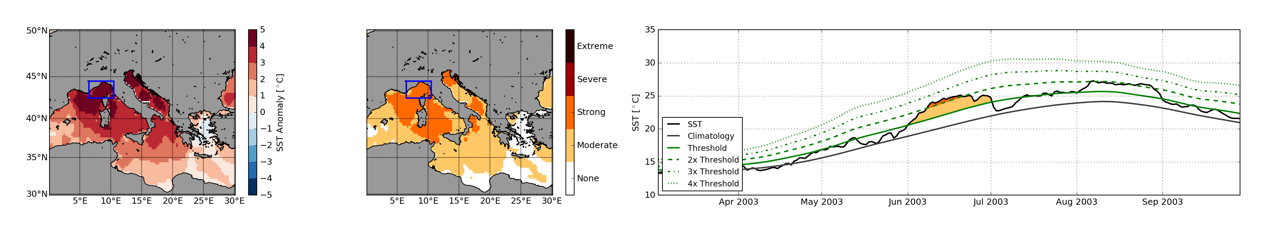
C | 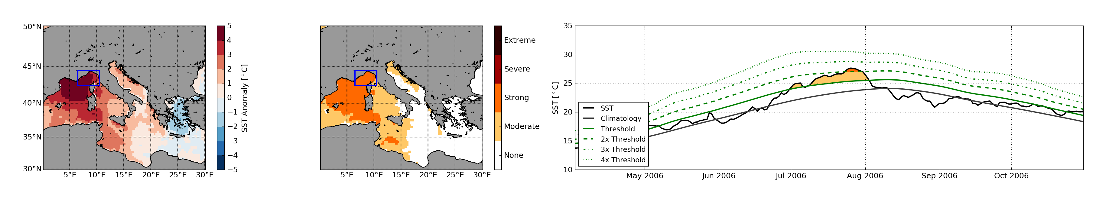
D | 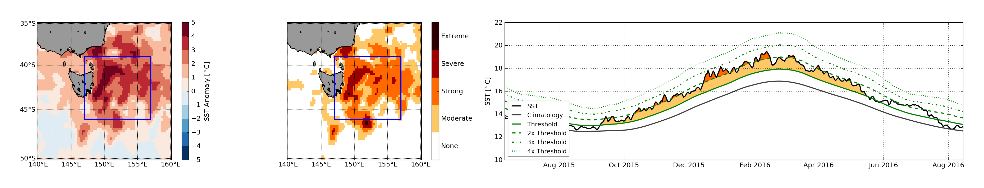
E | 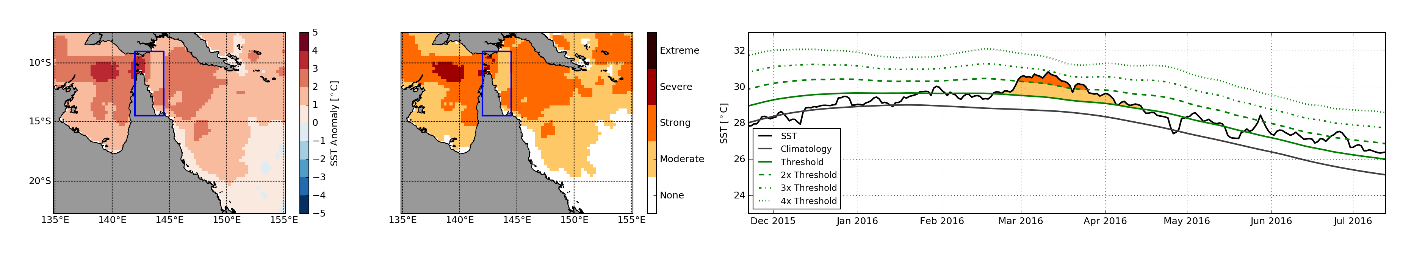
F | 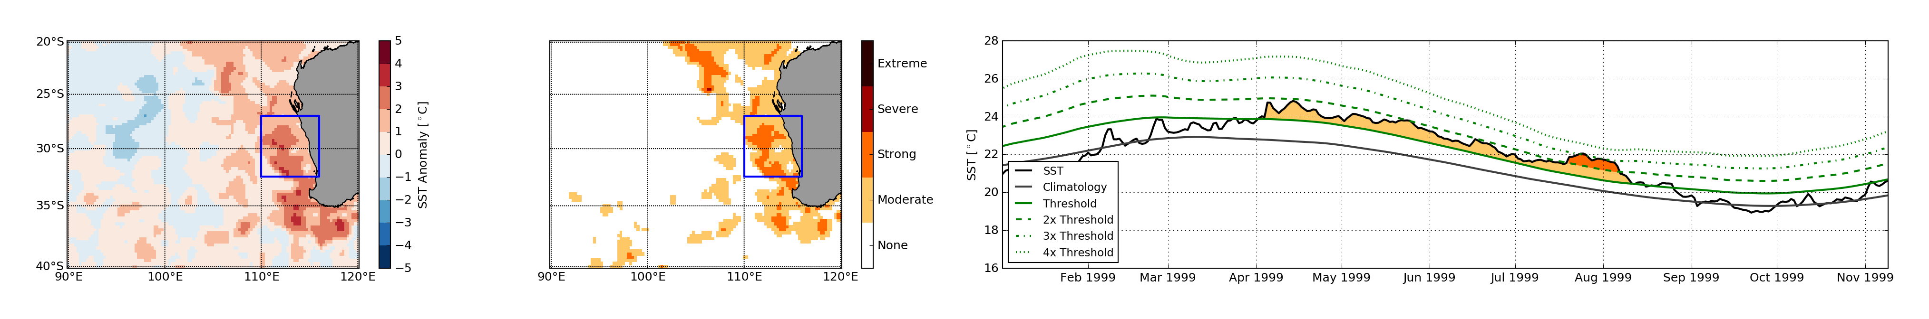
G | 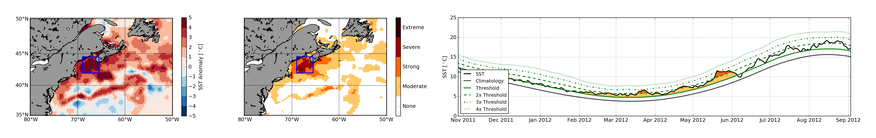
H | 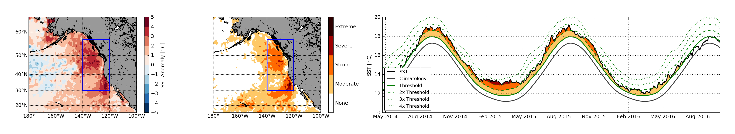
I | 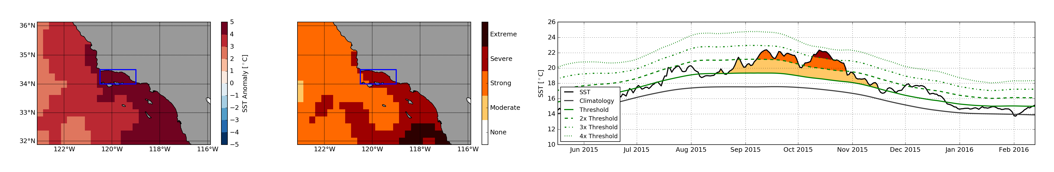
J | 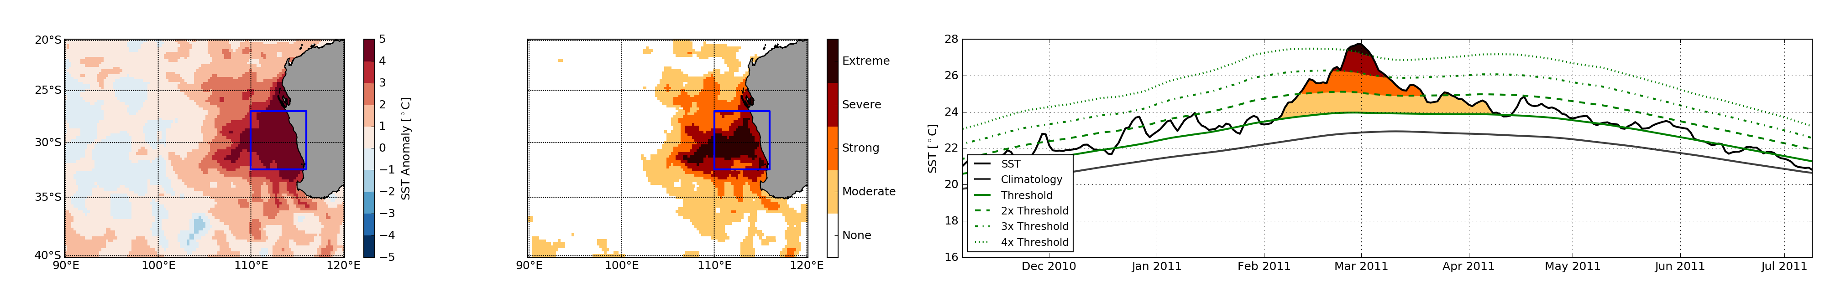

Figure 3. Representative marine heatwave (MHW) events showing the sea surface temperature anomaly at the peak of the event (left column) based on NOAA OISST V2, the categories of MHW (middle column), and the time series of each event, spatially-averaged over the area shown in blue in column 1 and 2, with the category for each day indicated by colors (right column). A. Mediterranean Sea 1999. B. Mediterranean Sea 2003. C. Mediterranean Sea 2006. D. Tasman Sea 2015. E. Great Barrier Reef 2016. F. Western Australia 1999. G. North-west Atlantic 2012. H. North-east Pacific 2015. I. Santa Barbara 2015. J. Western Australia 2011.

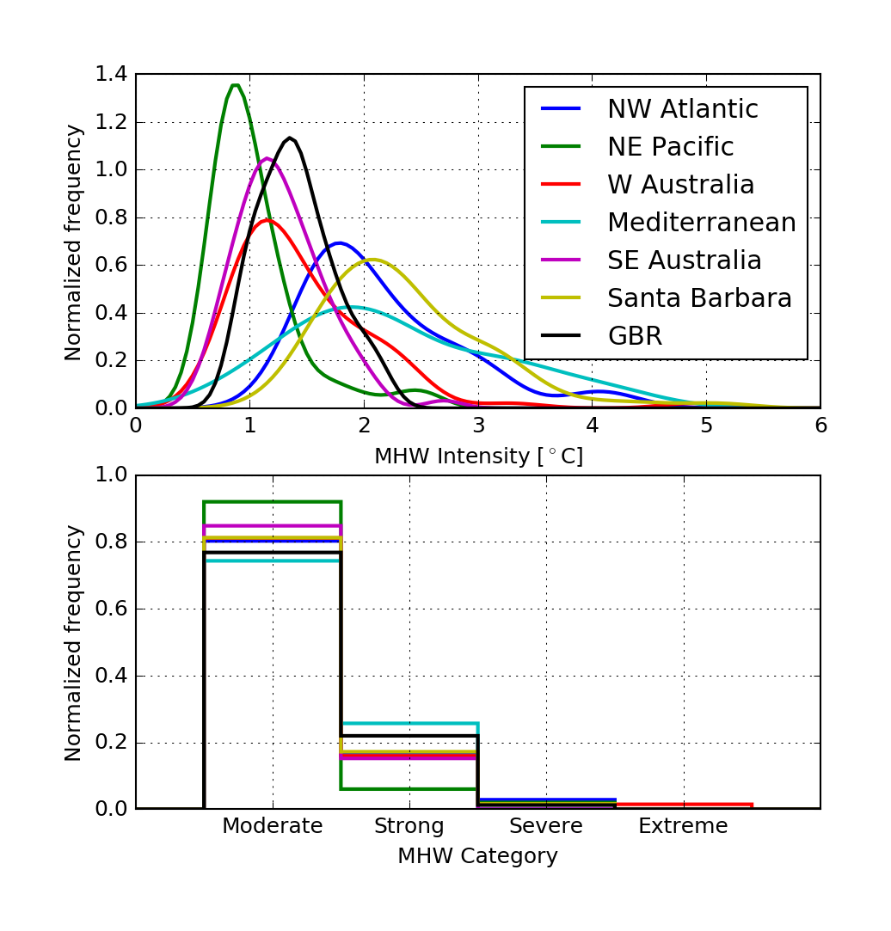
Figure 4. Frequency distribution of all marine heatwaves (MHWs) in regions listed in Table 2, based on analysis of the NOAA OISST V2 dataset. (A) Probability distribution of MHW intensities for each of the regions considered over the time period 1982-2016. (B) Normalized distribution of all MHWs in each category in each region over the time period.

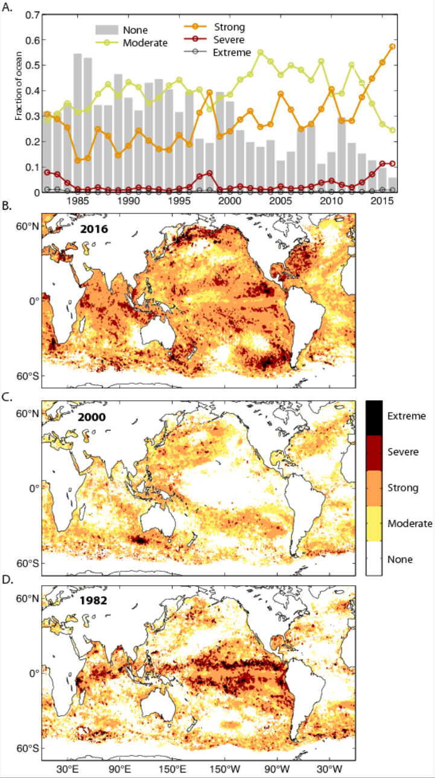

Figure 5. Maximum marine heatwave (MHW) category experienced per year based on the NOAA OISST V2 ¼° dataset. A. Fraction of ocean that experienced no, moderate, strong, severe or extreme MHWs, and maps of maximum experienced MHW category for example years (B) 2016, (C) 2000, and (D) 1982.

While there is some use of the term “heat wave” rather than “heatwave”, we follow the convention used for earthquake (not earth quake) and bushfire (not bush fire).
https://en.wikipedia.org/wiki/Wikipedia:WikiProject_Disaster_management/Naming
http://www.alternateroute.com.au/blog/2013/10/18/how-to-name-a-fire
The McArthur Forest Fire Danger Index was developed in the 1960s by CSIRO scientist A. G. McArthur to measure the degree of danger of fire in Australian forests. The index combines a record of dryness, based on rainfall and evaporation, with meteorological variables for wind speed, temperature and humidity.
The code described earlier also allows calculatation Marine Cold Spells (MCS)
https://github.com/cran/RmarineHeatWaves, also available in Python

