Projections of change in key ecosystem indicators for planning and management of Marine Protected Areas: an example study for European seas
Susan Kay and Momme Butenschön, Plymouth Marine Laboratory

Corresponding author: Susan Kay, Plymouth Marine Laboratory, Prospect Place, The Hoe, Plymouth, PL1 3DH, UK. Email: suka@pml.ac.uk Tel: +44 1752 633417

Abstract
Marine Protected Areas (MPAs) are widely used as tools to maintain biodiversity, protect habitats and ensure that development is sustainable. If MPAs are to maintain their role into the future it is important for managers to understand how conditions at these sites may change as a result of climate change and other drivers, and this understanding needs to extend beyond temperature to a range of key ecosystem indicators This case study demonstrates how spatially-aggregated model results for multiple variables can provide useful projections for MPA planners and managers. Conditions in European MPAs have been projected for the 2040s using unmitigated and globally managed scenarios of climate change and river management, and hence high and low emissions of greenhouse gases and riverborne nutrients. The results highlight the vulnerability of potential refuge sites in the north-west Mediterranean and the need for careful monitoring at MPAs to the north and west of the British Isles, which may be affected by changes in Atlantic circulation patterns. The projections also support the need for more MPAs in the eastern Mediterranean and Adriatic Sea, and can inform the selection of sites.

Keywords: climate changes, marine parks, biodiversity, nutrients (mineral), eutrophication, Mediterranean, North-East Atlantic

1. Introduction
Marine protected areas (MPAs) are a key element of strategies to protect coastal and shelf sea ecosystems in many parts of the world. They have been set up to maintain biodiversity, restore damaged ecosystems, ensure sustainable development and to protect a representative range of species and habitats (OSPAR Commission, 2013). Creation of MPAs was spurred by the 1992 Convention on Biological Diversity (CBD) and the current CBD target is for 10% of coastal and marine areas to be conserved by well-managed, ecologically-representative and well-connected protected areas by 2020 (Gabrié et al., 2012). As well as protecting biodiversity, MPAs can help to ensure the long-term sustainability of fisheries (Weigel et al., 2014) and preserve coastal and marine sites of socio-cultural value (Börger et al., 2014; Gabrié et al., 2012).

Marine areas worldwide, and particularly coastal areas, face many anthropogenic threats, arising from both local and non-local sources (Halpern et al., 2008). Marine Protected Areas can reduce threats from local sources such as fishing and recreation, but they remain vulnerable to impacts from riverborne nutrients sourced from the wider area and from global climate change. These exogenous, unmanaged drivers (Elliott et al., 2015) will affect MPAs regardless of their protected status, and effective planning and management requires an understanding of the change in local environmental conditions that they are likely to produce. Environmental change may make an MPA unsuited to the purpose for which it was set up, for example if conditions are no longer appropriate for a target species. Management regulations which are framed in terms of current conditions may no longer be appropriate if climate change affects what can be considered ‘normal’ for a given system – the shifting baseline effect (Elliott et al., 2015).

A number of studies have looked at the potential impact of climate change on MPAs and suggested ways in which MPAs can be designed and managed so as to limit the risk of ecosystem damage. Results include guidance produced for North American MPAs (Brock et al., 2012; ICES, 2011), for coral reefs and other tropical seas (Green et al., 2014) and for the Mediterranean (Otero et al., 2013). These studies are based on the expected response of organisms and ecosystems to rising temperatures (e.g. O’Connor et al., 2007, Marras et al., 2015, Hoegh-Guldberg and Bruno, 2010). Studies are beginning to show how the effect of other variables can interact with temperature changes, making assessments based only on temperature changes inadequate e.g. (Deutsch et al., 2015; Muir et al., 2015).

There has been little use of model projections of future conditions for the planning of marine protected areas (Levy and Ban, 2013; Makino et al., 2014) and those that do tend to use projections of surface temperature only. They also rely on global circulation models (GCMs) with resolutions typically 50 km or more. Satellite data provides higher resolution, but does not by itself give information about future conditions (Chollett et al., 2014). As future projections downscaled to the regional level become more common, their potential for MPA planning and management can be developed.

Other studies have used a species-based approach to investigate the threat to biodiversity from climate change. Jones et al. (2013) used species distribution models to project changes in the range of 17 fish species in the North Sea. The species distribution models made use of a number of variables taken from GCMs, and so they go beyond projections based only on temperature. Jones et al. considered the use of their model results to judge the change in habitat suitability of protected areas, but they suggest that this would need to be done on a species by species and area by area approach: there is no simple pattern of change across areas.

Another anthropogenic threat to marine ecosystems comes from riverborne influxes of nitrates and phosphates. Eutrophication associated with high river nutrient loadings has long been a problem in parts of the North Sea and the Mediterranean (Coll et al., 2010; Langmead et al., 2007). Reduction of this threat requires changes in land use and water treatment upstream, perhaps in a different jurisdiction. Model projections have been more widely used to investigate this issue and the consequences of possible mitigation actions e.g. (Lenhart et al., 2010; Skogen et al., 2014). In practice, MPAs are experiencing the combined effects of climate change and river nutrient loadings and models can be used to investigate the interaction between these stressors.

Here we show how a regional model, downscaled from global data, can be used to make projections of change in a number of key ecosystem indicators resulting from changes in climate and river nutrient loadings. We present spatially-aggregated results that give an overview of projected change in conditions in a selected area under two different scenarios: these provide a starting point from which managers and planners can go on to investigate possible actions, such as increased protection through changes in local management (Micheli et al., 2012), an extension of the MPA area, creation of other MPAs nearby to give a more robust network or perhaps future relocation of the MPA to an area where future conditions are more appropriate for its purpose. The model projections include both physical and biogeochemical indicators – temperature, salinity and mixed layer depth, nutrient concentrations, dissolved oxygen, surface chlorophyll, primary production and zooplankton biomass. They thus give a richer view of conditions in an area of interest than is possible with use of a single indicator, and they demonstrate how resilient a given area is to climate change, i.e. whether the changes occurring in this area are significantly altering habitat conditions. They also illustrate how susceptible an area is to policy change by showing how much the projected changes differ between the contrasting scenarios. The examples given are for European seas, but the methods used are general and could be applied anywhere in the world – and to any spatial area of interest, not just to MPAs.

Our study areas are the Mediterranean Sea and the North East Atlantic (Fig. 2). These seas encompass a wide range of temperate marine conditions and include coastal, shelf sea and deep water areas. The Mediterranean is largely enclosed, being connected to the Atlantic only via a narrow strait at the western edge. The sea has a long northern coastline which limits the poleward movement of species in a warming climate. Surface temperatures are typically 16-28°C (Butenschön and Kay, 2013). The North East Atlantic comprises the shallow North Sea and English Channel, to the east and south of the British Isles respectively, as well as the deeper waters to the west. Unlike the Mediterranean, it is open to influence from the wider Atlantic Ocean and has no land mass to the north. Surface temperatures are cooler and more variable than in the Mediterranean, from near-freezing up to 20°C (Butenschön and Kay, 2013).

Networks of protected areas have been set up in both seas. In 2012 Mediterranean MPAs covered an area of about 115,000 km², about 4.6% of the Sea's area. However, three quarters of this was in a single MPA, the Pelagos Sanctuary for Mediterranean Marine Mammals (Gabrié et al., 2012). The network is largely restricted to small coastal sites and there are relatively few sites on the southern and eastern shores. The North-East Atlantic has a better-developed MPA network: in December 2012 there were 333 MPAs, covering an area of 700,000 km², 5% of the entire OSPAR area and 22% of coastal waters (OSPAR Commission, 2013). These range from coastal zones, to larger shelf sea areas and deep sea areas around seamounts. Fig. 2 shows the sample of MPAs which are included in the current study and their main features are listed in Table 1.

The scenarios presented here have been produced using projections of marine physics and biogeochemistry and the lower trophic level ecosystem. These projections were developed under the EU project VECTORS (Austen et al., this issue) and have delivered the baseline for the socioeconomic scenarios used in this project (Groenveld et al.,2015). They have been run for two contrasting future scenarios of climate change and river nutrient levels for the period 2040-2049, as well as a reference run for 2000-2009. The two scenarios were chosen to represent more and less sustainable situations of economic development – lower/higher greenhouse gas emissions and river nutrient levels. The projections thus give an envelope of potential conditions in the 2040s.

2. Methods
2.1 The numerical model
Modelling was carried out using the biogeochemical and lower trophic level model ERSEM (Blackford et al., 2004; Butenschön et al., 2015) coupled to the hydrodynamic shelf sea model POLCOMS (Holt and James, 2001). Both have a long history of use in modelling the North-East Atlantic system e.g. (Allen et al., 2007; Siddorn et al., 2007) and global shelf seas (Barange et al., 2014; Blanchard et al., 2012; Holt et al., 2009). For the current study the model system was designed to be consistent across all marine areas included: the same model resolution (0.1º, about 6-11 km) and the same sources of forcing data. Separate domains were used for the Mediterranean and the North-East Atlantic. A full description of the model set-up is given in Butenschön and Kay (2013); a brief summary is given here.

ERSEM includes three size-class based functional types of phytoplankton plus diatoms, three functional types for zooplankton, bacteria, three size classes of particulate organic matter, dissolved and semi-labile organic matter and the inorganic components nitrate, phosphate, silicate, dissolved oxygen and DIC (Fig. 1). The cycles of the main chemical constituents of the system, i.e. carbon, nitrogen, phosphate and silicate, are resolved explicitly, with variable stoichiometry in the organic components, and the model also includes microbial dynamics. For the North-East Atlantic the ERSEM benthic model was used to model the seabed subsystem, but this was not suitable for Mediterranean conditions and instead a simple remineralisation closure scheme was used: this returns benthic organic matter as inorganic component through a fixed rate.
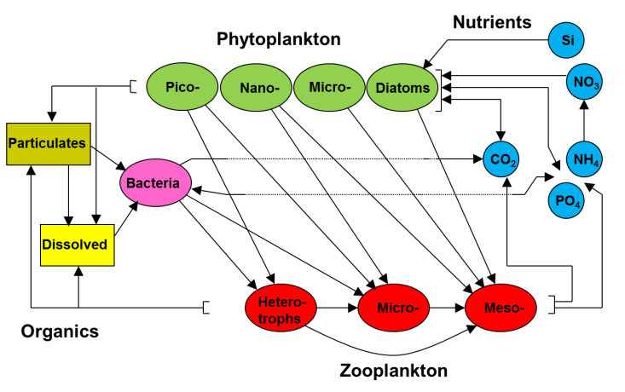
Fig. 1 The ERSEM pelagic food web

External conditions were applied to the model at the atmospheric and open-ocean boundaries and at river mouths. For the present-day model run, forcing data was derived from reanalysis data: ERA Interim meteorological data (Dee et al., 2011) at the atmospheric boundary and GLORYS data (Ferry et al., 2012) at the open ocean boundary. River outflow volumes and nutrient levels were taken from the Global NEWS database (Seitzinger et al., 2005). River inputs were assumed to be constant throughout the year.

For each run, the model was spun up for 5 years before starting the 10 year run. The reanalysis-driven run was for 2000-2009, future projections for 2040-2049.

2.2 Scenario setup and downscaling of forcing data
Two future scenarios were modelled: these were chosen to represent opposing socioeconomic environments and mitigation strategies and hence to illustrate the range of response of the system. They are broadly based on the SRES scenarios A2-National Responsibility and B1-Global Community (Nakićenović and Swart, 2000).
- In the National Responsibility (NR) scenario, development and management decisions are generally based on a nation’s self-interest. Greenhouse gas emissions are relatively high and limited efforts have been made to reduce pollutants in rivers.
- Under the Global Community (GC) scenario international co-operation and environmental sustainability are higher priorities. Mitigation strategies have kept greenhouse gas emissions relatively low and river pollution is coming under control.

Forcing data for these future scenarios was developed from the present-day values using a delta method: the fine-scale temporal and spatial variation from the present-day forcing data was applied to the coarser scale conditions taken from a global circulation model (GCM), thus creating a plausible decade of conditions consistent with the GCM but at higher resolution. Delta downscaling allows regional-level data to be generated from a GCM without the cost of a full regional climate model run, but it decouples the fine-scale variation from the larger patterns in the GCM so there is a risk of inconsistency: the resulting data set is physically plausible rather than physically consistent and small-scale variation associated with climate change is not captured.

The GCM used was the coupled atmosphere-ocean model ECHAM5/MPIOM (Jungclaus et al., 2006); this model gives comparable simulations of current conditions to other models used in the Fourth Assessment Report of the Intergovernmental Panel on Climate Change (IPCC AR4,Randall et al., 2007) and its carbon sensitivity is in the middle of the range of the IPCC AR4 models. This GCM can thus be seen as typical of the models available at the time the data was used, and use of two contrasting climate change scenarios, A2 and B1, means that a range of possible futures has been explored. It was beyond the scope of this work to investigate the variation produced by using different GCMs, but that would be desirable in a larger study.

The GCM provided monthly data at resolution 1.875°. Two types of modification were used to generate the downscaled data: additive [1] and multiplicative [2]:
$Ψ_{future}(x,t)=Ψ_{RA}(x,t)+\left[M_{future}(x',t')-M_{present}(x',t')\right]$ [1]
$Ψ_{future}\left(x,t\right)=Ψ_{RA}\left(x,t\right)*\left[\frac{M_{future}\left(x^{'},t^{'}\right)}{M_{present}(x',t')}\right]$ [2]
where Ψ_{RA}, Ψ_{future} are the present-day and future forcing data, M_{present} and M_{future} the values from the GCM output. (x,t) represents a point in the forcing data, (x',t') is used for the GCM data grid, which is typically at a different resolution and interpolated to match the forcing data grid.

For each variable, linear regression between future and present climate model data across all time and space points was used to select which method to use:
$M_{future}=k*M_{present}+X$ [3]
In cases where the regression showed a strong correlation with k≈1 and X≠0 an additive method was used; where X was close to 0 a multiplicative method gave a better fit to the model's behaviour. The additive method was used for solar and thermal radiation, temperature (air and sea), salinity, pressure and wind and current components, the multiplicative method for cloud cover, precipitation and relative humidity.

For all variables except precipitation, the spatial resolution of the climate model was retained, while the data for each month was averaged over the ten year period to give a monthly climatology for the calculations of the deltas. This choice was preferred over the full temporal resolution to avoid spurious trends due to interannual/decadal variability that remain unidentifiable in short time-slice experiments like these. However, intra-annual (e.g. seasonal) changes between the present and future GCM runs have been retained. In the case of precipitation, averaging only over the time period led to some low values in the present-day model data and hence unrealistically high future values when using equation [2]. The problem was resolved by using model data averaged over the whole domain to smooth the input; this means that spatial variation in rainfall derive only from the original reanalysis data and not from the climate model.

Atmospheric CO₂ levels were set at 505 ppm for A2 and 475 ppm for B1, based on IPCC model projections (IPCC, 2001)

The effect of these changes was an increase of air temperatures at sea level in the region of 1°C with respect to present day for the NR scenario, and about 0.7°C for GC. Wind speeds showed no change in the Mediterranean, but a slight rise in the North East Atlantic, of the order of 1 m s⁻¹ for both scenarios. The result in the modelled outputs was an increase in sea surface temperature in the Mediterranean of 0.6-1.0°C under the NR scenario and 0.4-0.8°C under the GC scenario; for the NE Atlantic shelf seas the increases were 0.7-1.0°C under NR and 0.5-0.9°C under GC (Fig. 4). These values are consistent with other modelling studies, which have looked at longer time scales: projected end-century sea surface temperature increases for the Mediterranean are 2.5-3.0°C under the A2 scenario and 1.7°C for the B1 scenario (Adloff et al., 2015) and for the NE Atlantic shelf 2-4°C under the A1B scenario (Holt et al., 2010).

River flow volumes were not changed from their present-day values, because consistent hydrological projections were not available for both seas. In a sensitivity study for the Mediterranean, Adloff et al. (2015) found that river flow volume had a much smaller effect on model evolution than other drivers. River flows affect salinity and hence stratification and transport within a few grid cells of river mouths, but in other areas forcing from precipitation is likely to be more important (Holt et al., 2010). Values for river nitrate and phosphate levels were adjusted based on the assessments given in the European Lifestyles and Marine Ecosystems report (Langmead et al., 2007). Under the NR scenario nitrates and phosphates were both increased by 60% for the Mediterranean; nitrates increased by 30% and phosphates were unchanged for the North-East Atlantic. Under the GC scenario there was no change in the Mediterranean; nitrates were unchanged and phosphates decreased by 30% for the North-East Atlantic.

Nitrate and phosphate values at the ocean boundary were set using the World Ocean Atlas climatological values (Garcia et al., 2010). These were not changed for the future scenarios as no biogeochemical information was available from the GCM.

2.3 Site description
The model outputs were used to calculate present-day and future scenario values for a range of indicators, for a set of MPAs chosen to include all parts of each sea (Fig 2). Smaller MPAs were avoided where possible, as the model is less reliable at the 6-11 km scale of the model grid (see section 3.1). However, in areas where no large MPAs exist, some smaller ones were included, and a larger area of sea including the MPAs was modelled (Table 1). In the case of the Israeli coast a single area covering several small MPAs was used. No attempt was made to resolve spatially within the area of a single MPA, all results are presented for entire MPAs only.

Table 1. Marine protected areas included in this study, with location and size features
Name of MPA | Sea | Latitude (°N) | Longitude (°E) | Depth (m) | Reserves area (km²) | Modelled area (km²)
Alboran Island | W Med | 36.0 | -3.0 | 902 | 264 | 300
Evro Delta | W Med | 40.6 | 0.8 | 52 | 357 | 281
Garraf Coast | W Med | 41.2 | 1.9 | 420 | 265 | 372
Migjorn de Mallorca | W Med | 39.3 | 3.0 | 370 | 223 | 861
Gulf of Lion | W Med | 42.7 | 3.5 | 244 | 4009 | 3997
Calanques | W Med | 43.1 | 5.4 | 647 | 435 | 1263
Pelagos Sanctuary | W Med | 42.7 | 8.8 | 1458 | 87305 | 82762
Iles Kneiss | Central Med | 34.3 | 10.3 | 13 | 160 | 408
Isole Egadi | Central Med | 38.0 | 12.2 | 338 | 540 | 975
Kornati | Adriatic | 43.8 | 15.4 | 102 | 166 | 893
Capo Rizzuto | Central Med | 39.0 | 17.1 | 537 | 147 | 481
Porto Cesareo | Central Med | 40.2 | 17.9 | 135 | 167 | 283
Alonissos-Northern Sporades | Aegean | 39.3 | 24.1 | 429 | 2070 | 2297
Sallum Gulf | E Med | 31.6 | 25.6 | 260 | 327 | 1052
Gokova | E Med | 36.9 | 27.7 | 266 | 820 | 396
Israeli coastal sites | E Med | 32.7 | 34.8 | 511 | 7 | 2912
East Rockall Bank | NE Alantic | 57.7 | -13.4 | 886 | 3695 | 3170
Hovland Mound Province | NE Alantic | 52.2 | -12.8 | 754 | 1090 | 1060
Stanton Banks | Celtic Seas | 56.2 | -7.9 | 93 | 817 | 755
Haig Fras | Celtic Seas | 50.3 | -7.7 | 83 | 481 | 474
Wyville Thomson Ridge | NE Alantic | 60.0 | -6.8 | 617 | 1740 | 1730
Iroise | Celtic Seas | 48.2 | -5.0 | 73 | 3428 | 3105
Luce Bay and Sands | Celtic Seas | 54.7 | -4.7 | 24 | 479 | 71
Cardigan Bay | Celtic Seas | 52.3 | -4.6 | 23 | 953 | 453
Moray Firth SAC | North Sea | 57.9 | -3.6 | 30 | 1513 | 575
Liverpool Bay | Celtic Seas | 53.5 | -3.5 | 16 | 1703 | 660
Wight-Barfleur Reef | English Channel | 50.3 | -1.5 | 54 | 1373 | 1263
Pobie Bank Reef | North Sea | 60.5 | -0.3 | 91 | 966 | 973
Margate and Long Sands | North Sea | 51.6 | 1.4 | 11 | 649 | 690
Norfolk Sandbanks and Saturn Reef | North Sea | 53.4 | 2.1 | 25 | 3606 | 3684
Dogger Bank | North Sea | 54.9 | 2.2 | 27 | 12340 | 12229
Vlaamse Banken |  | 51.3 | 2.6 | 17 | 1182 | 1003
Noordzeekustzone | North Sea | 53.2 | 5.2 | 14 | 1416 | 1089
Sylt.Aussenr.-Oestl.Dt.Bucht | North Sea | 54.8 | 7.4 | 25 | 5595 | 5693
Gule Rev | North Sea | 57.3 | 8.2 | 67 | 473 | 334
Wadden Sea National Park | North Sea | 54.5 | 8.4 | 9 | 4602 | 2027

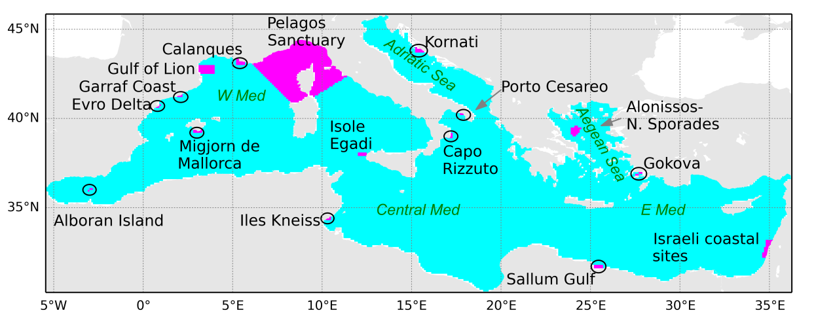
(a)
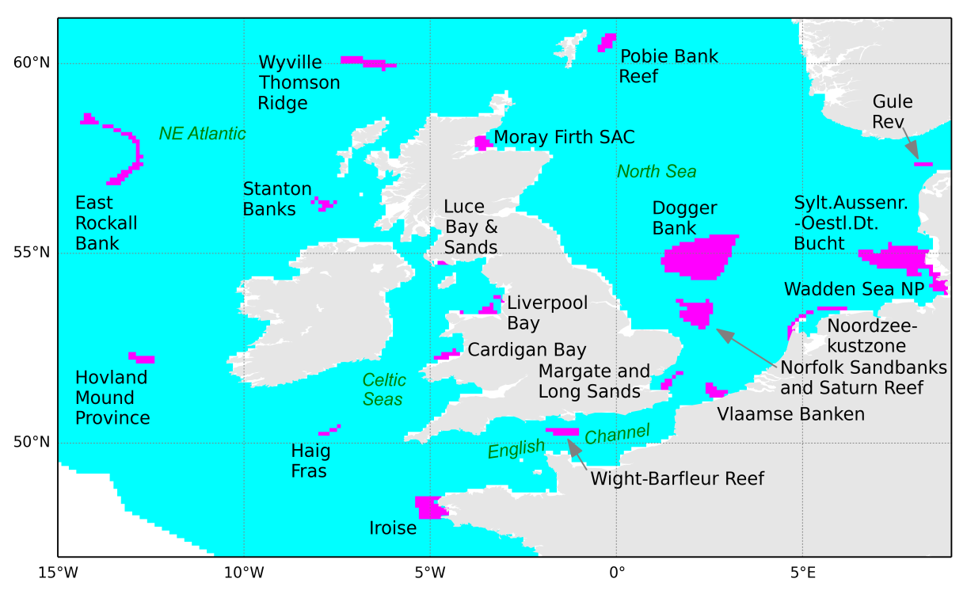
(b)
Fig. 2 MPAs selected for analysis, (a) Mediterranean and (b) North-East Atlantic. MPAs are shown in pink, black circles are used to highlight the smaller MPAs. The sea area shown in white at the bottom left of (b) is outside the model domain.

2.4 Data analysis and presentation
Projected change in the MPAs is presented in the form of tables showing the size of the difference between present and future values for a number of key ecosystem indicators (Tables 2 and 3). In each case the difference was calculated for each of the ten years of the model run:
$size of change=\frac{1}{n}\sum_{i=1}^{n}{\left( I_{future}^{i}-I_{present}^{i}\right)}$ [4]
where $I_{future}^{i}$ represents the mean value of the indicator for month i of the 2040s,averaged over the MPA, and $I_{present}^{i}$ represents values for the 2000s. For most indicators all 12 months of each year were used (n=120); for winter nutrients only the mean for November-February of each year (n=40) and for summer chlorophyll the mean for March to October (n=80); these season definitions have been used to match those in the OSPAR criteria for eutrophication status (OSPAR Commission, 2005). The tables are colour-coded to show the mean difference relative to the range of values seen in the 120 months of the present-day run: this gives an index of change which can be compared across the different indicators.
$index of change=\frac{size of change}{max⁡(I_{present})-min⁡(I_{present})}$ [5]
Model cells where the difference is not statistically significant (p>0.05) are coloured white and the difference given as grey text. Statistical significance was based on a t-test of the null hypothesis that current and future conditions are the same, using the 10 years of the model run as a sample. The delta method of producing the model forcing means that the years of the present-day and future runs are not completely independent: for example, the small-scale variation in 2041 is based on that in 2001. However the large-scale variation provided by the GCM is not related in this way and so the data are neither completed paired nor completely independent. The p-values presented are for a t-test of independent data, which would tend to underestimate rather than overestimate the significance.

The indicators presented are:
- Temperature (T) - the mean surface and bottom-water values, and also the maximum and minimum surface values: changes in these could push local temperatures out of the acclimatisation range of some native species or into the range for non-native competitors (Hoegh-Guldberg and Bruno, 2010).
- Biological indicators – net primary production (netPP), mean zooplankton biomass for the water column (Zc) and mean surface chlorophyll-a (Chl) for the growing season.
- Dissolved oxygen (O₂) at the bottom level: this can be affected by temperature change and low values can also result from eutrophication
- Dissolved nutrients – winter mean surface nitrate (N), phosphate (P) and silicate (Si); also the mean winter N:P ratio: these can be indicators of eutrophication
- Other physical indicators – surface salinity (S) and mixed layer depth (MLD): these can indicate changes in the water column structure

3. Results
3.1. Model validation
The capability of the model to represent the MPA domains consistently was assessed using methods of comparative spatial pattern recognition in order to justify the application of the model projections. In this context it is important to show the model’s ability to reflect the natural ecosystem at spatial scales of the MPAs and upwards as we are not investigating the variability within one area. To this purpose model outputs of surface chlorophyll-a concentration for the present-day run were compared to monthly composites of satellite chlorophyll data from the GlobColour database (www.globcolour.info, accessed 5 March 2013) and the model error was decomposed into its spatial scale components using the wavelet method presented by Saux Picart et al. (2012). The difference between model and satellite data sets is aggregated at successively larger spatial scales and assessed at each scale using a binary map using quartile-based thresholds. The results are summarised using a skill score defined as the mean square difference relative to the mean square difference for random data: 1 represents a perfect match, 0 would be the score for matching random data and scores below 0 show that agreement is worse than random. This method of validation penalises small features which appear in one dataset but not the other, but does not over-penalise larger features which appear in both sets but slightly displaced. For both seas, the skill assessment used data for the entire model domain, where cloud-free satellite data existed, and the variability was due to differences between months.

Fig. 3 shows a boxplot summarising the skill scores for all months at all scale levels. Skill levels were consistently above 0 with the exception of the smallest scale, corresponding to one model cell (0.1°); all the areas selected to assess change in MPA conditions are at least 2 cells wide (Fig. 2). Skill levels were comparable for the two seas, though with more variability for the NE Atlantic.
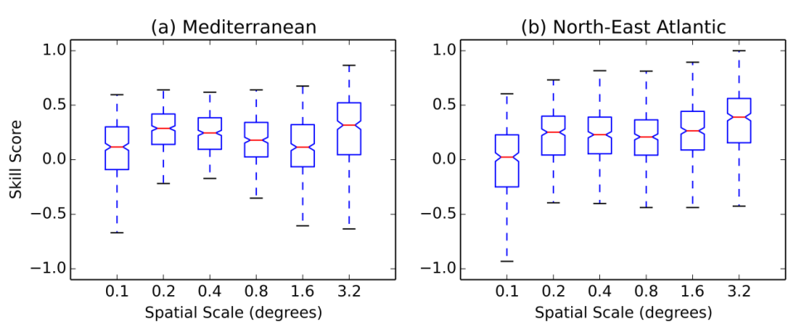
Fig. 3 Model skill at different spatial scales (degrees) against GlobColour satellite chlorophyll, derived from wavelet analysis (<0:poor, >0 good, 1=perfect match). (a) Mediterranean (b) North-East Atlantic. Each bar represents the average score for 120 months.

As an additional validation, the Spearman rank correlation between the monthly mean modelled and satellite values at each model point was calculated for each year (n in the range 266000-298000, depending on domain and amount of cloud cover). Correlations were consistently around 0.5, indicating a sound representation of the spatial-temporal structure of phytoplankton biomass throughout all years.

3.2. Differences between present day and future model conditions
Tables 2a and 2b show the difference between present-day and future scenario data for Mediterranean MPAs under the National Responsibility (a, purple-orange) and Global Community (b, green-brown) scenarios. Tables 3a and 3b give similar information for North-East Atlantic MPAs. For both seas, the MPAs are arranged from west to east going down the table.

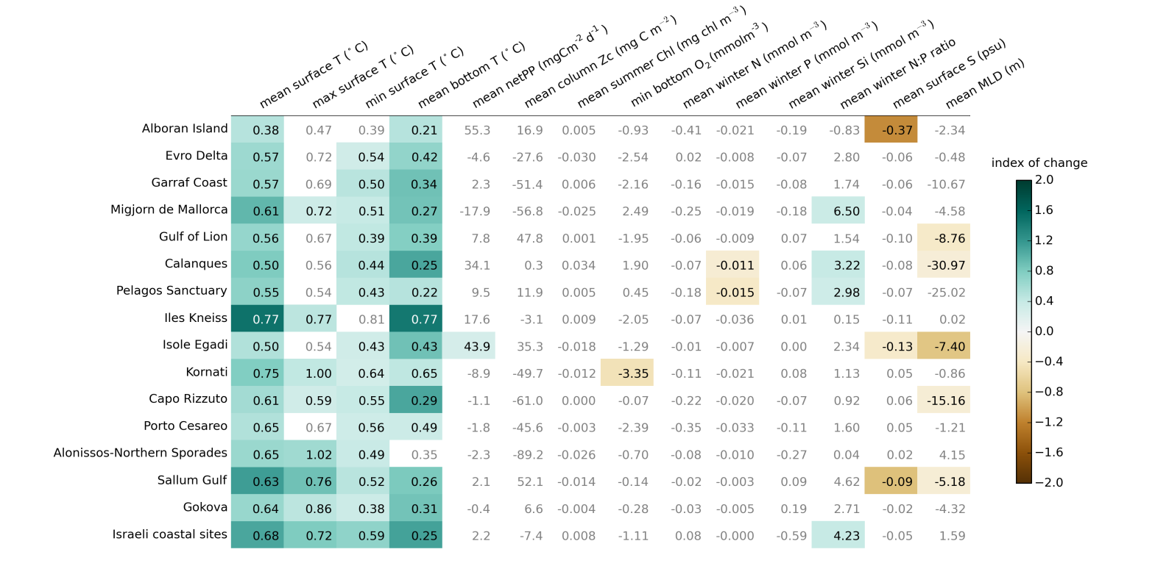
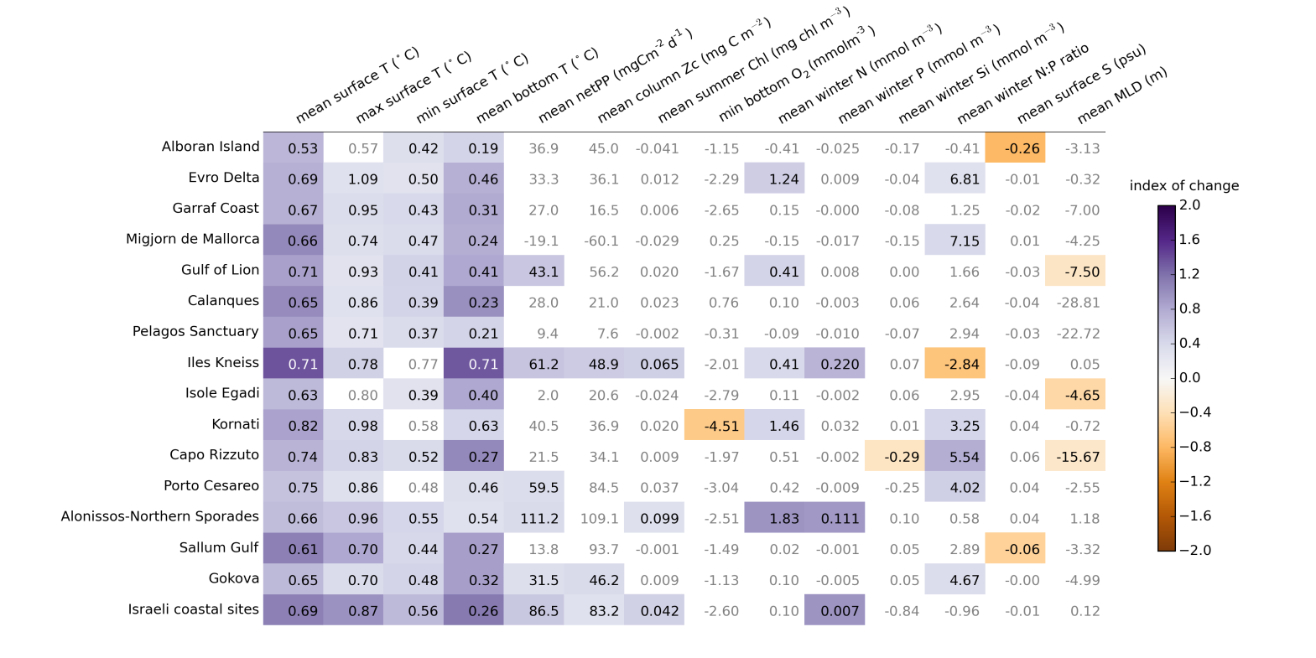
Table 2 Difference 2040s-2000s for ecosystem indicators for Mediterranean MPAs under (a) National Responsibility scenario (b) Global Community scenario. Differences shown are for the annual mean or minimum monthly value, as shown in the column headings, except for winter nutrients which are the mean for Nov-Feb and summer chlorophyll which is the mean for March-Oct. Cells are coloured by an index of change, defined as the ratio of the change to the range of values seen in the present-day model run (equation 5). White cells are used where the change is not statistically significant (i.e. p>0.05). See section 2.4 for more details on how the changes are calculated.
(a)
(b)

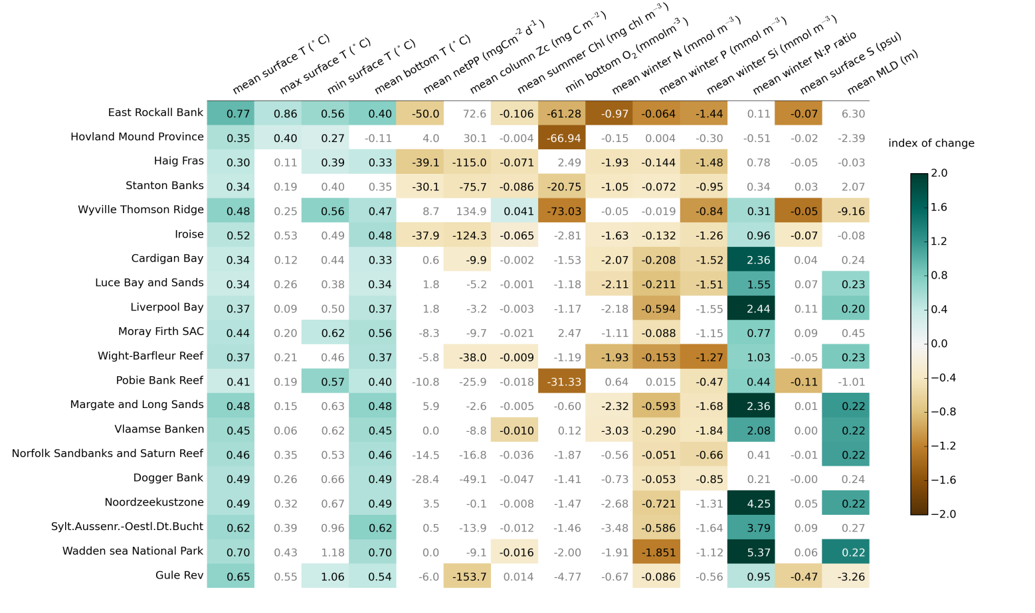
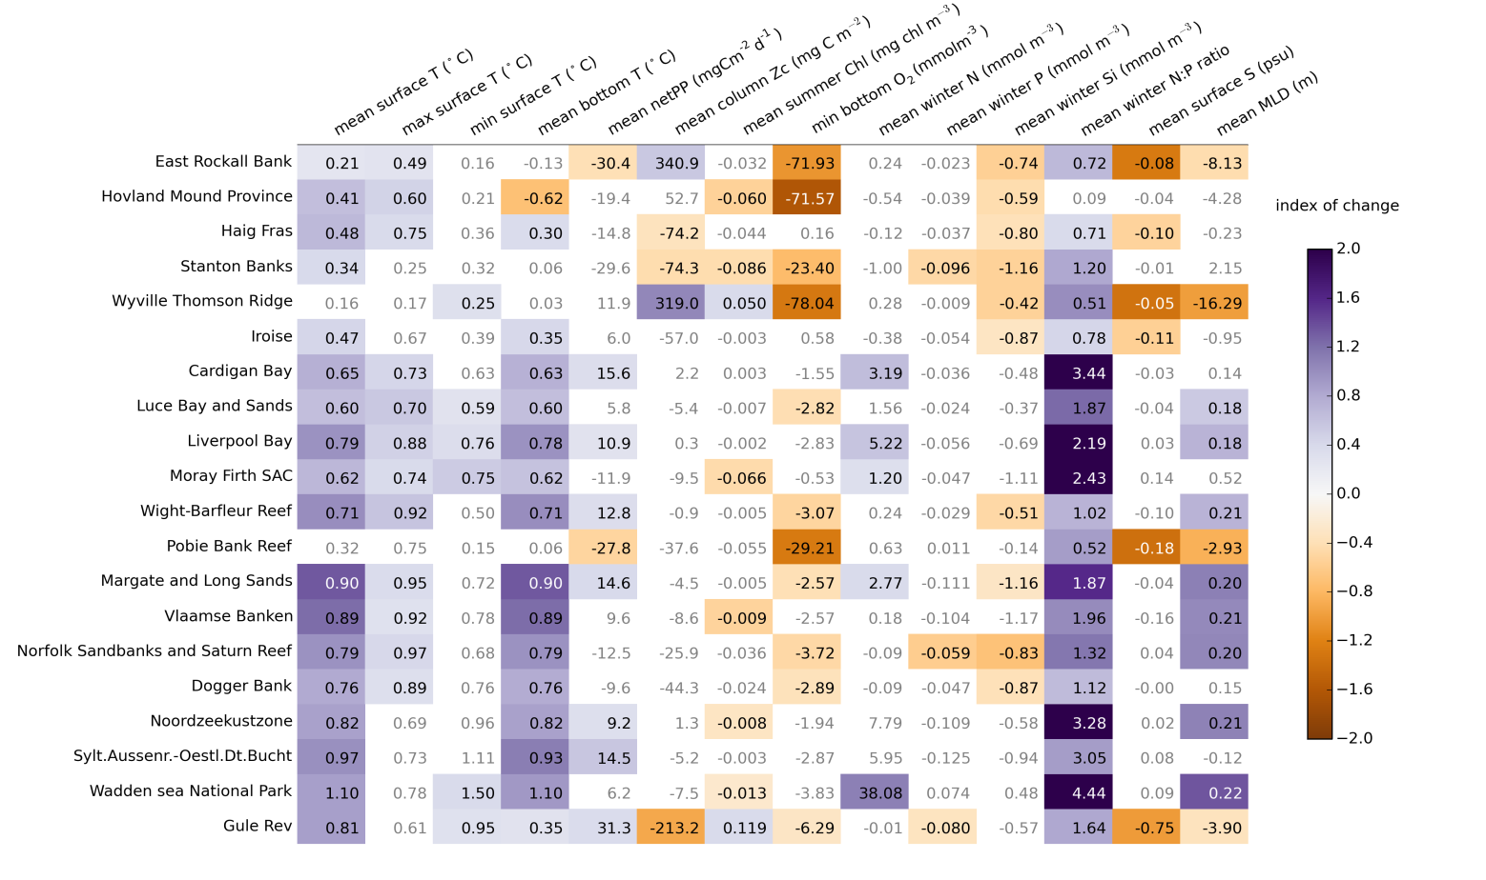
Table 3 Difference 2040s-2000s for ecosystem indicators for North-East Atlantic MPAs (a) National Responsibility scenario (b) Global Community scenario. See the Table 2 caption for details.
(a)
(b)
The biggest changes are seen in temperature (T), for all areas and for both scenarios. The results show a rise in annual mean sea surface temperature of 0.5-0.8 ºC for most Mediterranean sites and 0.4-1.0 ºC for sites in the North-East Atlantic. The index of change in mean surface temperature tends to be larger than for minimum or maximum temperature, i.e. the mean changes more than the extremes in relation to its present-day variability. Many of the sites are shallow, so that bottom level temperatures are similar to surface values, but changes are also seen at some of the deeper sites, such as Haig Fras in the North-East Atlantic and the Gulf of Lion in the Mediterranean; for both these sites the bottom-level temperature change is about the same for both scenarios, 0.3 and 0.4ºC respectively, even though the surface temperature rise is about 0.15ºC higher for the NR scenario than for GC. For MPAs in the northern parts of the Atlantic domain (East Rockall Bank, Wyville Thompson Ridge) there are more benthic temperature changes in the GC scenario than NR.

For other ecosystem indicators, there are few changes at Mediterranean sites, with some tendency towards more change in the east than the west of the region (Table 1a). The North-East Atlantic is more affected by external conditions in the wider sea (through the boundary conditions set by the GCM in this model) and by river inputs. Reduction in nutrient levels (N,P,Si) is observed both at the western sites, influenced by changes in the wider circulation, and at North Sea sites nearer river mouths. An increase in net primary production (netPP) is seen at roughly half the sites in the Mediterranean and at coastal sites in the North-East Atlantic under the NR scenario, but at very few sites for the GC scenario: sites in the western parts of the North-East Atlantic show a reduction in net primary production under the GC scenario. In spite of the greater stratification expected for warmer surface waters, there is little sign of change in the annual mean mixed layer depth (MLD) for most Mediterranean sites; the exceptions are Gulf of Lion and Isole Egadi, which show decreases in the range 4-9 m. Many of the shallower North Sea sites show a small increase in mixed layer depth, around 0.2 m, while there are decreases of a few metres for some of the deep water sites.

Reduced solubility due to higher temperatures and increased eutrophication due to higher nitrate levels can both lead to a reduction in bottom water oxygen levels (bottom O₂). This is seen at Kornati, the only Adriatic site, and for some of the North Sea MPAs, particularly under the NR scenario. At Kornati the decrease in oxygen levels is greater than that expected based on rise in temperature alone, around 2.8 mmol m⁻³; however at the shallow North Sea sites temperature change may be enough to explain the change in oxygen levels. For sites on the NE Atlantic shelf, levels of summer chlorophyll and winter mean nitrate and phosphate were compared to the thresholds agreed by OSPAR as indicating elevated levels associated with eutrophication (OSPAR Commission, 2005). Elevated chlorophyll was not found for any MPAs, consistent with the findings of Skogen et al. (2014), but elevated nutrient levels were found at eight sites. Nutrient levels were lower under the GC scenario than under NR, and for Vlaamse Banken the difference was enough to take the concentrations below the OSPAR thresholds. No thresholds have been agreed for the Mediterranean (Garmendia et al., 2015), so the analysis was not repeated for those sites. Reduced bottom-level oxygen is also seen in the outputs for western sites in the North-East Atlantic, of order 60-80 mmol m⁻³ at East Rockall Bank, Hovland Mound Province and Wyville Thompson Ridge: here temperature changes only account for a change of at most 10 mmol m⁻³.The reduced oxygen levels may be a cause for concern given the sensitive benthic ecosystem of these deep-water sites.

In general, there is more change in the National Responsibility than Global Community scenario: higher increases in temperature and a greater number of significant changes in other variables. In the Mediterranean the increase in mean surface temperature is around 0.1-0.15ºC higher under the NR scenario for most sites except those in the far east, where the differences between scenarios are small (see the last four rows in Table 2a,b). For the NE Atlantic the difference between scenarios is 0.2-0.5ºC for most sites; here the exception is the west, where the differences are smaller and East Rockall Bank has a 0.5 ºC lower increase under the NR scenario. The other exception to the general pattern of larger changes under the NR scenario is nutrient levels in the North-East Atlantic, where the effect of reductions in river loadings can be seen especially in the reduced phosphate levels in the GC scenario, down by 0.1-0.2 mmol m⁻³ at most MPAs and more near river mouths, and corresponding increases in the N:P ratio.

The above results all consider annual values and so do not consider changes in seasonality. Monthly mean data was examined for changes in intra-annual variation between present and future conditions. There were small shifts in a few cases, but no consistent patterns were found.

To put the changes in the MPAs into the wider context, the change in surface temperature was plotted across the whole domain for each sea and each scenario (Fig. 4). In general the pattern of change is similar for the NR and GC results, with greater increases for the NR scenario. The exception is the Atlantic area to the north and west of the British Isles, as already noted for MPAs in that region: there are few significant changes for the NR scenario, but some temperature rises for the GC scenario. In the Mediterranean the greatest increases are seen in the Adriatic and to the south of Sicily; in the North-East Atlantic the biggest changes occur at the shelf break and around Norway, there are also greater than average changes in the eastern North Sea. This presentation of a single variable across a wide spatial area contrasts with the multiple-indicator, spatially aggregated view shown in Tables 1 and 2. The approaches are complementary, but here our focus is on the multi-indicator view.

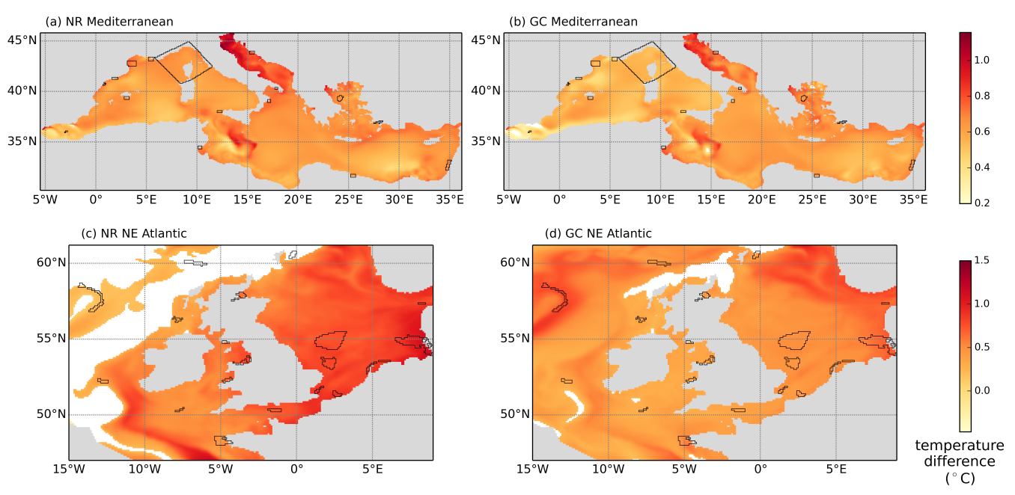
Fig. 4 Change in annual mean surface temperature from present-day values for (a,b) the Mediterranean and (c,d) the North-East Atlantic model domain. (a,c) results for National Responsibility scenario; (b,d) results for Global Community scenario. Points where the difference between present and future runs was not significant (p>0.05) are shown in white. MPAs discussed in this paper are outlined in black.

4. Discussion
Results from a regional model have been used to produce multi-indicator projections of change between the 2000s and the 2040s under two scenarios of climate change and river management. Tables 2 and 3 give an overview of how conditions in a sample of Marine Protected Areas may change. Changes in temperature occur at all locations, but changes in other indicators vary from place to place, demonstrating that temperature is not adequate as a proxy for all change. Even within temperature, patterns of minimum and maximum surface temperature and of benthic temperature differ from the mean: a multi-indicator view is needed to capture the wider picture of projected change.

The case study presented here is for two contrasting European seas, the Mediterranean and the North East Atlantic. In the Mediterranean, more changes across multiple indicators were seen in eastern than western sites (Table 2a). This is to be welcomed in the light of the greater biodiversity currently found in the west of the sea (Coll et al., 2010), but it also highlights the need for greater attention to the eastern region, particularly as higher temperatures here may enable invasive species arriving from the Suez Canal to survive and spread (Coll et al., 2010). There are currently many fewer MPAs in the east and those that have been established are small and not well connected (Gabrié et al., 2012): they are unlikely to be sufficient to act as refuge sites for species challenged by rising temperatures as well as other stressors. Further MPAs are needed and model results for the wider area can be a useful tool in the selection of suitable sites. Fig. 4 shows some areas of the eastern Mediterranean where the rise in surface temperature is lower than average, and similar plots for other ecosystem indicators could further assist in MPA location.

The north-western part of the Mediterranean has a key role to play as warming drives species north from their current range. This area already has a number of reserves, including the Gulf of Lion, Calanques and the Pelagos Sanctuary in the current study: of these, the Gulf of Lion is projected to have the largest changes in mean and extreme sea surface temperature; this MPA is discussed further below. The Adriatic could be another refuge site for cool-water species, but the projections show it increasing in temperature more than other areas (Fig 4 a,b). In addition, the results for Kornati (Table 2 and section 3.2) suggest that eutrophication could continue to be a problem in this already affected region if controls on river nutrients are not put in place.

The NE Atlantic is more open to the influence of the wider ocean than the Mediterranean, and this is apparent in the projections for the north-west of the region (East Rockall Bank, Wyville Thompson Ridge, Stanton Banks). These are projected to experience changes in most indicators studied (Table 3) and, unlike all other areas, the changes are greater under the GC scenario than under the higher emission NR scenario. This is because of differences in the position of the North Atlantic Current in the GCM under the NR and GC scenarios, with the Gulf Stream directed further to the south for NR; such differences in North Atlantic circulation have also been observed between different GCMs (Randall et al., 2007). Hence MPAs in this region may be particularly sensitive to climate change and uncertainty is high: monitoring of environmental conditions and more focussed modelling studies are recommended. Pobie Bank Reef, in the northern North Sea, is also affected by these circulation changes. Benthic oxygen levels are projected to decrease and this could affect the northward movement of species in a warming sea, even though this sea lacks the physical boundary present in the Mediterranean.

Comparing the two seas, the Mediterranean ecosystem seems more resilient: changes in temperature occur everywhere, but there are relatively few changes in other indicators, especially in the GC scenario. The picture is more varied in the North East Atlantic, with different patterns of change for the North Sea and the deep water regions to the north and west. The North Sea results show the influence of rivers, with nutrient levels falling especially under the GC scenario, while the north and west are dominated by the influence of the open ocean and so depend on the circulation patterns projected by the GCM.

The projections presented here are most useful for considering regional environmental change and the impact on networks of MPAs. However, they can also give insights into policy guidance for individual MPAs: to illustrate this we briefly consider how they could be applied to four MPAs, located across the region and set up for a variety of reasons.

The Hovland Mound Province Special Area of Conservation (NE Atlantic) was set up under the EU Habitats Directive to protect its reefs – in this case carbonate mounds colonised by cold water corals, which are recognised by OSPAR as a threatened habitat requiring protection (OSPAR 2010). Reefs are directly vulnerable to change in environmental conditions at the sea bed and also to changes higher in the water column affecting primary production and hence the food supply to deeper water. Our projections show cooling and sharp decreases in oxygen at the sea bed, especially under the NR scenario. At the surface, temperatures rise and nutrients decline, overall there is no change in primary production. Advice to OSPAR, based on general expectations for climate change, suggests that there may be shifts in productivity and hence in the food supply to benthic organisms, but does not mention decline in oxygen levels (OSPAR, 2010): the contrast with our projections demonstrates the value that regional modelling can add to more general understanding of change. If changes in environmental conditions threaten the corals a move of the MPA may be indicated; however this may be difficult given the limited spatial extent of carbonate mounds. Common monitoring procedures for this MPA and other coral carbonate mounds further to the north (e.g. NW Porcupine Bank SAC, not included in this study) would improve understanding of the link between environmental conditions and coral health and facilitate early identification of climate-related change.

Margate and Long Sands Special Area of Conservation (North Sea) was also set up under the Habitats Directive, in this case as an example of sandbanks covered at all times. The fauna includes commercially important species such as sole and herring. Conservation advice (Natural England, 2012) includes the effects of physical loss and damage, contamination and biological disturbance but does not mention climate change. Under the NR scenario we project a mean temperature rise of almost 1°C throughout the water column in this shallow water location: we recommend that environmental monitoring should include looking for signs of temperature stress and/or change in community structure consistent with rising temperatures. It is also worth noting that, although not included in the current model, sea level rise and changes in storminess will affect water depth and sediment movement in this estuary-mouth environment.

As noted, above, the Gulf of Lion MPA (Parc Marin du Golfe du Lion) is projected to have the largest temperature changes in the north-west Mediterranean. The MPA was created to protect its wide biodiversity, with habitats including seagrass beds, muddy shelf areas and submarine canyons and a number of protected species such as red corals and cetaceans. Its management guidelines are broadly drawn and include sustainable socio-economic development and conservation of maritime heritage as well as well as protection of marine ecosystems (www.parc-marin-golfe-lion.fr, accessed 1 February 2016). Attention to watersheds is explicitly included and this is supported by our projections, which show rising nitrogen and primary production under the NR scenario but no significant change under GR. A decrease in the mixed layer depth suggests greater stratification associated with surface warming. Temperature rises in the order of 0.4-1.0°C are projected, and with some fish already shown to be moving northwards as the seas warm (Sabatés et al., 2006, Maynou et al., 2014) new species must be expected in the MPA. If monitoring shows that existing species are under threat from new competitors or thermal stress a further protected area may be needed. Our projections show a region of lower temperature rise to the east of the MPA, between Gulf of Lion and Calanques MPAs (Fig. 4), and this could be investigated for suitability.

As a final example, the National Marine Park of Alonissos, North Sporades (eastern Mediterranean) was set up to provide protection for a single endangered species, the Mediterranean monk seal, which is threatened by human activities including fishing and tourism (Karamanlidis et al., 2004). Our projections show higher temperatures and, for the NR scenario, increased nutrients and primary production. Higher productivity could potentially benefit the seal if the temperature rise is not out of its range of tolerance and fisheries are controlled; the maximum projected temperature rise of 1°C leaves conditions cooler than present-day Crete, where seals are currently found (Karamanlidis and Dendrinos 2015). The projections suggest that it would be wise to monitor environmental conditions, but managing the direct human threat is probably more important in this case.

These examples show how projections at the regional scale can put individual MPAs into their environmental context and indicate how that context may change under contrasting scenarios of wider emissions changes; hence they can play a part in indicating vulnerability and deciding where resources should be used to monitor conditions and investigate future impacts more fully. However, they cannot resolve the fine detail of local conditions, for example the canyons of the Gulf of Lion or the shallow waters of Margate and Long Sands, and they may be less accurate close to the coast than in open water; plans at the local level should be based on tailored projections using a model appropriate to the local environment. For example, given the importance of the Gulf of Lion area as a refuge for cold-water species and its vulnerability as shown by this work, high-resolution modelling of the whole area should be considered as part of future planning. In addition, detailed knowledge of the biology of locally-important species is needed in order to understand the potential impacts of environmental change: response to temperature change is often not linear and change in other variables can add further complexity (e.g. Maynou, 2014).

Extension of the current work could include the use of other indicators, such as biomass for higher trophic levels and a measure of larval distribution distance and/or connectivity to neighbouring MPAs. Inclusion of pH would allow ocean acidification to be investigated. For a full implementation, a wider range of forcing data should be tested, taken from a range of GCMs and using up to date emissions scenarios.

Regional projections of climate change impacts are subject to substantial uncertainties. We have given a first indication of one aspect of this uncertainty by projecting scenarios of contrasting mitigation strategy. In order to develop the approach into an operational tool for management and decision support more in-depth simulations would be required in order to deliver a comprehensive quantification of the uncertainties in the provided estimates.

The results presented here back up other work in suggesting that there is no simple formula which can be applied to all MPAs (Jones et al., 2013; Otero et al., 2013). Understanding potential change, both qualitatively and quantitatively, is an important step in building a resilient network that can adapt to future conditions. Multi-indicator projections from regional models can help to show which reserves are vulnerable to change and may need further attention and resources.

5. Conclusion
Regional models can provide projections of change in multiple ecosystem indicators for a given spatial area. This multi-indicator view complements spatially-resolved information about a single variable, which has more traditionally been used, giving an overview of projected change for a given MPA. We have illustrated this approach for MPAs in two European seas, showing that vulnerable areas can be indicated and particular MPAs identified for further study or action. In particular, the results highlight the vulnerability of potential refuge sites in the north-west Mediterranean and the need for careful monitoring at MPAs to the north and west of the British Isles, which may be affected by changes in Atlantic circulation patterns. The projections also support the need for more MPAs in the eastern Mediterranean and Adriatic Sea, and can provide information about present and future environmental conditions to assist with site selection.

The results quantify the difference that can be expected under two scenarios of climate change and river management and demonstrate the effect that mitigation through reduced emissions could have. Models have an increasing role to play in planning for and managing MPAs under climate change and other non-local stressors: this study has demonstrated a way to make use of the wide range of data available from coupled physical-biogeochemical-ecosystem models to help ensure that MPAs will be fit for purpose in the future.

Acknowledgements
The research leading to these results has received funding from the European Union’s Seventh Framework Programme for research, technological development and demonstration (FP7/2007-2013) within the Ocean of Tomorrow call under Grant Agreement No.266445 for the project Vectors of Change in Oceans and Seas Marine Life, Impact on Economic Sectors (VECTORS). GLORYS reanalysis received support from INSU-CNRS, Mercator Océan, Groupe Mission Mercator Coriolis and the European Community's Seventh Framework Programme FP7/2007-2013 under grant agreement n°218812 (MyOcean). This work made use of the facilities of HECToR, the UK's national high-performance computing service, which is provided by UoE HPCx Ltd at the University of Edinburgh, Cray Inc and NAG Ltd, and funded by the Office of Science and Technology through EPSRC's High End Computing Programme. The authors would like to thank the guest editor and two anonymous referees, whose comments greatly improved the quality of this paper.

References

Adloff, F., Somot, S., Sevault, F., Jordà, G., Aznar, R., Déqué, M., Herrmann, M., Marcos, M., Dubois, C., Padorno, E., Alvarez-Fanjul, E., Gomis, D., 2015. Mediterranean Sea response to climate change in an ensemble of twenty first century scenarios. Clim. Dyn. 1–28. doi:10.1007/s00382-015-2507-3
Allen, J.I., Somerfield, P.J., Gilbert, F.J., 2007. Quantifying uncertainty in high-resolution coupled hydrodynamic-ecosystem models. Contrib. Adv. Mar. Ecosyst. Model. Res. 27-29 June 2005 Plymouth UK AMEMR 64, 3–14. doi:10.1016/j.jmarsys.2006.02.010
Austen, M., Crowe, T., Groeneveld, R., Paterson, D., Peck, M., Piraino, S., Elliot, M., this issue. Vectors of Change: Introduction to the special issue. Estuar. Coast. Shelf Sci.
Barange, M., Merino, G., Blanchard, J.L., Scholtens, J., Harle, J., Allison, E.H., Allen, J.I., Holt, J., Jennings, S., 2014. Impacts of climate change on marine ecosystem production in societies dependent on fisheries. Nat. Clim. Change 4, 211–216. doi:10.1038/nclimate2119
Blackford, J.C., Allen, J.I., Gilbert, F.J., 2004. Ecosystem dynamics at six contrasting sites: a generic modelling study. J. Mar. Syst. 52, 191–215. doi:10.1016/j.jmarsys.2004.02.004
Blanchard, J.L., Jennings, S., Holmes, R., Harle, J., Merino, G., Allen, J.I., Holt, J., Dulvy, N.K., Barange, M., 2012. Potential consequences of climate change for primary production and fish production in large marine ecosystems. Philos. Trans. R. Soc. B Biol. Sci. 367, 2979–2989. doi:10.1098/rstb.2012.0231
Börger, T., Hattam, C., Burdon, D., Atkins, J.P., Austen, M.C., 2014. Valuing conservation benefits of an offshore marine protected area. Ecol. Econ. 108, 229–241. doi:10.1016/j.ecolecon.2014.10.006
Brock, R.J., Kenchington, E., Martínez-Arroyo, A. (Eds.), 2012. Scientific Guidelines for Designing Resilient Marine Protected Area Networks in a Changing Climate. Commission for Environmental Cooperation., Montreal, Canada.
Butenschön, M., Clark, J., Aldridge, J.N., Allen, J.I., Artioli, Y., Blackford, J., Bruggeman, J., Cazenave, P., Ciavatta, S., Kay, S., Lessin, G., van Leeuwen, S., van der Molen, J., de Mora, L., Polimene, L., Sailley, S., Stephens, N., Torres, R., 2015. ERSEM 15.06: a generic model for marine biogeochemistry and the ecosystem dynamics of the lower trophic levels. Geosci Model Dev Discuss 8, 7063–7187. doi:10.5194/gmdd-8-7063-2015
Butenschön, M., Kay, S., 2013. Future scenarios of the biogeochemistry of the three Regional Seas (Project report No. D5.1.1), VECTORS of Change in Oceans and Seas Marine Life, Impact on Economic Sectors. Plymouth Marine Laboratory.
Chollett, I., Enríquez, S., Mumby, P.J., 2014. Redefining Thermal Regimes to Design Reserves for Coral Reefs in the Face of Climate Change. PLoS ONE 9, e110634. doi:10.1371/journal.pone.0110634
Coll, M., Piroddi, C., Steenbeek, J., Kaschner, K., Ben Rais Lasram, F., Aguzzi, J., Ballesteros, E., Bianchi, C.N., Corbera, J., Dailianis, T., Danovaro, R., Estrada, M., Froglia, C., Galil, B.S., Gasol, J.M., Gertwagen, R., Gil, J., Guilhaumon, F., Kesner-Reyes, K., Kitsos, M.-S., Koukouras, A., Lampadariou, N., Laxamana, E., López-Fé de la Cuadra, C.M., Lotze, H.K., Martin, D., Mouillot, D., Oro, D., Raicevich, S., Rius-Barile, J., Saiz-Salinas, J.I., San Vicente, C., Somot, S., Templado, J., Turon, X., Vafidis, D., Villanueva, R., Voultsiadou, E., 2010. The Biodiversity of the Mediterranean Sea: Estimates, Patterns, and Threats. PLoS ONE 5, e11842. doi:10.1371/journal.pone.0011842
Dee, D.P., Uppala, S.M., Simmons, A.J., Berrisford, P., Poli, P., Kobayashi, S., Andrae, U., Balmaseda, M.A., Balsamo, G., Bauer, P., Bechtold, P., Beljaars, A.C.M., van de Berg, L., Bidlot, J., Bormann, N., Delsol, C., Dragani, R., Fuentes, M., Geer, A.J., Haimberger, L., Healy, S.B., Hersbach, H., Hólm, E.V., Isaksen, L., Kållberg, P., Köhler, M., Matricardi, M., McNally, A.P., Monge-Sanz, B.M., Morcrette, J.-J., Park, B.-K., Peubey, C., de Rosnay, P., Tavolato, C., Thépaut, J.-N., Vitart, F., 2011. The ERA-Interim reanalysis: configuration and performance of the data assimilation system. Q. J. R. Meteorol. Soc. 137, 553–597. doi:10.1002/qj.828
Deutsch, C., Ferrel, A., Seibel, B., Pörtner, H.-O., Huey, R.B., 2015. Climate change tightens a metabolic constraint on marine habitats. Science 348, 1132–1135. doi:10.1126/science.aaa1605
Elliott, M., Borja, Á., McQuatters-Gollop, A., Mazik, K., Birchenough, S., Andersen, J.H., Painting, S., Peck, M., 2015. Force majeure: Will climate change affect our ability to attain Good Environmental Status for marine biodiversity? Mar. Pollut. Bull. 95, 7–27. doi:10.1016/j.marpolbul.2015.03.015
Ferry, N., Parent, L., Garric, G., Drevillon, M., Desportes, C., Bricaud, C., Hernandez, F., 2012. Scientific Validation Report (ScVR) for Reprocessed Analysis and Reanalysis. MyOcean project report, MYO-WP04-ScCV-rea-MERCATOR-V1.0 (No. WP 04 – GLO – MERCATOR – TOULOUSE - FR). Toulouse, France.
Gabrié, C., Lagabrielle, E., Bissery, C., Crochelet, E., Meola, B., Webster, C., Claudet, J., Chassanite, A., Marinesque, S., Robert, P., Goutx, M., Quod, C., 2012. The Status of Marine Protected Areas in the Mediterranean Sea (No. ISBN 979-10-92093-06-3 9791092093063). MedPan and RAC/SPA, Marseille.
Garcia, H.E., Locarnini, R.A., Boyer, T.P., Antonov, J.I., Zweng, M.M., Baranova, O.K., Johnson, D.R., 2010. World Ocean Atlas 2009, Volume 4: Nutrients (phosphate, nitrate, silicate). S. Levitus, Ed. (No. NOAA Atlas NESDIS 71). U.S. Government Printing Office, Washington, D.C.
Garmendia, M., Borja, Á., Breton, F., Butenschön, M., Marín, A., Miller, P.I., Morisseau, F., Xu, W., 2015. Challenges and difficulties in assessing the environmental status under the requirements of the Ecosystem Approach in North African countries, illustrated by eutrophication assessment. Environ. Monit. Assess. 187, 1–22. doi:10.1007/s10661-015-4316-x
Green, A.L., Fernandes, L., Almany, G., Abesamis, R., McLeod, E., Aliño, P.M., White, A.T., Salm, R., Tanzer, J., Pressey, R.L., 2014. Designing Marine Reserves for Fisheries Management, Biodiversity Conservation, and Climate Change Adaptation. Coast. Manag. 42, 143–159. doi:10.1080/08920753.2014.877763
Groeneveld, R.A., Bosello, F., Butenschön, M., Elliott, M., Peck, M.A., Pinnegar, J.K., 2015. Defining scenarios of future vectors of change in marine life and associated economic sectors. Estuar. Coast. Shelf Sci. doi:10.1016/j.ecss.2015.10.020
Halpern, B.S., Walbridge, S., Selkoe, K.A., Kappel, C.V., Micheli, F., D’Agrosa, C., Bruno, J.F., Casey, K.S., Ebert, C., Fox, H.E., Fujita, R., Heinemann, D., Lenihan, H.S., Madin, E.M.P., Perry, M.T., Selig, E.R., Spalding, M., Steneck, R., Watson, R., 2008. A Global Map of Human Impact on Marine Ecosystems. Science 319, 948–952. doi:10.1126/science.1149345
Hoegh-Guldberg, O., Bruno, J.F., 2010. The Impact of Climate Change on the World’s Marine Ecosystems. Science 328, 1523–1528. doi:10.1126/science.1189930
Holt, J., Harle, J., Proctor, R., Michel, S., Ashworth, M., Batstone, C., Allen, I., Holmes, R., Smyth, T., Haines, K., Bretherton, D., Smith, G., 2009. Modelling the Global Coastal Ocean. Philos. Trans. R. Soc. Math. Phys. Eng. Sci. 367, 939–951. doi:10.1098/rsta.2008.0210
Holt, J.T., James, I.D., 2001. An s coordinate density evolving model of the northwest European continental shelf 1, Model description and density structure. J. Geophys. Res. 106, 14015–14,034. doi:10.1029/2000JC000304
Holt, J., Wakelin, S., Lowe, J., Tinker, J., 2010. The potential impacts of climate change on the hydrography of the northwest European continental shelf. Prog. Oceanogr. 86, 361–379. doi:10.1016/j.pocean.2010.05.003
ICES, 2011. Report of the Study Group on Designing Marine Protected Area Networks in a Changing Climate (SGMPAN), (No. ICES CM 2011/SSGSUE:01). International Council for the Exploration of the Sea, Woods Hole, Mas-sachusetts, USA.
IPCC, 2013. Climate Change 2013: The Physical Science Basis. Contribution of Working Group I to the Fifth Assessment Report of the Intergovernmental Panel on Climate Change. Cambridge University Press, Cambridge, United Kingdom and New York, NY, USA.
IPCC, 2001. Climate Change 2001: The Scientific Basis. Contribution of Working Group I to the Third Assessment Report of the Intergovernmental Panel on Climate Change. Cambridge University Press, Cambridge, United Kingdom and New York, NY, USA.
Jones, M.C., Dye, S.R., Fernandes, J.A., Frölicher, T.L., Pinnegar, J.K., Warren, R., Cheung, W.W.L., 2013. Predicting the Impact of Climate Change on Threatened Species in UK Waters. PLoS ONE 8, e54216. doi:10.1371/journal.pone.0054216
Jungclaus, J.H., Keenlyside, N., Botzet, M., Haak, H., Luo, J.-J., Latif, M., Marotzke, J., Mikolajewicz, U., Roeckner, E., 2006. Ocean Circulation and Tropical Variability in the Coupled Model ECHAM5/MPI-OM. J. Clim. 19, 3952–3972. doi:10.1175/JCLI3827.1
Karamanlidis, A.A., Dendrinos, P., Tounta, E., Kotomatas, S., 2004. Monitoring Human Activity in an Area Dedicated to the Protection of the Endangered Mediterranean Monk Seal. Coast. Manag. 32, 293–306. doi:10.1080/08920750490448523
Karamanlidis, A., Dendrinos, P., 2015. Monachus monachus. The IUCN Red List of Threatened Species 2015: e.T13653A45227543.
Langmead, O., McQuatters-Gollop, A., Mee, L.D. (Eds.), 2007. European Lifestyles and Marine Ecosystems: Exploring challenges for managing Europe’s seas. University of Plymouth Marine Institute, Plymouth, UK.
Lenhart, H.-J., Mills, D.K., Baretta-Bekker, H., van Leeuwen, S.M., van der Molen, J., Baretta, J.W., Blaas, M., Desmit, X., Kühn, W., Lacroix, G., Los, H.J., Ménesguen, A., Neves, R., Proctor, R., Ruardij, P., Skogen, M.D., Vanhoutte-Brunier, A., Villars, M.T., Wakelin, S.L., 2010. Predicting the consequences of nutrient reduction on the eutrophication status of the North Sea. J. Mar. Syst., Contributions from Advances in Marine Ecosystem Modelling Research II 23-26 June 2008, Plymouth, UK 81, 148–170. doi:10.1016/j.jmarsys.2009.12.014
Levy, J.S., Ban, N.C., 2013. A method for incorporating climate change modelling into marine conservation planning: An Indo-west Pacific example. Mar. Policy 38, 16–24. doi:10.1016/j.marpol.2012.05.015
Makino, A., Yamano, H., Beger, M., Klein, C.J., Yara, Y., Possingham, H.P., 2014. Spatio-temporal marine conservation planning to support high-latitude coral range expansion under climate change. Divers. Distrib. 20, 859–871. doi:10.1111/ddi.12184
Marras, S., Cucco, A., Antognarelli, F., Azzurro, E., Milazzo, M., Bariche, M., Butenschön, M., Kay, S., Bitetto, M.D., Quattrocchi, G., Sinerchia, M., Domenici, P., 2015. Predicting future thermal habitat suitability of competing native and invasive fish species: from metabolic scope to oceanographic modelling. Conserv. Physiol. 3, cou059. doi:10.1093/conphys/cou059
Maynou, F., Sabatés, A., Salat, J., 2014. Clues from the recent past to assess recruitment of Mediterranean small pelagic fishes under sea warming scenarios. Clim. Change 126, 175–188. doi:10.1007/s10584-014-1194-0
Micheli, F., Saenz-Arroyo, A., Greenley, A., Vazquez, L., Espinoza Montes, J.A., Rossetto, M., De Leo, G.A., 2012. Evidence That Marine Reserves Enhance Resilience to Climatic Impacts. PLoS ONE 7, e40832. doi:10.1371/journal.pone.0040832
Muir, P.R., Wallace, C.C., Done, T., Aguirre, J.D., 2015. Limited scope for latitudinal extension of reef corals. Science 348, 1135–1138. doi:10.1126/science.1259911
Nakićenović, N., Swart (Eds.), 2000. Special Report on Emissions Scenarios: A special report of Working Group III of the Intergovernmental Panel on Climate Change. Cambridge University Press, Cambridge, UK.
Natural England, 2012. Margate and Long Sands candidate Special Area of Conservation Formal advice under Regulation 35(3) of The Conservation of Habitats and Species Regulations 20101. Natural England.
O’Connor, M.I., Bruno, J.F., Gaines, S.D., Halpern, B.S., Lester, S.E., Kinlan, B.P., Weiss, J.M., 2007. Temperature control of larval dispersal and the implications for marine ecology, evolution, and conservation. Proc. Natl. Acad. Sci. 104, 1266–1271. doi:10.1073/pnas.0603422104
OSPAR Commission, 2013. 2012 Status Report on the OSPAR Network of Marine Protected Areas (No. 618/2013). OSPAR Commission, London.
OSPAR Commission, 2010. Background Document for Carbonate mounds (No. 489/2010). OSPAR Commission, London.OSPAR Commission, 2005. Common Procedure for the Identification of the Eutrophication Status of the OSPAR Maritime Area (No. 2005-03). OSPAR Commission, London.
Otero, M., Garrabou, J., Vargas, M., 2013. Mediterranean Marine Protected Areas and climate change: A guide to regional monitoring and adaptation opportunities. IUCN, Malaga, Spain.
Randall, D.A., Wood, R.A., Bony, S., Colman, R., Fichefet, T., Fyfe, J., Kattsov, V., Pitman, A., Shukla, J., Srinivasan, J., Stouffer, R.J., Sumi, A., Taylor, K.E., 2007. Climate Models and Their Evaluation, in: Solomon, S., Qin, D., Manning, M., Chen, Z., Marquis, M., Averyt, K.B., Tignor, M., Miller, H.L. (Eds.), Climate Change 2007: The Physical Science Basis. Contribution of Working Group I to the Fourth Assessment Report of the Intergovernmental Panel on Climate Change. Cambridge University Pres, Cambridge, United Kingdom and N ew York, NY, USA.
Sabatés A., Martín, P., Lloret, J., Raya, V., 2006. Sea warming and fish distribution: the case of the small pelagic fish, Sardinella aurita, in the western Mediterranean. Glob Change Biol 12:2209–2219. doi:10.1111/j.1365-2486.2006.01246.x
Saux Picart, S., Butenschön, M., Shutler, J.D., 2012. Wavelet-based spatial comparison technique for analysing and evaluating two-dimensional geophysical model fields. Geosci. Model Dev. 5, 223–230. doi:10.5194/gmd-5-223-2012
Seitzinger, S.P., Harrison, J.A., Dumont, E., Beusen, A.H.W., Bouwman, A.F., 2005. Sources and delivery of carbon, nitrogen, and phosphorus to the coastal zone: An overview of Global Nutrient Export from Watersheds (NEWS) models and their application. Glob. Biogeochem. Cycles 19, GB4S01. doi:10.1029/2005GB002606
Siddorn, J.R., Allen, J.I., Blackford, J.C., Gilbert, F.J., Holt, J.T., Holt, M.W., Osborne, J.P., Proctor, R., Mills, D.K., 2007. Modelling the hydrodynamics and ecosystem of the North-West European continental shelf for operational oceanography. J. Mar. Syst., Marine Environmental Monitoring and Prediction Selected papers from the 36th International Liège Colloquium on Ocean Dynamics 36th International Liège Colloquium on Ocean Dynamics 65, 417–429. doi:10.1016/j.jmarsys.2006.01.018
Skogen, M.D., Eilola, K., Hansen, J.L.S., Markus Meier, H.E., Molchanov, M.S., Ryabchenko, V.A., 2014. Eutrophication Status of the North Sea, Skagerrak, Kattegat and the Baltic Sea in present and future climates: A model study. J. Mar. Syst. 132, 174–184. doi:10.1016/j.jmarsys.2014.02.004
Weigel, J.-Y., Mannle, K.O., Bennett, N.J., Carter, E., Westlund, L., Burgener, V., Hoffman, Z., Simão Da Silva, A., Kane, E.A., Sanders, J., Piante, C., Wagiman, S., Hellman, A., 2014. Marine protected areas and fisheries: bridging the divide. Aquat. Conserv. Mar. Freshw. Ecosyst. 24, 199–215. doi:10.1002/aqc.2514

