Physical Damage Indicator development for the Marine Strategy Framework Directive

A report from a Workshop held at the Marine Biological Association of the United Kingdom, Plymouth, 26th-27th February 2014.

Frost, M. T., Sanderson, W., Vina-Herbon, C. & Vaughan, D
This report is the proceedings of the workshop “Physical Damage Indicator development for the Marine Strategy Framework Directive”, February 2014 and was commissioned by the Department for Environment, Food and Rural Affairs (Defra). The workshop was held as part of the Research and Development programme being managed by the UKMMAS Healthy and Biologically Diverse Seas MSFD Funders Group.
The minutes of the workshop are available as a supplementary report.
Reference:
Frost, M. T., Sanderson, W. Vina-Herbon, C,& Vaughan, D (2014). Physical Damage Indicator development for the Marine Strategy Framework Directive. Report for the Department for Environment, Food and Rural Affairs (DEFRA). Marine Biological Association, Plymouth.

- Background and Aims
The Marine Strategy Framework Directive (MSFD), which came into force on the 15th July 2008, is the environmental pillar of the European Maritime Policy. The aim of the Directive is the achievement of ‘Good Environmental Status’ (GES) in the marine environment for all member states by 2020. In order to achieve GES in a coherent and strategic manner, the Directive establishes four European Marine Regions (Article 4), based on geographical and environmental criteria. Annex I of the Directive lists 11 descriptors of GES including a number of descriptors explicitly linked to marine biodiversity. In fact the MSFD is the first legislative instrument in relation to the marine biodiversity policy in the European Union.The MSFD was transposed into UK law in July 2010 via the Marine Strategy Regulations (Great Britain, Marine Strategy Regulations 2010). Responsibility for the development of indicators and targets related to the biodiversity descriptors (D1, D4, D6) was given to the Healthy and Biologically Diverse Seas Evidence Group (HBDSEG) at the request of the UK Department for Environment, Food and Rural Affairs (Defra), and also on behalf of the Devolved Administrations (DAs). The initial advice to UK government on biodiversity targets and indicators was provided in Moffat et al. (2011). It is important to note however, that the indicators are not being developed purely at the national level as a core principle of MSFD is that of regional cooperation. Although national strategies should be specific to the waters of the Member State, they should also reflect the overall perspective of the marine region or sub-region, as GES is assessed at the sub-regional scale. The UK is therefore working through the OSPAR Convention for the Protection of the Marine Environment of the North-East Atlantic, and specifically with expert groups set up under the remit of the Intersessional Correspondence Group for Coordination of Biodiversity Assessment and Monitoring (ICG-COBAM) to develop common indicators where regarded feasible and sensible (OSPAR, 2012).
One of the challenges around the OSPAR biodiversity work has been the development of indicators for benthic habitats. These habitats can be both spatially extensive and heterogeneous. For example, when considering the UK, Hiscock (1996) stated that the UK had the ‘widest range of habitats of any European country with an Atlantic border’. With benthic habitats occurring from less than 50 m depth to over 3000 m and over an area more than three times the UK land area (Frost, 2010) the challenge to develop indicators and associated monitoring and assessment strategies is considerable, even at the purely UK level. The aim however is to produce benthic indicators that are applicable not only on OSPAR regions that overlap with MSFD areas (Celtic Sea, North East Atlantic, Bay of Biscay/Iberian peninsula) but also on regions outside MSFD remit (Artic region and Wider Atlantic). Once the areas and habitat ranges of all these member states are combined, the scale of the challenge can really be appreciated.
Pressure-based biodiversity indicators (as opposed to directly measured state indicators) can provide a targeted, cost-effective means of assessment and also have the advantage of being based on knowledge of and links to specific anthropogenic impacts. This is ideal when the ultimate aim of this specific indicator is to identify pressures hindering the attainment of GES and put in place programmes of measures to address the issues. An indicator was therefore proposed that will meet the requirement of being practical to apply over large spatial scales, applicable over a wide range of benthic habitat types within the NE Atlantic Region and show strong links to pressures that may compromise the attainment of GES. Specifically, the proposed indicator (mainly focused on the delivery of Descriptor 6 Sea-floor integrity, but also relevant to Descriptor 1 Biological Diversity) will assess physical damage to benthic habitats by assessing the vulnerability of these habitats to various pressures. This indicator has been identified as a prioritised candidate indicator ‘BH3 Extent of Physical Damage’ for the OSPAR region. The work on its development is being led by Joint Nature Conservation Committee (JNCC) in the UK (JNCC) and by Federal Agency for Nature Conservation (BfN) in Germany.
1.1 Extent of Physical Damage Indicator and Vulnerability Assessments
The overall aspiration for the Extent of Physical Damage Indicator is to design an indicator that will help assess the area of habitat being damaged by anthropogenic pressures using an approach based on habitat sensitivity and pressure data. There are however variations in the approaches that can be used to develop an indicator of this type. These differences are mainly focused on: the way information on pressures and activities is utilised; the way habitat and species sensitivity is assessed; and the process in which the pressure information is brought together with the sensitivity analyses to create a combined product showing the vulnerability of habitats to pressures.
The work being undertaken by the UK and Germany via the OSPAR ICG-COBAM common indicators proposal BH-3 (Extent of physical damage of predominant and special habitats) therefore provides an ideal opportunity to examine the variations in approaches at both the national and international level.
1.2 Workshop aims

A workshop was proposed to address the issues above, and in particular the best approach to utilise sensitivity information by focusing on three key approaches to undertaking assessments of the extent of sea bed affected by physical damage. It is important to note that the workshop focused therefore on methods to measure the indicator but did NOT consider GES thresholds.

The three approaches are summarised below within a comparison table provided in Annex 1.

    - Vulnerability Assessment, United Kingdom

This Vulnerability Assessment approach has been developed by the Joint Nature Conservation Committee (JNCC) and incorporates work undertaken for a project to support the designation and implementation of Marine Conservation Zones in UK waters and for Article 17 reporting for the Council Directive 92/43/EEC of 21 May 1992 on the conservation of natural habitats and of wild fauna and flora (Habitats Directive). The method utilises a pressure-state-response model based on methodology adapted from Robinson et al. (2008) and used for Charting Progress 2 (Frost, 2010) and the Scottish Marine Atlas (Baxter, 2011) assessments.

This approach develops a vulnerability assessment that can utilise indirect evidence, but incorporates direct evidence where available to provide validation and improve confidence in outputs. The first step is to take a habitat map and classify habitats using the appropriate European Nature Information System (EUNIS) classification code. Where available this should be at EUNIS level 4/5 i.e. biotope complex and biotope (often however, particularly offshore, only EUNIS level 3 or above is available). Sensitivity scores are then assigned to each habitat for a given pressure (from an activity) using a method adapted from the Marine Life Information Network (MarLIN) approach developed by Tyler-Walters et al. (2001). The MarLIN method, which has been widely adopted, was built on a review of the strengths and weaknesses of prior approaches to sensitivity assessment and studies undertaken by UK nature conservation agencies and meetings of the OSPAR IMPACT group among others (for full details on this methodology see MarLIN, (2014)). The habitat sensitivity scores are derived from characterising species at a biotope (EUNIS 4/5) level. However, as the basic habitat information is often only available at a higher level (EUNIS level 3 or above) this results in a range of scores encompassing the various species or biotopes for which the different assessments exist. The habitat and activity maps are used to assign an exposure class to each habitat and this exposure class is combined with the sensitivity score to produce a spatial vulnerability assessment layer. Spatial vulnerability assessment layers in GIS are aggregated with other spatial vulnerability layers derived from other pressures to produce an overall assessment.

    - Bioconsult concept model, Germany

This approach was developed as part of a R&D project of the German Environmental Agency (UBA) and the Federal German Agency for Nature Conservation (BfN) conducted by BioConsult in Germany in order to establish a national assessment concept for the MSFD indicator 6.1.2 ‘Extent of the seabed significantly affected by human activities for the different substrate types’ and outlined in their project report (Bioconsult, 2013). The first stage is the identification of human activities and pressures based on the MSFD categories physical loss (sealing, smothering) and physical damage (selective extraction, abrasion, changes in siltation). The area affected by each activity is then defined (spatial extent of pressure) and temporal extent (=frequency and duration) determined using a five-step scale ranging from rare (once per six year reporting period) to persistent (permanent installation or more than three times per year): an indication of ‘exposure’ of an area to a pressure is thus produced. Assessment of habitat sensitivity was undertaken using a method adapted from the MarLIN approach developed by Tyler-Walters et al. (2001)10 and therefore shares the same basis as the UK Vulnerability Assessment (above). The sensitivity of ecosystem components is determined using a combination of resistance (or tolerance) and resilience (or recoverability). Resistance and resilience (measured as recovery time) are categorised in relation to each pressure both for the physical habitat features and the characteristic species and a decision matrix is used to obtain sensitivity categories for the physical habitat and a set of characteristic species (taken mainly from the species identified by Rachor & Nehmer (2003)). The highest (i.e. most sensitive) rank assigned to either habitat structure or species determines the overall habitat sensitivity.

Finally, the information on sensitivity and exposure is used to produce the impact assessment. A matrix combining pressure intensity in terms of the temporal extent and habitat sensitivity supports the classification in nine categories of physical impact. A percentage value is assigned to each rank which should provide an approximation of the relative impact on the habitat with regard to e.g. habitat structure, species richness, abundance or biomass. Due to the different nature of the pressures ‘selective extraction’, ‘abrasion’ and ‘changes in siltation’, for each of these physical damage pressures a separate impact matrix is provided in order to include a weighting factor in the impact assessment. Impact maps are produced for each of the physical pressures separately. In order to determine the cumulative physical impact on a particular habitat, the impact values are summed up assuming additive effects. The method combines the different impacts of the pressures physical loss (reduction in extent) and physical damage (impairment of condition) thus resulting in a single percentage value of physical degradation for each habitat.

    - Seafloor Integrity, United Kingdom

This approach is based on a project undertaken by the Centre for Environment, Fisheries and Aquaculture Science (Cefas) to determine spatial variability of functional sensitivity to trawling across Greater North Sea with initial results being reported in Bolam et al. (2014). The parameter chosen to represent functional sensitivity was secondary productivity. 327 sites were sampled in the North Sea and English Channel using a grab. 777 taxa (genera) were found and classified into 46 groups based on biological (functional) trait analysis. Traits varied in their spatial distribution showing that different areas of the seabed were likely to exhibit different functionalities. A series of steps were then used to convert the raw abundance and biomass data from samples to estimates of secondary production for the 327 stations (Bolam et al., 2013). The trait modalities were then scored for their relative sensitivity to trawling and overall sensitivity scores derived for each taxon (both short-term (instantaneous) and long-term sensitivities were considered). As the sensitivity classes were relative the result was each taxon being assigned to the relative sensitivity class ‘low’, ‘medium’ or ‘high’. This classification was then applied to the contribution made by each taxon to total production. The total production and the sensitivity of production to trawling were then assessed against environmental factors. The final results were a spatial assessment (e.g. showing differences in sensitivity to trawling in taxa found in the southern North Sea and that of the northern North Sea and western English Channel) and links to the abiotic environmental conditions (e.g. the more sensitive and productive regions are associated with poorly-sorted, gravelly or muddy sediments, which experience low levels of natural disturbance).
1.3 Workshop Objectives
The objectives of the workshop were:
- For the participants to assess the three key approaches to sensitivity analyses;
- To examine the necessary supporting information requirements for the different components (e.g. pressure lists, habitat & species maps), including their availability and feasibility to access or gather information in different EU member states;
- To examine how the approaches could help establish a methodology to measure/assess ecological status;
- To propose a way forward with recommendations to finalise the conceptual approach for a single indicator assessing physical damage to benthic habitats.
The workshop addressed the objectives through three targeted discussions. The first addressed the issue of pressures, the second the issue of sensitivity and the third discussion asked whether a single approach could be developed. Each of the discussions is summarised below followed by a series of recommendations that came out of the workshop.
1.4 Definitions
Before discussing the key issues however, it is worth stating the importance of terminology. It became clear in the workshop that there is potential for misunderstanding if strict agreed terminology is not adhered to. A number of projects have found that agreeing a strict set of definitions is crucial in order to facilitate further development (see for example Roberts et al., 2010). Readers are therefore referred to Roberts et al. (2010) as one of a number of resources that include a detailed discussion of terminology (core definitions are also given, for example, on the Marine Life Information Network (MarLIN) site).

- Workshop discussion outcomes
2.1 Discussion 1: Pressures
2.1.1 Background
The first step in developing an indicator linking pressures to impacts on habitats and species is to agree on an approach to the gathering and analysis of the pressure data. Pressures are “the mechanism through which an activity has an effect on any part of the ecosystem” but there are a number of challenges that arise when using these data. These challenges are usually in the form of issues of access to activity data and how activities should be assigned to pressures. For the purposes of the workshop and its focus on developing the physical damage indicator the key questions were:
- what pressure layers should be included in the physical damage category;
- what activities should be included under each pressure and what data is required?
2.1.2 Differences in approach
A key question relating to the three different approaches being discussed was how the activities data is utilised in order to produce the initial pressure layers. There are two general approaches to this as shown in Models 1 and 2 (Fig. 1) below. The difference between the approaches is that with Model 1 activities are combined into a single pressure layer which can then be overlaid spatially onto the habitat map. Model 2 in contrast results in the production of a separate pressure layer for each activity and these pressure layers are combined at a later stage in the assessment process.
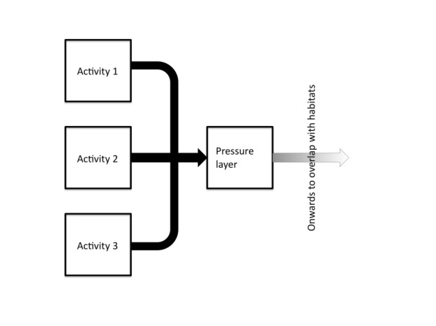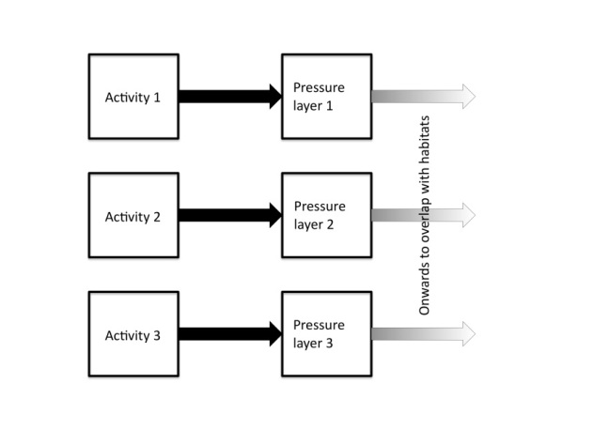
Figure 1: Model 1 (Left): A pressure layer derived from an aggregation of activities. Model 2 (right): Separate pressure layers derived from each non-aggregated activity.
2.1.3 Discussion summary
Key points are summarised in Box 1 below. It is important to keep in mind that the focus of the MSFD is not just on assessing the status of the marine environment, but on implementing a ‘programme of measures’ so that effective management enables better progress towards the achievement of GES. Development of directed measures have to be based on a clear understanding of the change in state (as revealed by the indicator) and the pressure and associated activity most responsible for deterioration or the failure of any thresholds or indicator targets . For that reason, Model 2 was the preferred option as it allows the activities in the pressure layers to be auditable. The main advantage of Model 1 is that it is simpler to communicate and may be politically easier to deal with because the result is a single pressure layer at one level of resolution, and it may still be appropriate in certain circumstances. The consensus of the workshop however was, that for this indicator, Model 2 is the most appropriate as it will allow a clear the audit trail from activity to pressure.
Moreover, different activities, for example trawling and dredging, have different characteristics in terms of pressures such as abrasion. For this reason there is a need to ensure that pressure layers derived from different activities are operating in the same units (e.g. not just swept area), otherwise the aggregation of pressure layers will compound errors and misrepresent the relative importance of some pressures. These units need to relate to the proportion of the habitat area that is being impacted or disturbed and where possible, the creation of multiple pressure layers for the same pressure type should be avoided where not strictly necessary.

BOX 1. KEY POINTS: PRESSURES
- It is important to remember that a ‘programme of measures’ can only be effective if a clear chain of evidence from impact to activities and resulting pressures can be described.
- It is preferable to derive pressure layers from a single activity (Model 2) and then combine pressure layers as this provides a clear audit trail i.e. link from activity to impact.
- Pressure layers should be applied at different spatial scales as appropriate.
- Activities in pressure layers need to be clearly defined reflecting the given environmental targets and measures and allow the presentation of various pressure layers where appropriate and necessary (although this can be resolved anyway through the adoption of the Model 2 approach).
- Access to pressures data is a recurrent issue that needs to be resolved if regional assessments of this indicator are to be possible across the OSPAR region (e.g. access to VMS data).
- Data types that have never been collated before should be considered (e. g. anchoring of large vessels and other activities identified by the contracting parties).

2.2 Discussion 2: Sensitivity
2.2.1 Background
A widely available method for undertaking sensitivity analyses was developed by the Marine Life Information Network (MarLIN) on behalf of the UK statutory agencies, regulators, and marine research institutes. The ‘sensitivity’ of a species or other unit (e.g. habitat) is an “estimate of its intolerance to damage from an external factor and is determined by its biological and physical characteristics”. Therefore the fundamental concept remains the same when sensitivity assessments are undertaken. However, the method is often adapted to reflect issues such as data availability, new understanding concerning pressure-state relationships or changes in pressure definitions. Examples of recent projects in the UK that have utilised and adapted the sensitivity assessments developed by MarLIN include the work undertaken for Defra contract MB1024 and FEAST (see Tillin et al., 2010).
2.2.2 Differences in approach
Despite the range of applications of sensitivity analyses, the fundamental differences in approach considered at the workshop were the choice of species required as a basis for sensitivity assessment and the EUNIS resolution at which sensitivity is assessed and mapped.
The Vulnerability Assessment (JNCC) approach used for Article 17 reporting was informed and validated by a number of stakeholder workshops. This approach, based on information from habitat maps, can be used at different levels of the EUNIS classification because it was based on sensitivity assessed at EUNIS level 4/5. It is less useful at higher levels (i.e. 1 - 3) of the classification when choices have to be made about which of the biotopes should represent the more coarse resolution habitat types. The Bioconsult approach using a selection of characteristic species of benthic associations and combining these with EUNIS level 3 has the advantage of using more rigorous underpinning data on response of the chosen sensitive species, which added weight to the sensitivity analysis. It should be noted however that only a selection of species were chosen to represent a broader area in terms of sensitivity so a EUNIS 4/5 biotope based approach (as biotopes are also based on characteristic species) would provide a more accurate assessment. The Seafloor integrity approach (Cefas) used biological trait analysis to examine sensitivity of functional types rather than defined biological units such as species, habitats or biotopes. This approach was used as it provides information on the structure and function aspects of the marine ecosystem.
2.2.3 Discussion summary
For the discussion on the level at which sensitivities should be assessed, it was noted that EUNIS Level 3 is often used as it is the most realistic and repeatable in terms of map availability and model-derived information for habitats for most of the Atlantic Area. The problem is that EUNIS level 3 habitats actually contain a wide range of lower level habitats (specifically EUNIS level 5 Biotopes) with a potentially wide range of sensitivities to various impacts. Assessing sensitivity at EUNIS level 4 or 5 would therefore be far more accurate, but would be extremely challenging at the regional sea level due to the lack of accurate data at this resolution. It was generally agreed that the focus on a single level of assessment was unhelpful because in some areas (e.g. proposed Marine Conservation Zone areas) there could be high resolution data available even though for offshore habitats data may only be available at a coarse resolution.

BOX 2. KEY POINTS: SENSITIVITY.

- Due to the range of sensitivities within the biotopes of EUNIS level 3 it is preferable to use the higher resolution data where it is available.
- Additional mapping of biotopes should be considered for areas subject to a wide range of pressures and / or composed of sensitive habitats i.e. further seabed mapping should be undertaken using a risk-based approach.
- Sensitivities of biotopes can be based on species characteristic of the biotope.
- The Bioconsult approach used pre-defined characteristic species for areas. To generate characteristic species list for all biotopes in the OSPAR region might not be feasible and is very unlikely to be available. It was suggested that it might be easier for sedimentary habitats where a lot of work on biological traits has focused but the ‘data hungry’ nature of this approach might still be an issue.
- The sensitivity of all characteristic species for all biotopes is not available from the primary literature. However, the sensitivity of a species might be able to be inferred from its traits. Trait analysis could therefore potentially help provide the underlying information on the sensitivity of a biotope.
- Using biological traits could potentially be more ecologically meaningful and easier to communicate to non-specialists.
- Assessing vulnerability needs to account for the ‘frequency of a pressure’ (cf Bioconsult method) and this process needs to be agreed.
- It is pragmatic and feasible to use a ‘suite’ of approaches as the basis of sensitivity (e.g. traits and selected characterising species and EUNIS level 3/biotopes) but a method of standardisation / verification is necessary to enable confidence in comparability.
- Sensitivity assessment needs to be applied at the best resolution available. This may mean different resolutions for inshore and off-shore areas, but this is preferable to working with the lowest common denominator. Multi-resolution data therefore needs to be retained in the pressure layers.
- In order to use multi-resolution data a variety of polygons can be used. Using a gridded approach only does not deal with habitat complexity and pressure information at different resolutions. Grids should therefore be treated as polygons (which happen to be gridded squares in most instances but not always).
- A Best Practice trial is required across OSPAR regions to explore the suggestions above.

2.3 Can we develop a common approach?
2.3.1 Background
The introduction to this report outlined the differences in approaches that can be used to develop a physical damage indicator. These differences were illustrated by examining three key approaches that have been developed with a particular focus on methods for pressure and sensitivity analysis. The final discussion looked at whether the differences in approach could be resolved in order to produce a single methodology.
2.3.2 Discussion summary
There were three main areas for further consideration that came out of this discussion. The first was that more effort was required to understand the role of pressure frequency in deriving sensitivity scores. This involves resolving terminology (frequency, intensity, temporal extent) and working out whether this is accounted for within the sensitivity analysis or whether a post-analysis weighting is required.
The second point was that much more work was required to consider the rules of aggregation. Aggregation of activities within pressure layers was not thought to be useful but aggregation of the combined pressure/sensitivity layers is required to produce Vulnerability Assessment (VA) layers to provide a final conclusion. These VA layers then need to be aggregated to produce a physical damage layer. It is also worth noting that aggregation rules will need to be developed at a number of scales for MSFD (e.g. across descriptors, biodiversity components) and it is important this is done in a way that is ecologically meaningful in terms of assessing progress towards GES.
Finally, it was agreed that some way of expressing confidence needs to be developed. It is important that for each physical damage layer, issues such as real vs modelled data, data resolution, role of expert judgement and other issues are considered as the end result of the physical damage assessment should be management measures being implemented. There is also scope to link to other indicators such as BH2 to allow ground truthing of BH3 indicators in order to gain some aspects of this confidence.

BOX 3. KEY POINTS: a single approach?

- It is vital to consider pressure intensity / frequency. Further work is needed to establish how frequency of activity is included in the initial sensitivity analysis of a common approach. If not then rules on frequency can be applied post-hoc.
- There is work to be done to develop the rules for the aggregation of vulnerability layers within a pressure. Also the same needs to be done for the aggregation across pressures (issues of weighting and units) to produce the physical damage layer.
- It is important that a confidence assessment is included in any vulnerability assessment. This is linked to the issue of Quality Assurance (QA) of data.
- The basic issue is checking that outcomes from any assessment match reality on the ground so some sort of ground-truthing is required to provide calibration for the assessments(BH2).

- Next Steps
The final section of the report contains the suggested ‘next steps’ for the development of the BH3 indicator. First of all the areas where agreement was reached are summarised, then a ‘single model’ as developed in response to the final discussions is proposed and finally areas where further work is required are highlighted. It is important to note that the aim of the workshop was not to agree on the single final method but to crystallise thinking around potential key approaches to be taken further on the next steps of indicator testing and development.
3.3.1 Areas of agreement
The following is a list of areas where agreement was reached resulting in clear recommendations for a way forward:
a) Production of a single pressure layer per activity is one of the basic requirements of the indicator (see Figure 1, Model 2). This is vital for audit purposes and to provide a clear link to any proposed programme of measures.
b) Multi-resolution mapping. There are limited resources available for habitat mapping and the issue often comes down to effort being put into broad-scale habitat mapping versus the high resolution required for specific purposes such a establishing UK Marine Conservation Zones. It was agreed that BOTH are useful for the purposes of MSFD and the BH3 indicator.
c) Linked to point b) it was agreed that best available data should always be used. It is not sensible to work with the lowest common denominator as biotope level information, for example, can lead to much greater accuracy in the assessment for certain areas.
d) Biological traits are another way of identifying the sensitivity of species that represent a biotope in a sensitivity analysis i.e. there is equivalency. Both options should therefore be utilised as appropriate.
3.3.2 A proposed single model.
A Single model as derived from workshop discussions is shown in figures 2 and 3 below. This model captures the points of agreement listed in section 3.3.1
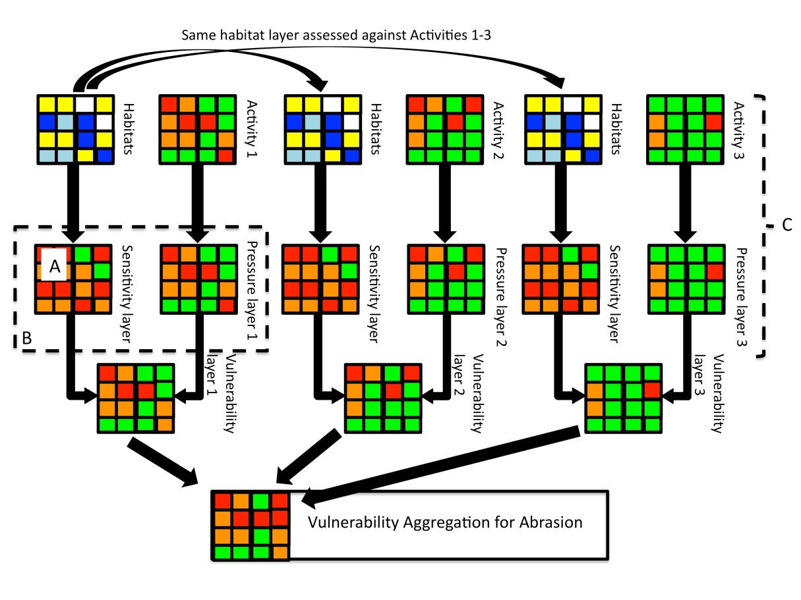
Figure 2: From activities to vulnerability assessment layers. Point 'A' indicates the part in the process where the sensitivity information on species or habitats to a given pressure is provided. Box 'B' indicates where there is additional work to be done to accommodate an element of intensity (=frequency) of a pressure in an agreed common approach. The part of the process indicated 'C' is where agreement was reached on the most appropriate model for bringing together pressure information (see Box 1).

The model detailed in Figure 2 above is derived by combining JNCC’s Article 17 Vulnerability Assessment approach and the approach developed by BioConsult. It is based on sensitivity layers overlaid with pressure lavers to be combined into vulnerability layers. These sensitivity layers are generated for a single pressure, which can be caused by multiple activities e.g. there will be several sensitivity layers for the pressure “abrasion” as this can be caused by several activities like fishing or sand and gravel extraction. Sensitivity in those layers is derived from habitat layers containing information on the distribution of habitats in the relevant area of seabed.
Sensitivity layers will be joined with pressure layers according to the model developed by BioConsult. Pressure layers will thus include information on the temporal and spatial extent of pressures. The combination of pressure and sensitivity layers into a vulnerability layer will be executed as detailed in the JNCC vulnerability assessment.
The next step of this process is combining individual vulnerability layers into a single layer, displaying the vulnerability of an area to a pressure regardless of the source of the pressure. However, the pressure source will always be auditable throughout the process through ensuring that as a first step activities are treated separately.
This process will generate several aggregated vulnerability layers for several pressures, which then need to be combined into a single “physical damage” layer to assess the spatial and temporal extent of physical damage as well as the severity of impacts caused on different habitats. This step is demonstrated in Figure 3.
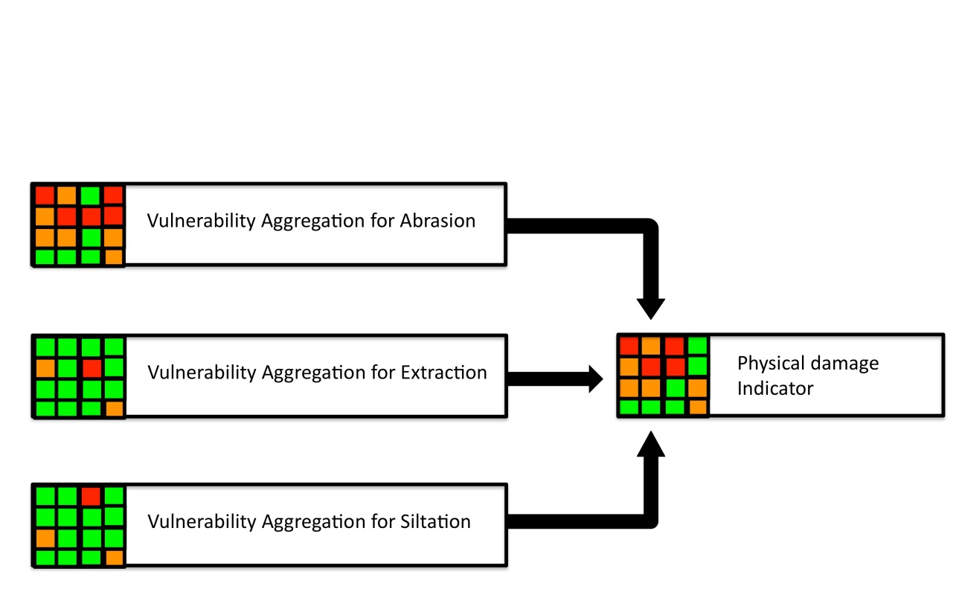
Figure 3: From VA layers to a final assessment. This part of the process has not yet been tested and may identify other issues requiring resolution on the potential aggregation of the individual analysis to calculate a single result, including potential weighting.

3.3.3 Areas for which further work is required
The following is a list of areas where agreement was NOT reached within the workshop. This is not because of disagreement, but because there was no time to address these significant issues within the limited timeframe. Further work is therefore required on:
- Pressure: to understand how best to represent intensity (frequency) of a pressure in a common approach, how this is included in current methodologies and to check and agree terminologies.
- Sensitivity: Test how the detail (e.g. species, biotopes, traits) in a sensitivity assessment affects the outcome i.e. evaluation required as to whether it makes a difference how species are selected at different levels and if so how this is best mitigated.
- Aggregation: a rule-based metric needs to be investigated for aggregating at various scales.
- Confidence: having a confidence assessment that incorporated or was linked to a QA procedure was seen as vital
- Data availability: Access to data, particularly VMS and other new data types (e.g. anchoring and inshore fisheries), is crucial for the successful operation of the BH3 indicator, and in particular this data needs to be available across the relevant Ospar region. There should therefore be good links to workstreams that are seeking to address the issue of data availability.
- Single indicator concept: The UK and Germany will jointly develop a single physical damage indicator concept based on discussions and conclusions from this workshop report to address and solve the issues identified in this report.

- Acknowledgements
We would like to thank Defra for funding the workshop. Also, we would like to thank the participants and facilitators: Annika Clements (AFBINI); Becky Seeley (MBA); Carmen Pia Günther (BioConsult); Chris Frid (University of Liverpool); David Vaughan (JNCC); Deborah Hembury (Defra); Gareth Johnson (JNCC); Gavin Black (NE); Hayley Hinchen (JNCC); Heather Stewart (BGS); Héloïse Muller (Bureau de Recherches Géologiques et Minières); Jane Hawkridge (JNCC); Janet Khan (SEPA); Janette Lee (Cefas); Jason Hall-Spencer (Plymouth University); Jennifer Lewis (NE); Jon Baxter (SNH); Kirsten Ramsey (NRW); Krysia Mazik (IECS); Laurent Guerin (Museum National D'Histoire Naturelle); Markus Diesing (Cefas); Mike Camplin (NRW); Myles O'Reilly (SEPA); Nina Schroeder (Federal Agency for Nature Conservation, BfN); Penny Wilson (JNCC); Peter Hayes (Marine Scotland); Petra Schmitt (Bioconsult); Sam Davis (Cornwall IFCA); Silvana Birchenough (Cefas); Sophie Green (BGS); Tim Mackie (DOENI). Thanks are also due to Nina Schroeder and Jochen Krause for their contributions to the workshop and workshop report both before and after the workshop.

References
Baxter, J.M., Boyd, I.L., Cox, M., Donald, A.E., Malcolm, S.J., Miles, H., Miller, B., Moffat, C.F., (Editors), 2011. Scotland's Marine Atlas: Information for the national marine plan. Marine Scotland, Edinburgh. pp. 191
Bolam, S. G, Coggan, R. C., Eggleton, J., Diesing, M & Stephens, D. (2014). Sensitivity of macrobenthic secondary production to trawling in the English sector of the Greater North Sea: A biological trait approach. Journal of Sea Research 85 (2014) 162–177.
Frost, M. (2010). Charting Progress 2 Healthy and Biological Diverse Seas Feeder Report: Section 1: Introduction. Published by Department for Environment Food and Rural Affairs on behalf of UKMMAS. p1-11. In: UKMMAS (2010) Charting Progress 2 Healthy and Biological Diverse Seas Feeder Report (Eds. Frost, M & Hawkridge, J).
Great Britain. Marine Strategy Regulations (2010) London: The Stationery Office.
Hiscock, K. ed. 1996. Marine Nature Conservation Review: rationale and methods. Peterborough, Joint Nature Conservation Committee. (Coasts and seas of the United Kingdom. MNCR Series).
Hiscock, K, Jackson, A. & Lear, D., 1999. Assessing seabed species and ecosystem sensitivities: existing approaches and development, October 1999 edition. Report to the Department of Environment, Transport and the Regions form the Marine Life Information Network (MarLIN), Marine Biological Association of the United Kingdom, Plymouth. [MarLIN Report No. 1.]
Holt, T.J., Jones, D. R., Hawkins, S.J. & Hartnoll, R.G., 1997. The sensitivity of marine communities to man-induced change. Nature Conservation and the Irish Sea seminar. 6th February 1997, pp. 6-23. Irish Sea Forum, Liverpool, Seminar Report No. 15.
Holt, T.J., Jones, D.R., Hawkins, S.J. & Hartnoll, R.G., 1995. The sensitivity of marine communities to man-induced change - a scoping report. Countryside Council for Wales, Bangor, CCW Contract Science Report, No. 65.
Laffoley, D.A., Connor, D.W., Tasker, M.L. & Bines, T., 2000. Nationally important seascapes, habitats and species. A recommended approach to their identification, conservation and protection, pp. 17. Peterborough: English Nature.
Moffat, C., Aish, A., Hawkridge, J. M., Miles, H., Mitchell, P. I., McQuatters-Gollop, A., Frost, M., Greenstreet, S., Pinn, E., Proudfoot, R., Sanderson, W. G. & Tasker, M. L (2011). Advice on United Kingdom biodiversity indicators and targets for the Marine Strategy Framework Directive. Healthy and Biologically Diverse Seas Evidence Group Report to the Department for the Environment and Rural Affairs. August 2011. 210pp
OSPAR's MSFD Advice Manual on Biodiversity, (2012) Approaches to determining good environmental status, setting of environmental targets and selecting indicators for Marine Strategy Framework Directive descriptors 1, 2, 4 and 6. Version 3.1. BDC 12/2/4-E, 2012.

Rachor, E. & P. Nehmer (2003): Erfassung und Bewertung ökologisch wertvoller Lebensräume in der Nordsee. Bremerhaven, Alfred-Wegener-Institut für Polar- und Meeresforschung: 175.
Roberts, C., Smith, C., Tillin, H. Tyler-Walters, H., 2010. Review of existing approaches to evaluate marine habitat vulnerability to commercial fishing activities. Report to the Environment Agency from the Marine Life Information Network and ABP Marine Environmental Research Ltd. Environment Agency Evidence Report: SC080016/R3. Available from http://publications.environment-agency.gov.uk/pdf/SCHO1110BTEQ-e-e.pdf(opens in a new window)
Robinson, L., Rogers, S., & Frid, C. (2008b). A marine assessment and monitoring framework for application by UKMMAS and OSPAR - Assessment of Pressures and Impacts. Phase II: Application for regional assessments.
Robinson L.A. and A.M. Knights. 2011. ODEMM Pressure Assessment User-guide. ODEMM Guidance Document Series No.2. EC FP7 project (244273) ‘Options for Delivering Ecosystem-based Marine Management’. University of Liverpool. ISBN: 978-0-906370-62-9, 12 pp.
Bioconsult (2013) Conceptual approach for the assessment of indicator 6.1.2: ‘Extent of the seabed significantly affected by human activities for the different substrate types’ – Draft Report within the R & D project ‘Compilation and assessment of selected anthropogenic pressures in the context of the Marine Strategy Framework Directive’. Umweltforschungsplan des Bundesministeriums für Umwelt, Naturschutz und Reaktorsicherheit. FKZ 3710 25 206
Tillin, H.M., Hull, S.C., Tyler-Walters, H., 2010. Development of a sensitivity matrix (pressures-MCZ/MPA features). Report to the Department of the Environment, Food and Rural Affairs from ABPmer, Southampton and the Marine Life Information Network (MarLIN) Plymouth: Marine Biological Association of the UK. Defra Contract no. MB0102 Task 3A, Report no. 22. Available from: http://randd.defra.gov.uk/Default.aspx?Menu=Menu&Module=More&Location=None&Completed=0&ProjectID=16368
Tyler-Walters, H., Hiscock, K., Lear, D.B. & Jackson, A., 2001. Identifying species and ecosystem sensitivities. Report to the Department for Environment, Food and Rural Affairs from the Marine Life Information Network (MarLIN), Marine Biological Association of the United Kingdom, Plymouth. Contract CW0826. [Final Report.]
Tyler-Walters, H. & Jackson, A. 1999. Assessing seabed species and ecosystems sensitivities. Rationale and user guide, January 2000 edition. Report to English Nature, Scottish Natural Heritage and the Department of the Environment Transport and the Regions from the Marine Life Information Network (MarLIN). Plymouth, Marine Biological Association of the UK. (MarLIN Report No. 4.).

ANNEX 1: Methods comparison
Approach | JNCC vulnerability assessments | German Bioconsult conceptual approach | Cefas Seafloor Integrity
Purpose of Methodology | Assessment of feature vulnerability to damage or deterioration from pressures caused by anthropogenic activities, known as vulnerability assessment. It is based on a mixture of direct and modelled data. It allows the prediction of an impact on areas where very little or no direct evidence is available | Estimating the cumulative physical impact on benthic habitats in order to assess the environmental status (GES or sub-GES). | To determine the spatial variability of secondary production variation across the Greater North Sea, and its relationships with environmental variables.
Example of use | Article 17 reporting. | Not yet applied within a management framework. | Not yet applied within a management framework.
Current usage | - MPS conservation advice;  - MPS assessment;  - UK Mar Bio R&D Programme strategy | MSFD indicator 6.1.2 | Method published in Journal of Sea Research (2014), Vol. 85, 162-177, so can be accessed and scrutinised by all scientists. Also, the ME5301 project report.
Origin | - MB0102  - UKSeaMap | Several approaches (e.g. MB0102, MarLIN, HELCOM indicator 'cumulative impacts'). | Cefas under the auspices of the Defra-funded ME5301 project (ended Mar 2013).
Key features | Sensitivity x Exposure=Vulnerability | Modelling of physical impact by combining information on pressures (spatial and temporal extent) with sensitivity of habitats.
Data requirements | - Broadscale Habitat map (EUNIS Level 5/6 where available);  - Vessel Monitoring System (VMS) record for all Member States with logbook information;  - Sensitivity assessments for all the Broadscale Seabed Habitats when exposed to each pressure. | Habitats: Distribution and characteristic species of EUNIS Level 3 habitats (preliminarily, better level 5/6) and special habitats (protected under national / international legislation).  Activities (e.g. fisheries, offshore installations, aggregate extraction): Information on spatial and temporal extent of pressures. | - Observed infaunal data to determine secondary production estimates (using an indirect method for estimating secondary production, e.g., Brey model); - Trait information for all the taxa sampled across these stations.  - A scoring of each trait category according to relative sensitivity to trawling.  - If one wants to determine the relationship between % production that is sensitive with environmental factors (to understand spatial variability) then observed or estimated/predicted values are required for each location.
Pressure layer | Physical abrasion layers were based on a raster grid, with resolution based on the approx. 2hours ping from VMS. Intensity calculated as swept area based on average speed and gear widths of demersal gear, and then aggregated over 2006-2009. Two abrasion layers used (surface & sub-surface). See supplementary information on fishing abrasion methodology | Spatial extent of pressures (see "Bioconsult_SpatExt_Pressures" tab) and temporal extent in a five-step scale (from rare to persistent). | Vessel Monitoring System (VMS) data for 2006-2008 for UK and non-UK registered vessels employing demersal fishing gear were processed to derive the cumulative area trawled for every grid cell. Dividing this by the area of the grid cell yielded the trawled proportion. Spatial models were developed to map probabilities of natural disturbance (ND) and disturbance by trawling (T); the latter was classified into ‘low’, ‘moderate’ and ‘high’ levels. ‘Significant’ trawl disturbance (Tsig) was defined as a state where T > ND.
Activities included | Only the dominant activity is included (for physical abrasion) for regional and national consideration: Demersal Fishing. | Bottom trawling, offshore installations, pipelines, cables, extraction sand and gravel. | Demersal Fishing
Multiple pressures or single pressure included | Single pressure | Multiple pressures | Single pressure
Which pressures included | Physical abrasion. Presence / absence footprint of extraction were also trialled but low spatial exposure. | Physical loss (sealing & smothering) & Physical damage (abrasion, extraction & siltation). | Physical abrasion
Sensitivity assessment | MB0102 based on a series of workshops with academic experts and stakeholders  Plans to update to EUNIS Levels 5/6 and with a robust evidence base this FY. | Adopted from MarLIN and MB0102. Sensitivity (resistance and recoverability) is assessed for characteristic species and physical properties of a habitat. | A traits-based approach was used to examine the sensitivity of total production to trawling. Eight traits were considered relevant: size, morphology, living habit, sediment position, mobility, longevity, larval development and egg development location. Sensitivity scores were applied at a family level; scores reflect the relative sensitivity of each trait category to trawling. For example, within 'mobility' trait, categories such as 'mobile' (e.g. swimmers) were given low scores while categories such as 'sessile' were ranked high sensitivity scores. It was necessary to split the traits into those which affected acute impacts as opposed to those which had relevance to the long-term affects of trawling on taxonomic survival.
Habitat used for sensitivity analysis | Selection of EUNIS Level 4 and 5 biotopes. Variation across different habitat types. | Selection of species representative of predominant and special habitats. | N/A
Temporal Units (no of events) | Four years aggregated fishing data, the benchmark of 1 pass per year (averaged across the square). This covered the sum of the individual gear types for the 4 years. Low and High values are located either side of the benchmark | Temporal scale from rare (1 event/reporting period) to persistent (>3 events/year or permanent installation). | This approach used data from 327 stations in the GNS, these were generally sampled during late spring/early summer but sampling year varied. We did not investigate the seasonal effect on this approach.
Vulnerability Assessment | Sensitivity and exposure to physical abrasion combined by MB0102 matrix to generate vulnerability to each sub-pressure, at level of habitat extent (not VMS square). As sensitivities different, the highest vulnerability selected at each spatial location prior to combination. | - Physical impact (= vulnerability) assessed by combination of habitat sensitivity and temporal extent of pressure in a matrix (different matrices for the different pressures - weighting factor).  - Physical impact expressed in percentage value as approximation of relative impact on habitat.  - Cumulative physical impact is obtained by adding up impact values from all pressures. | This approach has not been used to derive a vulnerability assessment. It mapped the proportion of total production that were classed as low, medium and highly sensitive to trawling for the stations considered by the study. From correlation analysis of these values with environmental factors, it was found that total production is more trawling-sensitive in deep, muddy habitats which experience little or no natural disturbance pressure. In contrast, shallow, coarse-sediment habitats which experience higher natural disturbance pressure show low sensitivity of total production. From this, it could be possible to derive a vulnerability assessment, but based on total production (i.e. functional sensitivity). However, as this is based on an assessment of vulnerability of each taxa, this can be used to define vlunerability of structural metrics (e.g. diversity vulnerability).
Habitat unit | Broadscale habitats EUNIS Level 3 (with plans to update to EUNIS Level 5/6 this FY). The Article 17 reporting also incorporated higher EUNIS Levels (4-6) where more detailed Annex I features were identified. | EUNIS Level 3 (A5.1, A5.2, A5.3, A5.4), Habitats Directive, OSPAR red list, §30 BNatSchG (German). | No habitat unit is used for the ME5301 sensitivity approach; it is based on sampling stations.
Spatial Unit | Approach based on VMS grids. | No grid used. | Seabed faunal data from the Greater North Sea (327 stations) were used. The approach can use data from any geographical area or work at various spatial units.
Development stage | - MB0102 report and sensitivity matrix have been produced and used by JNCC and others (e.g. MMO);  - Methods paper for the physical abrasion layer;  - Approach tested for Article 17. | Applied to the German EEZ of the North Sea; some improvements still necessary (e.g. improvement of database for activites and habitats, confidence levels, application to coastal waters). | This approach has not been developed any further from that presented in peer-review publication (J. Sea Res.)
Effort/cost | - Method already being developed for other JNCC monitoring requirements;  - Main costs associated with assessment. |  | The relative sensitivity of total production (or an attribute of bed structure, see previous) for a given location can be derived for small cost, but does require the availability of infaunal abundance and biomass from which to derive production estimates. The liklihood is that the trait information for the taxa sampled already exists (from the effort to acquire this information under ME5301).
Caveats | - At present, pressure layer only applicable offshore where most boats are ≥12m; Cefas contract to link inshore fisheries data with VMS. | - Information on distribution and optimum state of habitats (at best EUNIS level 5/6) required;  - Current data on all human activites necessary (unfortunately difficult to obtain);  - Present approach includes several assumptions.

European Commission (June, 2014). Legislation: the Marine Directive. Retrieved July 18th, 2014, from http://ec.europa.eu/environment/marine/eu-coast-and-marine-policy/marine-strategy-framework-directive/index_en.htm
Full details of the project (MB0102) and all associated reports can be accessed through the Defra website at: http://randd.defra.gov.uk/Default.aspx?Menu=Menu&Module=More&Location=None&Completed=0&ProjectID=16368
http://eunis.eea.europa.eu/habitats-code-browser.jsp &
MarLIN (July, 2014). Sensitivity assessment rationale - a summary. Retrieved July 25th, 2014, from http://www.marlin.ac.uk/sensitivityrationale.php.
http://www.marlin.ac.uk/sensitivityrationale.php
http://www.marlin.ac.uk/sensitivityrationale.php. Background on the development of the MarLIN sensitivity assessment methodology can be found in Tyler-Walters et al. (2001 ); Tyler-Walters & Jackson (1999) and Hiscock et al. (1999) with further revisions of the methodology being based on Laffoley et al. (2000) leading to the current MarLIN methods
It is important to note that MarLIN first assessed earlier attempts at providing a framework for sensitivities particularly methods discussed by Holt et al. (1995, 1996)
http://www.marlin.ac.uk/sensitivitybenchmarks.php
http://www.scotland.gov.uk/Topics/marine/marine-environment/FEAST-Intro

