Repeated rapid assessment surveys reveal contrasting trends in occupancy of marinas by non-indigenous species on opposite sides of the western English Channel.
John DD Bishop^{1*} Christine A Wood¹ Laurent Lévêque² Anna LE Yunnie^{1,3} Frédérique Viard³
¹ Marine Biological Association of the UK, Citadel Hill Laboratory, Plymouth PL1 2PB, UK; jbis@mba.ac.uk ; cwo@mba.ac.uk ; annyun@mba.ac.uk .
² Service Mer & Observation, UPMC Univ. Paris 06, CNRS FR 2424, Station Biologique de Roscoff, Place Georges Teissier, 29680 Roscoff, France; leveque@sb-roscoff.fr .
³ Laboratoire "Adaptation et Diversité en Milieu Marin", UPMC Univ. Paris 06, CNRS UMR 7144, Div&Co team, Station Biologique de Roscoff, Place Georges Teissier, Roscoff 29680, France ; viard@sb-roscoff.fr .

Abstract
Rapid assessment surveys of non-indigenous species (NIS) of sessile invertebrates were made at seven marinas in NW France and 10 marinas in SW England in 2010, and repeated in 2013. Fourteen NIS were recorded, 12 of which were seen on both coasts. Site occupancy differed between the opposite sides of the western English Channel. In Brittany, most species occurred at most sites in both 2010 and 2013. In 2010, site occupancy in Devon & Cornwall was distinctly lower; by 2013, the difference compared to Brittany had narrowed considerably, largely because of rapid colonisation of additional sites by species that were infrequent in 2010. Three more of the recent NIS are present in Devon & Cornwall but have still not become widespread. It is concluded that the recently introduced fouling animals studied here are longer established in NW France than in SW England, and have probably spread northwards across the Channel.
*Corresponding author:
John Bishop
Marine Biological Association of the UK,
Citadel Hill Laboratory,
Plymouth PL1 2PB, UK
jbis@mba.ac.uk ; Tel. +44(0)1752 633229

Keywords: Invasive species; monitoring; artificial habitat; pontoon; site occupancy; fouling.
Introduction
Non-indigenous species (NIS) are a threat to native biodiversity, human health and ecosystem services. Accordingly, managing their means of spreading to minimize new introductions and reduce secondary dispersal is a global priority. NIS are the focus of Descriptor 2 of good environmental status in the Marine Strategy Framework Directive (European Commission, 2008) which requires that NIS “are at levels that do not adversely alter the ecosystems.” Sheltered artificial habitats provided by ports and harbours are prime sites for the arrival and establishment of NIS; marinas are important stepping-stones for secondary spread within a new bioregion (Clarke Murray et al. 2011) and may also act as points of primary entry (Bax et al. 2002; Griffith et al. 2009). Coastal ports, harbours and marinas are frequently located in transitional waters of river mouths and estuaries where introduced species can spread seaward or into river systems, according to their environmental requirements.
Marinas are priority sites for monitoring, being ‘hotspots’ for the occurrence of NIS (Arenas et al. 2006; Campbell et al. 2007; Mineur et al. 2012a) and thus focal points for assessing the effectiveness of pathway management measures. Their floating pontoons allow access to shallow subtidal biota at any state of tide. Accordingly, protocols for rapid assessment of NIS in these habitats have been developed to allow synoptic surveys of NIS at numerous sites along extensive stretches of coast within a short time (Cohen et al. 2005; Arenas et al. 2006; Ashton et al. 2006; Campbell et al. 2007; Minchin 2007; Buschbaum et al. 2012).
Here we report the results of rapid assessment surveys (RASs), undertaken during the Interreg IVA ‘Marinexus’ project, intended to allow comparison of the composition and prevalence of NIS in marinas on opposite sides of the western English Channel , focusing primarily on sessile invertebrates. The surveys were repeated after a three-year interval with the intention of documenting any change in the species present and their occupancy of marina sites. This study thereby tested the ability of RASs to detect the arrival and spread of NIS on relatively short time-scales and local and regional spatial scales.
In addition, the progressive spread of one species, Botrylloides diegensis, within a marina following its first detection there in 2010 was monitored between the two surveys.

Materials and & Methods
Ten marinas on the south coast of Devon and Cornwall, SW England, and seven in Finistère and Côtes d’Armor, Brittany, France, were surveyed in summer 2010 and again in summer 2013 (Table 1). A core team of CAW, ALEY and JDDB conducted the surveys in both England and France in 2010, and in England in 2013. In France in 2013, CAW and JDDB were joined by LL.
The RASs were undertaken from floating pontoons at any state of the tide. The available pontoons at each site were divided between the staff, who worked separately for one hour. The pontoon floats were examined, using a scraper fitted with a collecting basket to retrieve specimens beyond arm’s length, and submerged substrates such as hanging ropes, keep cages, fenders and kelps were pulled up and examined. Specimens were collected to substantiate significant findings, or for discussion or laboratory identification. At the end of the observation period, the team re-convened to record their joint observations on a summary form, and a semi-quantitative estimate of abundance of each species encountered was made on a three-point scale: 1 (Rare-Occasional), 2 (Frequent-Common) and 3 (Abundant-Superabundant).
Two NIS of the ascidian genus Botrylloides, B. violaceus and B. diegensis, were observed in both southern UK and Brittany during our RASs. However, they were lumped together for recording here. B. diegensis occurs in at least two distinctively patterned two-colour morphotypes, but can also occur as single-colour colonies very similar in appearance to B. violaceus, and not readily separable (authors’ pers. obs. and unpublished genetic data).
Colonies of one of the characteristic “two-colour” morphs of B. diegensis were found in a small area of one pontoon at TOR during the 2010 RAS. This was the first record of the species in Devon & Cornwall, the furthest west record on the south coast previously being at Weymouth, Dorset. The site was re-visited periodically to map the extent of the species on the pontoons up to the time of the second RAS.
Statistical analyses were performed using Minitab 15.

Results
The lists of NIS recorded in Devon & Cornwall and Brittany during the 2010 and 2013 RASs were very similar, with 12 species in common out of a total of 14 (Tables 2 and 3; species’ authorities are given in Table 3). Thus only two species were recorded on a single side of the Channel in the present surveys. The didemnid ascidian Didemnum vexillum was widely recorded in Brittany marinas but was not encountered in Devon & Cornwall, although a single colony had been encountered (and removed) at PYH on two previous occasions, and a population has also been present in a Devon estuary not visited as part of this study (Griffith et al. 2009). The bryozoan Schizoporella japonica was recorded in the 2013 RAS at MIL only (its single known location in England at the time of writing); this species has not yet been recorded in France, but prior to its discovery in England it had been found in N. Wales then in Scotland (Ryland et al. 2014).
The number of NIS recorded per marina (Table 2) was higher in Brittany than in Devon & Cornwall, both in 2010 (Mann-Whitney test, P = 0.0008) and in 2013 (P = 0.0248). In Devon & Cornwall, a statistically significant increase in the number of NIS in each marina occurred between 2010 and 2013 (mean change at a site +1.80 species, estimated median change 2.0, Wilcoxon Signed-rank test of median = zero, P = 0.009), while in Brittany the mean change was -0.14, estimated median -0.5 (P = 0.855).
The sum of abundance scores of NIS per marina (Table 2) was higher in Brittany than in Devon & Cornwall in both 2010 (Mann-Whitney test, P = 0.0010) and 2013 (P = 0.0020). These total abundance scores per marina increased in both regions between 2010 and 2013 to a degree that approached statistical significance (Wilcoxon Signed-rank test of median = zero, P = 0.126 for Devon & Cornwall and P = 0.059 for Brittany).
The marinas in Brittany were generally larger, in terms of the number of berths, than those in Devon & Cornwall (Mann-Whitney test, P = 0.0359). It is thus possible that the greater number of NIS recorded in marinas in Brittany reflected their larger size. In 2010, the Spearman Rank-order correlation across all sites between the number of berths and the number of NIS recorded at a marina was significant (r_{s} = 0.534, P = 0.027, n = 17), but in the zone of size-overlap between the two sets of marinas, approximately 200 to 600 berths, the Brittany sites still had distinctly higher numbers of NIS than Devon & Cornwall (Fig. 1, left). There was no significant correlation between size and number of NIS in either of the separate sets of marinas in 2010 (Devon & Cornwall, r_{s} = 0.000, P = 1.000, n = 10; Brittany, r_{s} = 0.449, P = 0.312, n = 7). In 2013, largely as a result of the increase in numbers of NIS in Devon & Cornwall marinas, there was no overall correlation between marina size and numbers of NIS (r_{s} =0.094, P = 0.720, n = 17)(Fig 1, right), and both Devon & Cornwall and Brittany separately had negative but non-significant correlations between marina size and numbers of NIS. Thus it does not seem that the differences in numbers of NIS per marina between Devon & Cornwall and Brittany can be attributed to the difference in marina size.
In Brittany, the frequency distribution of site occupancy by species was dominated by species occurring at six or all seven sites (i.e. showing high or complete occupancy) in both 2010 and 2013, whereas in Devon & Cornwall the distribution was bimodal in 2010, with peaks of both low- and high-occupancy species, but had shifted towards domination by high-occupancy species by 2013 (Fig. 2). Two species underwent particularly strong increases in occupancy in Devon & Cornwall between the surveys: Asterocarpa humilis increased from a single site in 2010 to being present at all ten marinas in 2013 (Fig. 3), while Watersipora subatra increased from one marina to six. These may be contrasted with Perophora japonica, which failed to spread to other surveyed marinas from the single Devon & Cornwall site noted in 2010, where it has been present since 1999 (Nishikawa et al, 2000), although the species has been observed intermittently in PYH in recent years. In Brittany P. japonica enjoyed much higher occupancy of sites, but nevertheless apparently failed to colonise either of the two sites where it was not initially present in 2010.
Crassostrea gigas and Crepidula fornicata were recorded at low-intermediate occupancy in both Devon & Cornwall and Brittany, but with frequent gains and losses at different sites between 2010 and 2013 which largely cancelled each other out. They were invariably recorded as Rare-Occasional and it is probable that the recording of these species on pontoons was rather unreliable. C. gigas, at least, tends to be most noticeable on intertidal surfaces such as wave screens and pilings at low tide.
The B. diegensis discovered in a small area at TOR in the 2010 RAS spread throughout most of the marina in the following 2 yr, but further expansion was then very slow up to the time of the 2013 RAS (when the species was classified as Abundant-Superabundant overall) (Fig. 4), suggesting that conditions in the poorly colonised outer pontoons, close to the entrance from the open sea, were less favourable for this species. By August 2012, B. diegensis had additionally colonised BRI, approximately 6.5 km south of TOR, and the species was classified as Frequent-Common at BRI by the time of the 2013 RAS. This species has a non-feeding larva released from the maternal colony after being brooded throughout embryonic development; the free-living phase is thus presumed to be relatively brief.

Discussion
The first recorded occurrences on the Channel coasts of both England and France of the NIS encountered in these surveys are detailed in Table 3. The marinas studied in Brittany had almost complete occupancy by many of the sessile animal NIS present in the region in 2010 (ten species present in five, six or seven marinas out of seven), and the picture remained the same in 2013, with no overall change in occupancy. In Devon & Cornwall, occupancy was substantially lower in 2010: there was a bimodal frequency distribution in which six taxa had occupancy of eight, nine or ten marinas out of ten while the remaining seven species occupied three or fewer marinas. However, occupancy had increased by 2013, with eight taxa at six or more marinas but the remaining five species still at three or fewer. This change was largely because two species spread to several new marinas in Devon and Cornwall between the surveys: Asterocarpa humilis and Watersipora subatra. Both these species are relatively recent arrivals in England and had earlier first recorded occurrences in northern France (Table 3); they were already present in 2010 at all of the marinas surveyed in Brittany.
Of the species already having high occupancy in Devon & Cornwall in 2010, Austrominius modestus and Styela clava are both relatively old introductions to NW Europe (Table 3), while Tricellaria inopinata and Corella eumyota have spread very rapidly in Great Britain after initially being recorded on the south coast of England in 1998 (Dyrynda et al. 2000) and 2004 (Arenas et al. 2006) respectively. Bugula neritina was first noted early in the 20th Century but may have become extinct in Great Britain and re-colonised starting c. 1999, followed by rapid expansion (Ryland et al. 2011). The category Botrylloides spp. is difficult to interpret, being a combination of two species, but B. violaceus was already widespread on the S. coast of England in 2004 when reported by Arenas et al. (2006), and B. diegensis was present on the S. coast in 2004 (although not as far west as Devon & Cornwall), but was not included in the report by Arenas et al. (2006) because of incomplete taxonomic resolution. Both Botrylloides species are conspicuous NIS of the English Channel and deserve further study to clarify continuing uncertainty concerning the identification of some morphotypes.
A picture therefore emerges of very similar current rosters of sessile animal NIS on opposite sides of the western English Channel, with relatively high saturation of sites in Brittany already evident in 2010, giving a high average number of NIS per site. In Devon and Cornwall, saturation remains lower than in Brittany, but the difference was substantially reduced between 2010 and 2013, largely by rapid colonization of sites by Asterocarpa humilis and Watersipora subatra. Based on the greater occupancy of habitat patches and higher abundance seen in France, it is possible to infer a general pattern of spread of marine NIS from France to England since the turn of the millennium. The documented dates of first records of the species on either side of the Channel (Table 3) broadly confirm this direction of cross-Channel colonization, but such dates cannot be regarded as reliable given the absence of routine detailed monitoring on either side of the Channel and the resulting likelihood that species go undetected for considerable periods after arrival, particularly in poorly studied and/or taxonomically difficult groups. For instance, A. humilis was probably undetected in both Brittany and England for some time after it arrived (Bishop et al., 2013), and Botrylloides violaceus was already widespread and occurred in a variety of colour forms at the time of its recognition in England in 2004, suggesting it was not a recent arrival (Arenas et al. 2006); some records of the putatively native species Botrylloides leachii prior to 2004 are probably attributable to B. violaceus. In such cases, increasing site occupancy over time may be a more reliable indicator of recent arrival in an area than dates of first observation.
Table 3 and Fig. 5 document a cluster of discoveries of new sessile animal NIS around the turn of the millennium. Didemnum vexillum, Perophora japonica and Botrylloides violaceus are considered native to the NW Pacific and are thus candidates for introduction to France via commercial movements of Crassostrea gigas, albeit with a substantial delay between the peak documented importation to France of oysters from Japan between 1971 and 1975 (Grizel & Héral 1991) and the discovery of these NIS. Similar ongoing discovery of species of NW Pacific origin, probably attributable to commercial movements of C. gigas, has been documented among algae (Verlaque 2001; Mineur et al. 2009; 2012b; Boudouresque et al. 2011). Tricellaria inopinata and Botrylloides diegensis are also considered to be of north Pacific origin, but two of the remaining species that have recently colonized both sides of the Channel, Asterocarpa humilis and Corella eumyota, are of southern hemisphere origin, and are unknown in the northern hemisphere apart from Atlantic Europe; these do not seem likely to have been introduced with imports of C. gigas. Before all these arrivals, a slower rate of establishment of NIS was recorded throughout most of the 20th Century, during which time the first recorded occurrences were commonly on the English side, in contrast to the post-1970s trend of near-simultaneous discovery on both sides of the Channel or French first records occurring some years ahead of their English counterparts (Table 3 and Fig. 5).
Further infilling in Devon & Cornwall (and thus further increases in occupancy) would be predicted for Didemnum vexillum (present in SW England but unreported in the sites studied here), Perophora japonica (a species apparently slow to travel from marina to marina), and Botrylloides diegensis. In addition, Schizoporella japonica was noted as a new arrival in Devon & Cornwall (and in England). This species was first reported in Wales and Scotland in 2010 and 2011 respectively, and has apparently spread south to the Channel coast. Although considered a cold-water species (Ryland et al. 2014), S. japonica would be expected to colonize additional southern English sites and might ultimately spread across the Channel to France. If so, and given a significant delay before it reached France, S. japonica would enjoy a greater occupancy of sites in England than in France, at least temporarily—reversing the general trend in occupancy described here in accordance with the reversed direction of spread.

Conclusions
Rapid assessment surveys repeated at an interval of three years proved effective in documenting change in the assemblages of NIS, detecting colonization of new sites including range extensions, and enabling early detection of species new to the study region. The RASs thereby allowed inference of a general northward direction of movement of NIS across the Channel in recent years, a conclusion of relevance to pathway management. Probable vectors of this spread include leisure craft and cross-Channel commercial vessels such as ferries, with initial introduction to Europe often originating from aquaculture-related shipments of commercial species. The surveys also documented a rapid recent pace of change within the NIS component of fouling faunas in artificial habitats, with an apparent cluster of recent arrivals. The several colonisations documented in the English marinas and the rapid spread within one site of a newly-arrived fouling species suggest that a three-year survey interval is considerably too long for surveillance intended to allow early detection of arriving NIS.

Acknowledgements
This work was part of the Interreg IVA project ‘Marinexus’ financed under the European Regional Development Fund. We thank the marina operators for allowing us to conduct the surveys and Sarah Bouchemousse for assistance with the fieldwork.

References
Arenas, F., Bishop, J.D.D., Carlton, J.T., Dyrynda, P.J., Farnham, W.F., Gonzalez, D.J., Jacobs, M.W., Lambert, C., Lambert, G., Nielsen, S.E., Pederson, J.A., Porter, J.S., Ward, S., Wood, C.A., 2006. Alien species and other notable records from a rapid assessment survey of marinas on the south coast of England. Journal of the Marine Biological Association of the U.K. 86, 1329-1337.
Ashton, G., Boos, K., Shucksmith, R., Cook, E., 2006. Rapid assessment of the distribution of marine non-native species in marinas in Scotland. Aquatic Invasions 1, 209-213.
Bax, N., Hayes, K., Marshall, A., Parry, D., Thresher, R., 2002. Man-made marinas as sheltered islands for alien marine organisms: Establishment and eradication of an alien invasive marine species, in: Veitch, C.R., Clout, M.N. (Eds.), Turning the tide: the eradication of invasive species. IUCN SSC Invasive Species Specialist Group. IUCN, Gland, Switzerland and Cambridge, UK, pp. 26-39.
Bishop, J.D.D., Roby, C., Yunnie, A.L.E., Wood, C.A., Leveque, L., Turon, X., Viard, F., 2013. The southern hemisphere ascidian Asterocarpa humilis is unrecognised but widely established in NW France and Great Britain. Biological Invasions 15, 253-260.
Bishop, M.W.H., 1947. Establishment of an immigrant barnacle in British coastal waters. Nature, London 159, 501-502.
Bishop, M.W.H., 1954. Elminius modestus in France. Nature, London 173, 1145.
Blanchard, M., 1995. Origine et état de la population de Crepidula fornicata (Gastropoda Prosobranchia) sur le littoral français. Haliotis 24, 75-86.
Boudouresque, C.-F., Klein, J., Ruitton, S., Verlaque, M., 2011. Biological Invasion: The Thau Lagoon, a Japanese Biological Island in the Mediterranean Sea, in: Ceccaldi, H. J. Dekeyser, I. Girault, M., Stora, G. (Eds.), Global Change: Mankind-Marine Environment Interactions. Springer Netherlands, pp. 151-156.
Buschbaum, C., Lackschewitz, D., Reise, K., 2012. Nonnative macrobenthos in the Wadden Sea ecosystem. Ocean & Coastal Management 68, 89-101.
Campbell, M.L., Gould, B., Hewitt, C.L., 2007. Survey evaluations to assess marine bioinvasions. Marine Pollution Bulletin 55, 360-378.
Carlisle, D.B., 1954. Styela mammiculata n. sp., a new species if ascidian from the Plymouth area. Journal of the Marine Biological Association of the U.K. 33, 329-334.
Clarke Murray, C., Pakhamov, E., Therriault, T.W., 2011. Recreational boating: a large unregulated vector transporting marine invasive species. Biodiversity Research 17, 1161-1172.
Cohen, A.N., Harris, L.H., Bingham, B.L., Carlton, J.T., Chapman, J.W., Lambert, C.C., Lambert, G., Ljubenkov, J.C., Murray, S.N., Rao, L.C., Reardon, K., Schwindt, E., 2005. Rapid assessment survey for exotic organisms in southern California bays and harbors, and abundance in port and non-port areas. Biological Invasions 7, 995-1002.
Cook, E.J., Stehlikova, J., Beveridge, C.M., Burrows, M.T., De Blauwe, H., Faasse, M., 2013. Distribution of the invasive bryozoan Tricellaria inopinata in Scotland and a review of its European expansion. Aquatic Invasions 8, 281-288.
d'Hondt, J.L., 1984. Un nouvel immigrant dans le Bassin d'Arcachon, Watersipora aterrima (Ortmann, 1890) (Bryozoaire Cheilostome). 109e Congrès National des Sociétés Savants, Dijon, Sciences 2, 237-245.
Dyrynda, P.E.J., Fairall, V.R., Ambrogi, A.O., d'Hondt, J.L., 2000. The distribution, origins and taxonomy of Tricellaria inopinata d'Hondt and Occhipinti Ambrogi, 1985, an invasive bryozoan new to the Atlantic. Journal of Natural History 34, 1993-2006.
Eno, N.C., Clark, R., Sanderson, W., 1997. Non-native marine species in British waters: a review and directory. JNCC, Peterborough.
European Commission, 2008. Directive 2008/56/EC of the European Parliament and of the council of 17 June 2008 establishing a framework for community action in the field of marine environmental policy (Marine Strategy Framework Directive). Official Journal of the European Communities L164, 19 (25.06.2008).
Griffith, K., Mowat, S., Holt, R.H.F., Ramsay, K., Bishop, J.D.D., Lambert, G., Jenkins, S.R., 2009. First records in Great Britain of the invasive colonial ascidian Didemnum vexillum Kott, 2002. Aquatic Invasions 4, 581-590.
Grizel, H., Héral, M., 1991. Introduction into France of the Japanese oyster (Crassostrea gigas). Journal du Conseil International pour l'Exploration de la Mer 47, 399-403.
Holt, R.H.F, Ramsay, K., Mowat, S., Kent, F.E.A., Griffith, K., 2008. Survey of a non-native ascidian (sea-squirt) Didemnum vexillum in Holyhead Marina. Field Report: December 2008. CCW Marine Monitoring Report No: 67, 24 pp.
Lambert, G., 2004. The south temperate and Antarctic ascidian Corella eumyota reported in two harbours in north-western France. Journal of the Marine Biological Association of the U.K., 84, 239-241.
Lambert, G., 2009. Adventures of a sea squirt sleuth: unraveling the identity of Didemnum vexillum, a global ascidian invader. Aquatic Invasions 4, 5-28.
Minchin, D., 2007. Rapid coastal survey for targeted alien species associated with floating pontoons in Ireland. Aquatic Invasions 2, 63-70.
Mineur, F., Cook, E.J., Minchin, D., Bohn, K., MacLeod, A., Maggs, C.A., 2012a. Changing coasts: Marine aliens and artificial structures. Oceanography and Marine Biology: An Annual Review 50, 189-233.
Mineur, F., De Clerck, O., Le Roux, A., Maggs, C.A., Verlaque, M., 2009. Polyopes lancifolius (Halymeniales, Rhodophyta), a new component of the Japanese marine flora introduced to Europe. Phycologia 49, 86-96.
Mineur, F., Le Roux, A., Stegenga, H., Verlaque, M., Maggs, C.A., 2012b. Four new exotic red seaweeds on European shores. Biological Invasions 14, 1635-1641.
Monniot, C., 1970. Sur quatre ascidies rares ou mal connues des côtes de la Manche. Cahiers de Biologie Marine 11, 145-152.
Monniot, C., Monniot, F., 1985. Apparition de l'ascidie Perophora japonica sur les côtes et dans les ports de la Manche. Compte Rendu de la Société de Biogéographie 61, 111–116.
Nishikawa, T., Bishop, J.D.D., Sommerfeldt, A.D., 2000. Occurrence of the alien ascidian Perophora japonica at Plymouth. Journal of the Marine Biological Association of the U.K. 80, 955-956.
Orton, J.H., 1915. On the extension of the distribution of the American slipper-limpet (Crepidula fornicata) in the English coastal waters. Proceedings of the Malacological Society of London 11, 190-191.
Ryland, J.S., Bishop, J.D.D., De Blauwe, H., El Nagar, A., Minchin, D., Wood, C.A., Yunnie, A.L.E., 2011. Alien species of Bugula (Bryozoa) along the Atlantic coasts of Europe. Aquatic Invasions 6, 17-31.
Ryland, J.S., De Blauwe, H., Lord, R., Mackie, J.A., 2009. Recent discoveries of alien Watersipora (Bryozoa) in western Europe, with redescriptions of species. Zootaxa 2093, 43-59.
Ryland, J.S., Holt, R., Loxton, J., Spencer Jones, M.E., Porter, J.S., 2014. First occurrence of the non-native bryozoan Schizoporella japonica Ortmann (1890) in Western Europe. Zootaxa 3780, 481-502.
Verlaque, M., 2001. Checklist of the macroalgae of Thau Lagoon (Herault, France), a hot spot of marine species introduction in Europe. Oceanologica Acta 24, 29-49.
Walne, P.R., Spencer, B.E., 1971. The introduction of the Pacific oyster (Crassostrea gigas) into the United Kingdom. Ministry of Agriculture, Fisheries and Food, Shellfish Information Leaflet 21, 1-14.
Wolff, W.J., Riese, K., 2002. Oyster imports as a vector for the introduction of alien species into northern and western European coastal waters, in: E. Leppäkowski, E., Gollasch, S., Olenin, S. (Eds.), Invasive Aquatic Species of Europe. Distribution, Impacts and Management. Kluwer Academic Publishers, Dordrecht, Boston, London, pp. 193-205.

Table 1. Details of the marinas surveyed, with dates of the surveys.

 | Marina code | Town/City | Geographical  co-ordinates | Approx. no. of berths | Date of 2010 survey | Date of 2013 survey
England | PIN | Falmouth | 50° 9.1’N 5° 3.6’W | 66 | 14-Jul | 17-Jul
 | POU | Falmouth | 50° 9.1’N 5° 3.7’W | 100 | 14-Jul | 17-Jul
 | FPR | Falmouth | 50° 9.8’N 5° 5.1’W | 575 | 14-Jul | 17-Jul
 | MAY | Plymouth | 50° 21.8’N 4° 10.1’W | 350 | 16-Jul | 31-Jul
 | MIL | Plymouth | 50° 21.8’N 4° 9.1’W | 88 | 16-Jul | 12-Aug
 | SUT | Plymouth | 50° 22.2’N 4° 8.0’W | 310 | 13-Jul | 12-Aug
 | QAB | Plymouth | 50° 21.9’N 4° 7.8’W | 235 | 13-Jul | 12-Aug
 | PYH | Plymouth | 50° 21.5’N 4° 7.3’W | 450 | 13-Jul | 30-Jul
 | BRI | Torbay | 50° 24.0’N 3° 30.4’W | 500 | 15-Jul | 18-Jul
 | TOR | Torbay | 50° 27.6’N 3° 31.6’W | 440 | 15-Jul | 18-Jul
France | MOR | Crozon- Morgat | 48° 13.4'N 4° 29.7'W | 678 | 19-Aug | 24-Jul
 | CAM | Camaret-sur-Mer | 48° 16.8'N 4° 35.8'W | 250 | 19-Aug | 24-Jul
 | MOU | Brest | 48° 23.6'N 4° 26.0'W | 1460 | 17-Aug | 23-Jul
 | CHA | Brest | 48° 22.8'N 4° 29.4'W | 625 | 17-Aug | 23-Jul
 | AWR | L’Aber Wrac’h | 48° 35.9'N 4° 33.8'W | 200 | 17-Aug | 23-Jul
 | TRE | Trébeurden | 48° 46.3'N 3° 35.1'W | 650 | 18-Aug | 22-Jul
 | PER | Perros Guirec | 48° 48.3'N 3° 26.5'W | 800 | 18-Aug | 22-Jul

Table 2. Occurrence of sessile animal NIS at the 17 marinas surveyed in 2010 and 2013. A = ascidian, B = bryozoan, C = crustacean (barnacle), M = mollusc. 1 = Rare-Occasional; 2 = Frequent-Common; 3 = Abundant-Superabundant. Botrylloides spp. = B. violaceus and B. diegensis
 | Devon & Cornwall |  |  |  |  |  |  |  |  |  |  |  |  |  |  |  |  |  |  |  | Brittany
Marina | PIN |  | POU |  | FPR |  | MAY |  | MIL |  | SUT |  | QAB |  | PYH |  | BRI |  | TOR |  | MOU |  | CHA |  | AWR |  | PER |  | TRE |  | CAM |  | MOR
Year | 2010 | 2013 | 2010 | 2013 | 2010 | 2013 | 2010 | 2013 | 2010 | 2013 | 2010 | 2013 | 2010 | 2013 | 2010 | 2013 | 2010 | 2013 | 2010 | 2013 | 2010 | 2013 | 2010 | 2013 | 2010 | 2013 | 2010 | 2013 | 2010 | 2013 | 2010 | 2013 | 2010 | 2013
Species
Didemnum vexillum (A) |  |  |  |  |  |  |  |  |  |  |  |  |  |  |  |  |  |  |  |  | 2 | 2 |  | 1 | 1 | 1 | 2 | 1 | 1 | 1 | 2 | 2 | 1 | 1
Perophora japonica (A) |  |  |  |  |  |  |  |  |  |  |  |  | 1 | 1 |  |  |  |  |  |  | 2 | 2 |  |  | 2 | 2 | 1 | 1 | 2 | 2 | 2 | 2
Corella eumyota (A) |  | 1 | 1 | 2 | 2 | 2 | 1 | 1 | 2 | 2 | 1 | 1 | 1 | 1 | 3 | 2 | 2 | 1 | 1 | 1 | 2 | 2 | 1 | 2 | 2 | 3 | 2 | 2 | 2 | 2 | 2 | 2 | 2 | 2
Styela clava (A) |  |  | 1 | 2 | 2 | 1 | 2 |  | 2 | 2 | 1 | 1 | 3 | 1 | 2 | 1 | 2 | 2 | 2 | 2 | 3 | 3 | 2 | 2 | 1 | 1 | 3 | 3 | 2 | 2 | 1 | 1 | 1 | 1
Asterocarpa humilis (A) |  | 1 | 1 | 2 |  | 1 |  | 1 |  | 1 |  | 1 |  | 2 |  | 1 |  | 1 |  | 2 | 1 | 3 | 1 | 1 | 1 | 2 | 2 | 1 | 2 | 2 | 2 | 2 | 1 | 2
Botrylloides spp. (A) | 1 | 1 | 1 | 1 | 2 | 1 | 2 | 1 |  | 1 | 1 | 3 | 3 | 3 | 2 | 2 |  | 2 | 1 | 3 | 2 | 3 | 1 | 2 | 3 | 3 | 2 | 3 | 2 | 3 | 1 | 2
Bugula neritina (B) | 2 | 2 | 1 | 2 | 2 | 1 |  | 1 | 3 | 3 | 3 | 3 | 1 | 1 | 1 | 1 | 3 | 3 | 3 | 2 | 3 | 2 | 3 | 3 | 2 | 2 | 3 | 3 | 2 | 1 | 3 | 3 | 3 | 3
Tricellaria inopinata (B) | 2 | 1 | 3 | 2 | 2 | 1 | 2 | 1 | 2 | 3 | 1 | 3 | 3 | 3 | 2 | 0 | 2 | 2 | 2 | 1 | 1 | 2 | 2 | 3 | 3 | 3 | 2 | 2 | 1 | 3 | 1 | 2 | 2 | 3
Watersipora subatra (B) |  |  |  | 1 |  |  |  |  |  | 2 |  | 1 |  | 2 |  |  | 1 | 1 |  | 1 | 2 | 2 | 1 | 3 | 1 |  | 2 | 2 | 1 | 3 | 1 | 1 | 2 | 3
Schizoporella japonica (B) |  |  |  |  |  |  |  |  |  | 1
Crassostrea gigas (M) |  |  |  |  |  |  |  |  | 1 | 1 |  |  |  | 1 |  |  |  |  |  |  | 1 | 1 |  | 1 |  |  |  |  |  |  | 1 |  | 1
Crepidula fornicata (M) |  |  |  |  | 1 | 1 | 1 |  | 1 |  |  |  |  | 1 |  | 1 |  |  |  |  |  |  |  | 1 | 1 |  |  |  |  |  | 1
Austrominius modestus (C) | 1 | 1 | 1 | 1 | 1 | 1 | 2 | 2 | 2 | 2 | 2 | 2 | 1 | 2 | 2 | 2 | 1 |  |  | 1 | 2 | 2 | 2 | 2 | 1 | 1 | 1 | 1 | 1 | 2 |  | 2 | 1 | 1
Number of NIS | 4 | 6 | 7 | 8 | 7 | 8 | 6 | 6 | 7 | 10 | 6 | 8 | 7 | 11 | 6 | 7 | 6 | 7 | 5 | 8 | 11 | 11 | 8 | 11 | 11 | 9 | 10 | 10 | 10 | 10 | 11 | 10 | 9 | 8
Change from 2010 to 2013 | +2 |  | +1 |  | +1 |  | 0 |  | +3 |  | +2 |  | +4 |  | +1 |  | +1 |  | +3 |  | 0 |  | +3 |  | -2 |  | 0 |  | 0 |  | -1 |  | -1

Table 3. Years of first recorded occurrences on the French and English sides of the English Channel of the sessile animal NIS recorded in the RASs. Dates for the cultivated species Crassostrea gigas refer to placement into the open sea of stock derived from Pacific populations, which eventually gave rise to wild populations; wild populations do not seem to have arisen from earlier culture of the ‘Crassostrea angulata’ strain (‘Portuguese oyster’) (Wolff & Riese, 2002).
Species | First record on English Channel coast of England | First record elsewhere in Great Britain, if contemporary or earlier | First record on English Channel coast of France | First record on Atlantic coast of France, if contemporary or earlier
Didemnum vexillum  Kott, 2002 | 2008 (2005*?) (Griffith et al. 2009) | 2008 (N Wales) (Holt et al. 2008; Griffith et al. 2009) | 1998 (G Breton, as D. lahillei, quoted in Lambert 2009) | -
Perophora japonica  Oka, 1927 | 1999 (Nishikawa et al., 2000) | - | 1982 (Monniot & Monniot 1985) | -
Corella eumyota  Traustedt, 1882 | 2004 (Arenas et al. 2006) | - | 2002 (Lambert 2004) | -
Styela clava  Herdman, 1881 | 1953 (Carlisle, 1954) | - | 1968 (Monniot 1970) | -
Asterocarpa humilis  (Heller, 1878) | 2009 (Bishop et al. 2013) | - | 2005 (Bishop et al. 2013) | -
Botrylloides violaceus  Oka, 1927 | 2004 (Arenas et al. 2006) | - | 2004 (JDDB & G Lambert pers. obs.) | -
Botrylloides diegensis Ritter &  Forsyth, 1917 | 2004 (G Lambert pers. comm.) | - | 2004 (JDDB pers. obs.) | 1999 (G. Breton pers. comm.)
Bugula neritina  (Linnaeus, 1758) | c. 1911 (reappearance 1999**) (Ryland et al. 2011) | - | “Mid-20th century” (Ryland et al. 2011) | -
Tricellaria inopinata d’Hondt & Occhipinti Ambrogi, 1985 | 1998 (Dyrynda et al. 2000) | - | 1999 (Cook et al. 2013) | 2000 (Cook et al. 2013)
Watersipora subatra  (Ortmann, 1890) | 2008 (Ryland et al. 2009) as W. subtorquata | - | 1999 (Ryland et al. 2009) as W. subtorquata | 1968-73 d’Hondt,1984, as W. aterrima; see Ryland et al. 2009)
Schizoporella japonica  Ortmann, 1890 | 2012 (ALEY, CAW & JDDB pers obs) | 2010 (Ryland et al. 2014) | - | -
Crassostrea gigas  (Thunberg, 1793) | 1967 (Walne & Spencer 1971) | 1967 (Walne & Spencer 1971) | 1971 (Grizel & Héral 1991) | 1971 (1966?) (Grizel & Héral 1991)
Crepidula fornicata  (Linnaeus, 1758) | 1908-9 (Orton, 1915) | 1872 (extinct?) then c. 1888 (Eno et al. 1997) | 1949 (1935?) (Blanchard, 1995)
Austrominius modestus  (Darwin, 1854) | c. 1943 (Bishop, 1947) | - | 1950 (Bishop, 1954) | -
*Photographic record without specimen. ** No surviving populations were known towards the end of the 20th Century.

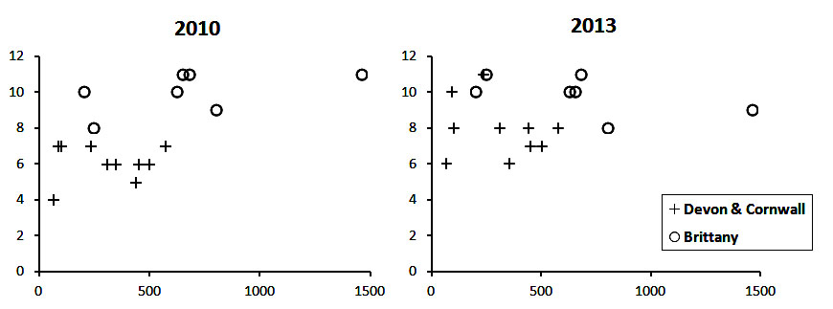

Fig. 1. Relationship between size (number of berths) of marinas and number of NIS recorded in each in 2010 and 2013.
[2 columns]

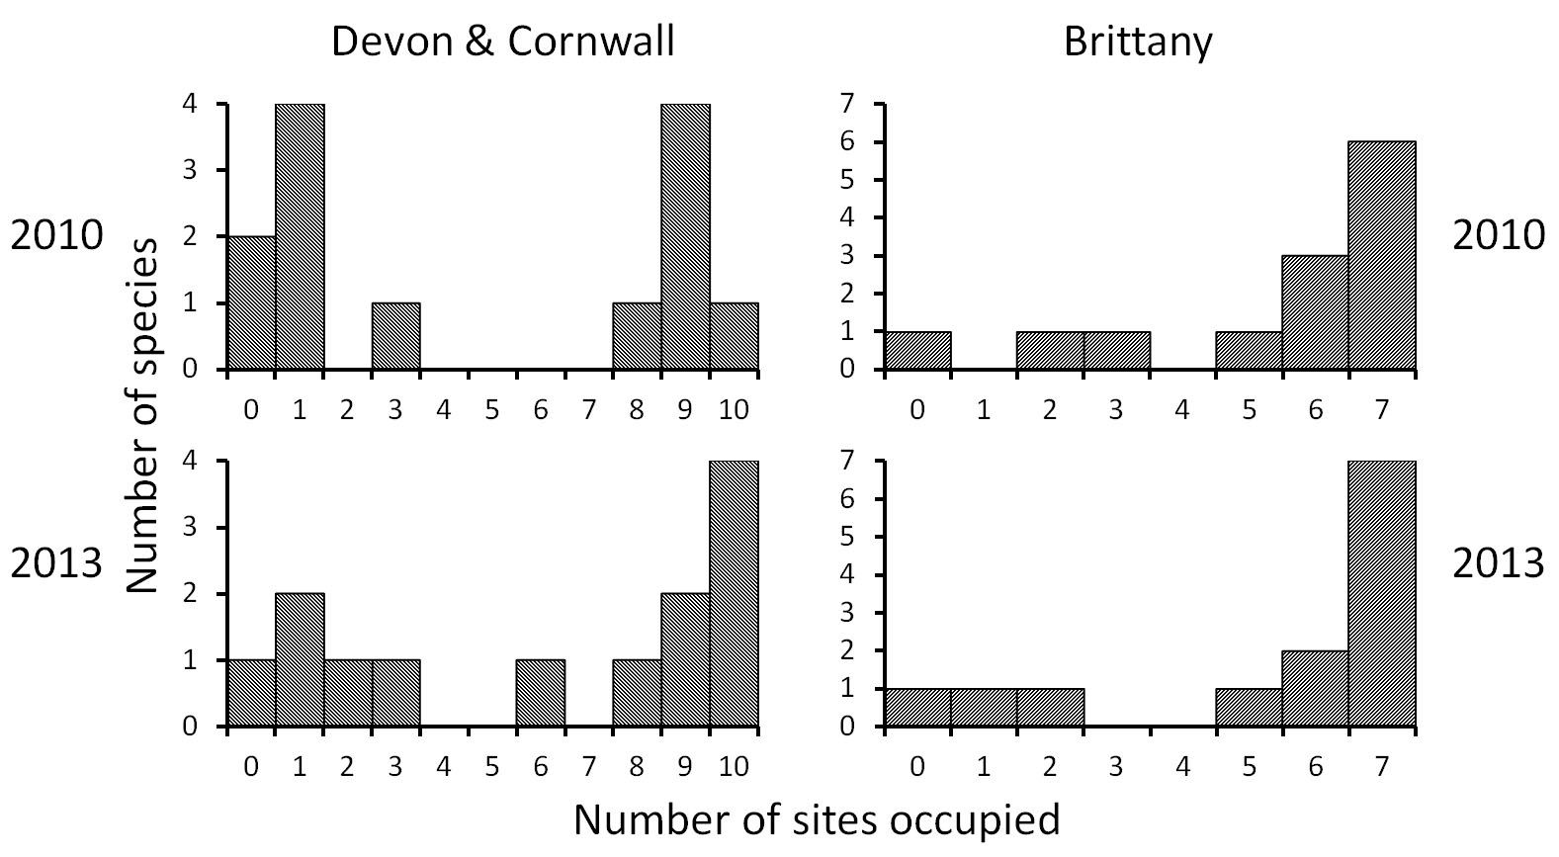

Fig. 2. Frequency distribution of NIS based on the number of marina sites occupied by each species in surveys in Devon & Cornwall (10 sites) and Brittany (7 sites). The same 13 taxa are included in each diagram.
[2 columns]

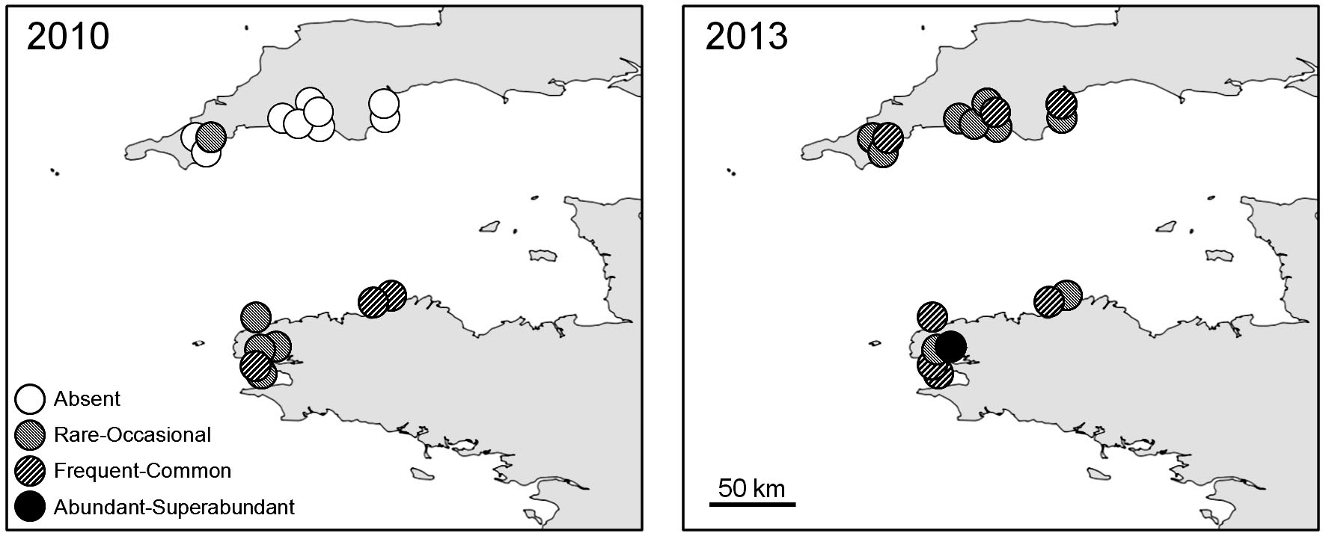

Fig. 3. Occurrence of the non-indigenous ascidian Asterocarpa humilis in marinas in Devon & Cornwall and in Brittany in repeat RASs in 2010 and 2013. Note rapid spread in Devon & Cornwall.
[2 columns]

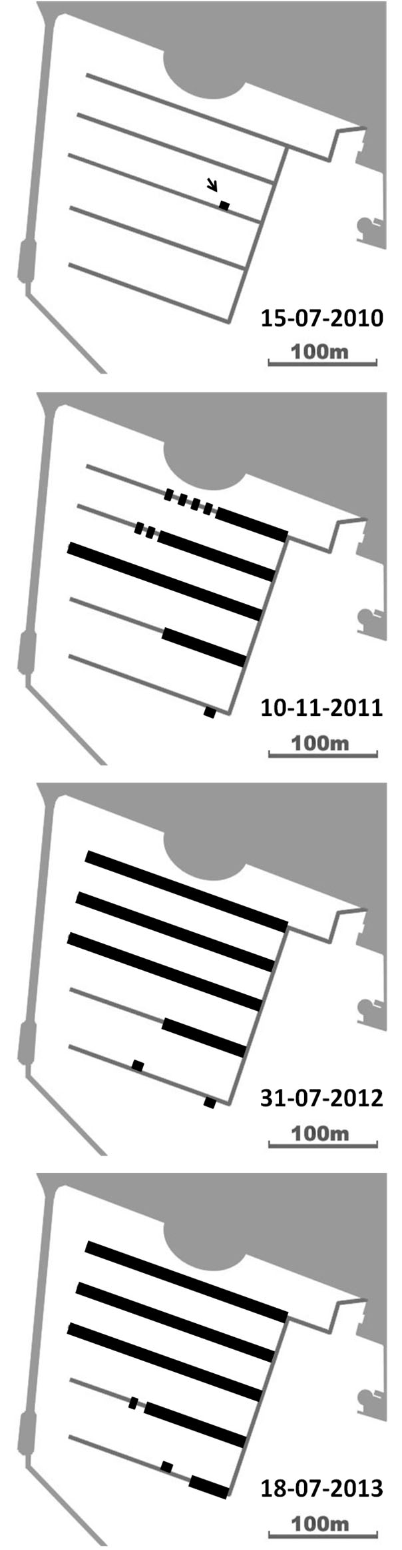

Fig, 4. Spread of Botrylloides diegensis (black) on the main pontoons at TOR following its initial discovery during the 2010 RAS. North is at top of page; entrance to marina lies just south of region shown.
[1 column]
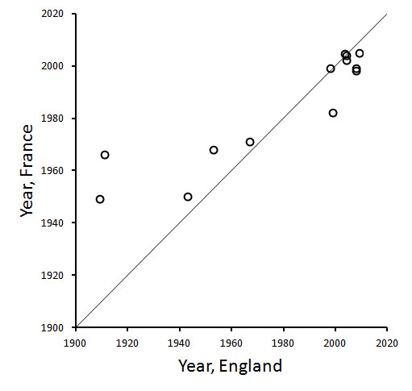

Fig. 5. Scatter plot of years of first recorded occurrence in France and England on the English Channel coast of the NIS recorded in the RAS surveys, with a line of equality. (Schizoporella japonica is not plotted as it has not yet been recorded on the French coast.)
[1.5 columns]

