An assessment of the state of nature in the United Kingdom: a review of findings, methods and impact

Burns, F. *ª, Eaton, M. A. ª, Hayhow, D. B. ª, Outhwaite, C. L. ^{a, b, c}, Al Fulaij, N. ^{d}, August, T. A. ^{b}, Boughey, K. L. ^{e}, Brereton, T. ^{f, g}, Brown, A. ^{h}, Bullock, D. J. ^{i}, Gent, T. ^{j}, Haysom, K.A. ^{e, 1}, Isaac, N. J. B. ^{b, c}, Johns, D. G. ^{k, 2}, Macadam. C. R. ^{l}, Mathews, F. ^{m, 3}, Noble, D. G. ^{n}, Powney, G. D. ^{b}, Sims, D. W. ^{o, p}, Smart, S. M. ^{q}, Stroh, P. ^{r}, Walker, K. J. ^{r}, Webb, J. R. ^{h}, Webb, T. J. ^{s}, and Gregory, R. D. ^{a, c}

*Correspondence author: fiona.burns@rspb.org.uk

ª RSPB Centre for Conservation Science, Sandy, UK.

^{b} Centre for Ecology & Hydrology, Maclean Building, Benson Lane, Wallingford, Oxfordshire, UK.

^{c} Centre for Biodiversity & Environment Research, Department of Genetics, Evolution and Environment, University College London, Darwin Building, Gower Street, London, UK.

^{d} People’s Trust for Endangered Species, London, UK.

^{e} Bat Conservation Trust, London, Quadrant House, 250 Kennington Lane, London, UK.

^{f} Butterfly Conservation, Wareham, UK.

^{g} Marinelife, Bridport, Dorset, UK.

^{h} Natural England, Northminster House, Peterborough, UK.

^{i} National Trust, Heelis, Kemble Drive, Swindon, UK.

^{j} Amphibian and Reptile Conservation, Bournemouth, UK.

^{k} Sir Alister Hardy Foundation for Ocean Science, Plymouth, UK.

^{l} Buglife – The Invertebrate Conservation Trust, Balallan House, 24 Allan Park, Stirling, UK.

^{m} Mammal Society/Life and Environmental Sciences, University of Exeter, Exeter, UK.

^{n} British Trust for Ornithology, Thetford, Norfolk, UK.

º Marine Biological Association of the United Kingdom, The Laboratory, Citadel Hill, Plymouth, UK.

^{p} Ocean and Earth Science, National Oceanography Centre Southampton, University of Southampton, Waterfront Campus, European Way, Southampton, UK.

^{q} NERC Centre for Ecology & Hydrology, Library Avenue, Bailrigg, Lancaster, UK.

^{r} Botanical Society of Britain and Ireland, Bristol, UK.

^{s} Department of Animal & Plant Sciences, University of Sheffield, Sheffield, UK.

¹ Present address: Amphibian and Reptile Conservation, Bournemouth, UK.

² Present address: Marine Biological Association of the United Kingdom, The Laboratory, Citadel Hill, Plymouth, UK.

³ Present address: Mammal Society/ University of Sussex, John Maynard Smith Building, Falmer, UK.

Abstract
Clear, accessible, objective metrics of species status are critical to communicate the state of biodiversity and to measure progress towards biodiversity targets. However, the population data underpinning current species status metrics is often highly skewed towards particular taxonomic groups such as birds, butterflies and mammals, primarily due to the restricted availability of high quality population data. A synoptic overview of the state of biodiversity requires sampling from a broader range of taxonomic groups. Incorporating data from a wide range of monitoring and analysis methods and considering more than one measure of species status are possible ways to achieve this.

Here, we utilise measures of species’ population change and extinction risk to develop three species status metrics, a Categorical Change metric, a Species Index and a Red List metric, and populate them with a wide range of data sources from the UK, covering thousands of species from across taxonomy. The species status metrics reiterate the commonly reported decline in freshwater and terrestrial species’ status in the UK in recent decades and give little evidence that this rate of decline has slowed.

The utility of species status metrics is further improved if we can extrapolate beyond the species sampled to infer the status of the community. For the freshwater and terrestrial species status metrics presented here we can do this with some confidence. Nevertheless, despite the range and number of species contributing to the species metrics, significant taxonomic bias remained and we report weighting options that could help control for this.

The three metrics developed were used in the State of Nature 2016 report and indications are they reached a large number of audience members. We suggest options to improve the design and communication of these and similar metrics in the future.

Keywords
Metric; Indicator; Index; Biodiversity; Species; Great Britain

1. Introduction
Across society people receive many varied nature conservation messages, ranging from success stories through to warnings about the imminent extinction of species. The frequency, variety and often contradictory nature of these messages may obscure an understanding of the overall state of nature and, importantly, the role of human actions in determining this state. Clear, objective, overarching metrics of the state of the natural environment can provide this understanding, facilitating informed decision making and supporting educational campaigns. This information also allows us to measure our progress towards conservation targets at global (e.g. Convention on Biological Diversity, 2010), European (e.g. Marine Strategy Framework Directive, European Union, 2008) and national scales (JNCC, 2017a).

The UK has some of the longest-running and best-supported biodiversity recording and monitoring in the world, with the majority of data being collected by skilled volunteers. Biological monitoring and recording programmes are well developed for many taxonomic groups (Barlow et al., 2015; Dennis et al., 2013) and these are used to report on species status (Fox et al., 2010), population trends (Holt et al., 2015), and conservation projects (Ellis et al., 2012), either for individual species or taxonomic groups.

Where volunteer-based monitoring of flora and fauna is well-developed, data are strongly skewed towards those groups that are popular to record, relatively easy to identify or accessible to observe, or those especially endangered and requiring close surveillance (UK NEA, 2011). As a result, we are able to assess population trends for only a small percentage of species overall. Recently, analytical techniques for accounting for some of the biases present in opportunistically collected biological records have developed into robust tools for detecting trends in species’ status (Isaac et al., 2014; Van Strien et al., 2013). This has enabled data from a much broader taxonomic set to contribute to multispecies metrics (Outhwaite et al., 2018; Van Strien et al., 2016).

A group of the UK’s leading wildlife organisations have synthesised data on species status across taxonomy and habitat types, with the ambition of moving closer to a goal of clear, consistent and objective assessment of biodiversity. The findings are published in two ‘State of Nature’ reports (Burns et al., 2013; Hayhow et al., 2016). The primary aim of these reports was to develop a robust synthesis of the state of species in the UK, Overseas Territories and Crown Dependencies, making the most of available data, and to increase the level of awareness and understanding by target audiences (policy makers, conservationists, conservation supporters, and the wider public) of the current state of nature and how and why it is changing.

The State of Nature 2016 (‘the report’ subsequently) brought together recent measures of species status for a far wider range of taxa than had previously been possible, and presented a series of metrics summarising species status and how it has changed over time. Since species monitoring across taxa in the UK is incomplete, the assessment aimed to maximise the sample size based on data availability, rather than on a preselected random sample of species’ data. Consequently there was variation between measures of species status in the time period covered, the method of data collection, the aspect of species status measured, and the statistical techniques used to assess trend. It is important therefore, to investigate whether the non-random species sample and the variation in assessment methodology had a significant impact on our results.

In this paper, we:
- Provide a full description of the species status metrics used to assess the State of Nature and the underpinning biological data used, in order to facilitate their interrogation and reproduction;
- Subject the metrics of species status to tests of robustness and representativeness of the entire species community and explore methods to control for observed biases;
- Identify measures to improve the design and communication of the species status metrics and similar studies in the future.

2. Materials and methods
The methods below describe the process used to collate measures of species status and how these were combined into three metrics: 1. A Categorical Change metric, which describes the distribution of species among five population change categories based on their average annual rate of change over a long-term and a short-term period; 2. A Species Index, which charts average species’ change over time, and 3. A Red List metric, which presents the proportion of species at risk of extinction from Great Britain. In order to maximise the taxonomic and ecological breadth of the species sample in the Categorical Change metric and the Species Index, we combined information from a diverse range of datasets, treating as equivalent different measures of population change, for instance changes in species abundance, occupancy or distribution. The three metrics use data from the United Kingdom only: the limited data available for the UK Overseas Territories are covered in the Discussion.

2.1 Data collation
We collated as many datasets as possible describing population change of native UK species in order to populate the first two metrics (Table 1; Tables A2:A4). The majority of these datasets were species time-series derived from statistical models, rather than raw counts or observations (Table 1). A small number of datasets consisted of biological records or periodic counts or estimates of species abundance, occupancy or range. For species with more than one dataset available, we gave precedence to assessments of change in abundance, as this is thought to be the most sensitive measure (Chamberlain and Fuller, 2001), and then the most robust dataset, based on the survey method subject to the fewest known biases, and maximising the sample size and time periods covered. Each population change dataset contained two or more comparable estimates of species abundance or distribution made between 1960 and the present, had a broad geographical coverage across the species’ UK range; the results or the methodology for data collection and/or analysis is published and start and end dates for estimates of status for each species are at least ten years apart. In addition to datasets of species population change, we collated national IUCN Red List assessments.

Assessments of population change in many terrestrial and freshwater species were based on unstructured biological records, meaning records were collected outside a formal monitoring framework. It can be difficult to use datasets of opportunistic records to assess change over time, as recording effort varies spatially and temporally (Hill, 2012; Szabo et al., 2010). Several statistical techniques are available to help account for these biases; here we used a hierarchical Bayesian occupancy modelling approach that has been shown to be robust to numerous biases associated with biological records (supplementary material; Isaac et al., 2014; Van Strien et al., 2013). We fitted an occupancy model to the records for each species (see supplementary material). The outputs from these models are annual estimates of the proportion of occupied sites (henceforth occupancy).

Table 1: Characteristics of the datasets contributing to the State of Nature analyses, showing the aspect of population status measured (Data Type), the format in which the data were collated and the number of species each data type contributed to the three metrics of species status. A full list of the datasets and the number and proportion of species included from each taxonomic group is given in Tables A2: A4 and A11. * Includes population time series at a higher taxonomic level than species.
 | Data type | Format of data at collation | Taxonomic groups represented | Categorical Change | Species Index | Red List | Example of contributing dataset
TERRESTRIAL AND FRESHWATER | Annual population estimates | Annual counts | birds | 29 | 29 |  | Rare Breeding Birds Panel (Holling, 2015)
 | Relative annual abundance from structured monitoring | Model derived annual estimate | birds, mammals, amphibians, lepidoptera | 555 | 555 |  | Breeding Bird survey (Harris et al., 2015)
 | Relative abundance or range from periodic but comparable surveys | Abundance/ range observed or estimate from each survey | birds, mammals, reptiles | 19 | 19 |  | Otter surveys (e.g. Strachan, 2007)
 | Occupancy from opportunistic recording data | Model derived periodic estimate | Moths | 309 | 309 |  | National Moth Recording Scheme (Fox et al., 2014)
 |  | Biological records | arthropods, bryophytes, lichens | 1589 | 1589
 | Range change between periodic atlases | Change Index | vascular plants | 1315 |  |  | Plant Atlas (Preston et al., 2002)
 | TOTAL |  |  | 3816 | 2501
 | National Red List Assessment |  | arthropods, molluscs, vascular plants, bryophytes, lichens |  |  | 7966
MARINE | Annual Catch Per Unit Effort from structured sampling | Average catch per hour per survey area | fish, zooplankton*, phytoplankton* | 73 | 73 |  | North Sea International Bottom Trawl Survey (ICES, 2015)
 | Relative annual abundance from structured sampling | Model derived annual estimate | birds, grey seal | 12 | 12 |  | Seabird Monitoring Programme (JNCC, 2015)
 | Relative abundance or range from periodic but comparable surveys | Observed or estimated abundance from each survey | cetaceans, harbour seal | 4 | 4 |  | SCANS Small Cetacean national survey (Hammond et al., 2013)
 | Categorical abundance from periodic surveys | Model derived average annual rate of change | algae | 14 | 14 |  | Brown seaweed surveys (Yesson et al., 2015)
 | Phytoplankton colour index |  | phytoplankton¹ | 1 | 1 |  | Continuous Plankton Recorder (Johns, 2015)
 | TOTAL |  |  | 104 | 104

2.2 Producing metrics of species status
For each of the three species status metrics developed we presented the results overall (across all species assembled), by higher taxonomic group (vertebrates, invertebrates and plants and fungi), and by lower taxonomic group where possible. Additionally, we produced habitat specific metrics based on status data for species assigned to seven broad terrestrial and freshwater habitat types: Farmland, Woodland, Freshwater and Wetland, Upland, Coastal, Grassland and Heathland, and Urban (defined in Table A5). Species were classified to habitats by extending the method used by Redhead et al. (2016) (see supplementary material).

The nature and quantity of data for marine species was different from that for terrestrial and freshwater species, with robust data available for a limited set of taxa (Table A3). We did not include marine data in the metrics described above, but constructed separate Categorical Change metrics and Species Indices for marine species (see supplementary materials for further details on the limitations of the marine metrics).

Species were weighted equally in the terrestrial and freshwater species metrics. Each higher taxonomic group was weighted equally in the equivalent marine metrics given the taxonomic bias and variation in the taxonomic level at which measures of species change were available.

2.2.1 The Categorical Change Metric
In order to provide a simple synthesis of the available species trends, we assigned each species to one of five categories: Strong increase, Moderate increase, Little change, Moderate decrease, Strong decrease. Categorisation was based on the estimated magnitude of each species’ population change, not its statistical significance, as the latter is determined by sample variance and thus influenced by sample size and, in relation to population change, by species’ life history. Using the magnitude of the species’ population change helped to reduce interspecific variance in our ability to detect change where it was present. We categorised species’ population change over two time periods: a long-term period (~1970–2013 or closest available time period) and a recent short-term period (2002–2013).

2.2.1.1 Categorisation based on changes in species’ abundance and occupancy
In order to allow a comparison of species’ trends across methods, we calculated the total change then the average annual change over the two time periods. We used published values where possible, otherwise they were calculated as follows (see Tables A3:A4 for exceptions). In general, total change ($t$) was the abundance (or occupancy) estimate in the final year expressed as a proportion of that in the first year. Smoothed time series were used when available to reduce the influence of unusual annual fluctuations. Here, $t$ was calculated using the abundance estimate of the penultimate year as opposed to that of the final year, as the final year of smoothed time-series can be erratic (Buckland and Johnston, 2017). For most species annual average change ($a$) was calculated using Equation 1, where duration is the difference between the first and last years of species’ time-series. For estimates of population change derived from Bayesian occupancy modelling $a$ was calculated following Isaac et al. (2015).

$a=\left(t^{^(\frac{1}{duration})}\right)-1$${a=\left(t^{\left(\frac{1}{duration}\right)}\right)-1}^{}$ (1)

We placed each species into one of the five categories based upon the average annual change in relative abundance or occupancy; defined as follows: Strong increase: a rate of change that would lead to a population doubling or more over 25 years $\left({ a≥(2}^{(1/25)})-1\right)$, Moderate increase: change that would lead to an increase of a third or more but less than doubling in 25 years$\left({ {((4/3)}^{(1/25)})-1≤a<(2}^{(1/25)})-1\right)$, Little change: change that would lead to an increase of less than a third or a decline of less than a quarter over 25 years${ ({ (0.75}^{(1/25)})-1<a<((4/3)}^{(1/25)})-1)$, Moderate decrease: change that would lead to a decline of greater than a quarter but less than a half over 25 years $\left({(0.5}^{(1/25)})-1<a≤\left({0.75}^{\left((\frac{1}{25}\right)}\right)- 1\right)$, Strong decrease: change that would lead to a population halving or more over 25 years $\left({ a≤(0.5}^{(1/25)})-1\right)$. These categories are very similar to those used in other conservation assessments (e.g. Eaton and Noble, 2017). In addition, we presented a binary split of the proportion of species with positive and negative trends, regardless of magnitude.

2.2.1.2 Categorisation based on change in the distribution of Plants
Annual estimates of abundance or occurrence were not available for vascular plants. However, two atlases have been produced and for each species an index – the Plant Atlas Change Index– was calculated, assessing the change in distribution between the first atlas and the second at the scale of 10-km grid squares (Hill et al., 2004). Changes were assessed relative to the change in the average species, as a way to partially control for recording effort by assuming that it has changed equally across species (Telfer et al., 2002). As this index is a relative measure of change it does not tell us how much a species’ distribution has changed in absolute terms. Similar change indices are available between each repetition of the Countryside Survey (Carey, 2008) and the one following it (1978-1990, 1990-1998, 1998-2007), allowing overall change between 1978 and 2007 to be calculated. We used Countryside Survey data for the species for which it was available (generally more common and/or widespread species), and otherwise used the Plant Atlas Change Index. We placed each plant species into one of five categories using the definitions below. The cut-offs at ±0.5 follow Preston et al. (2003). Strong increase: $Change Index (CIn)≥0.5$, Moderate increase: $0.5> CIn≥0.25$, Little change: $0.25> CIn >-0.25$, Moderate decrease: $-0.25≥CIn>-0.5$, Strong decrease:$CIn≤-0.5$. As above, we also included a simple binary positive/negative split.

2.2.2 Composite annual Species Index of abundance or occupancy
The Species Index combined annual time series of both abundance and occupancy, as in the Dutch Living Planet Index (Van Strien et al., 2016). The species composition of the Species Index was equal to that of the Categorical Change metric with the omission of vascular plants, where the population change measure, the ‘Change Index’, was incompatible with the indicator format. Additional processing was required for a small number of time series prior to calculating the index; missing years were estimated using log-linear interpolation (Collen et al., 2008) but time series were not extrapolated before the first available year of counts or after the last. Where genuine zero counts were present the time series was included from the year of the first positive count and 1% of the average value of the time series was added to each value in the time series of that species (Loh et al., 2005). Where time series ended prior to 2013, they were extended to 2013 by holding the final year’s value constant in all subsequent years; 49% of time series ended prior to 2013, but only 2% ended prior to 2010. All time series were converted to species indices by expressing each annual estimate as a percent of the first year of the time series. On the small number of occasions (1% of species indices) where species indices went above 10000 or below 1 they were set to that value as extreme index values can have a disproportionate influence (Noble et al., 2004). The Species Index was calculated as the geometric mean of the species indices (Gregory et al., 2005). Species’ indices starting after 1970 entered the index at the geometric mean value for that year. Confidence intervals (CI) for each Species Index were created using bootstrapping by species (Freeman et al., 2001); in each iteration (N=10,000) a random sample of species was selected with replication and the index was re-calculated. Short-term change in the Species Index was calculated as the geometric mean of species level change between 2002 and 2013, CI were estimated using bootstrapping by species. Some species status metrics use bootstrap methods incorporating intraspecific error (Van Strien et al., 2016). Although desirable this could not be achieved here as standard errors were unavailable for several contributing datasets.

We used a generalised mixed model (function lme, package nlme, R Core Team, 2016) to test whether the rate of change in the Species Index differed between the short-term period (2002-2013) and the prior period (1970-2001) (Equation 2). Note the prior period is not equal to the long-term period.

$lme(\log\left(Species Index\right)\sim \left(year-2002\right)+\max\left(0, year-2002\right), random = \sim 1|dummy ,correlation=corAR1\left(\right),data=Species_Index_data)$ (2)

Where AR(1) is an autoregressive model of order one, which takes temporal autocorrelation into account by using the index value ($I$) at time t-1 to help predict its value at time t. A uniform single level random effect was also included (dummy), which is required in order to include a correlation term. As the short-term and prior periods differed in duration we used bootstrapping to determine the significance of the second explanatory variable, which describes the relationship between the rate of change in the index and the two time periods. We re-ran the model (Eq. 2) across the 10,000 bootstraps of the Species Index used to generate its CI and extracted the relevant coefficient in each case. Significance was indicated if the 95% CI of the model coefficient omitted zero.

2.2.3 National Red List assessments
We synthesised all published national Red List assessments for Great Britain, where the risk of extinction was assessed using current regional IUCN criteria (IUCN, 2012), by presenting the proportion of species in each threat category. IUCN criteria primarily relate to quantitative changes in population parameters, but also include other measures, such as an assessment of threats and likelihood of rescue from populations outside the focal area. The proportion of species considered threatened with extinction is the sum of species in the categories, Critically Endangered, Endangered and Vulnerable (IUCN, 2016).

2.3 Understanding sources of bias in the metrics of species change
The species sample underpinning the metrics of species change is based on data availability because it is currently impractical to use a random sample of UK species within or between taxonomic groups or habitats. This means that we need to employ caution in extrapolating findings beyond the species assessed. To investigate the taxonomic representation of our datasets we assessed the extent to which each phylum and kingdom was over or underrepresented in our datasets relative to the proportion of freshwater and terrestrial species in that group. Secondly, we explored options for weighting our metrics to take account of taxonomic biases.

We calculated a weighted (w) version of our Categorical Change metric (Equation 3) by assuming that the number (N) of species present in our data (N_{d}) were representative of the taxonomic group (N_{g}) they belong to and extrapolating our assessment to all UK freshwater and terrestrial species (N):

${ N}_{c}=\sum_{g=1}^{n}{\frac{N_{c,d,g}.N_{g}}{N_{d,g}}}$ (3)
Where subscript letters denote that the parameter is specific to the population change category (c), to those species present in the dataset (d) and to the group (g).

We calculated weighted ($w$) Species Indices ($I$) (Equation 4) where each group’s weight ($w_{g}=N_{g}/N$) was equal to the proportion of UK freshwater and terrestrial species it represents. Subscript definitions as above.

${wI}_{t}={10}^{^}\sum_{g=1}^{n}{{\log_{10}I}_{g, t}*w_{g}}$ (4)

We calculated three different weighted versions of the two metrics, where the group i) represented the three higher taxonomic groups used (vertebrates, invertebrates and plants and fungi) ii) the three kingdoms of life represented in our datasets (animals, plants and fungi) and iii) the seven phyla represented in our datasets (Arthropoda, Chordata, Tracheophyta, Pteridophyta, Bryophyta, Marchantiophyta and Lichens; Lichens were considered a proxy phylum).

We investigated how ecologically representative our species sample was for two taxonomic groups where range sizes and habitat associations were readily available (vascular plants and bryophytes (Hill et al., 2007; Hill et al., 2004)) by assessing whether the species included in our dataset (i.e. those for which trends were available) were each associated with more or fewer habitat types than those excluded from our dataset, or whether they, on average, had a larger or smaller range size. Additionally, across all taxonomic groups we assessed whether the Categorical Change metric varied depending on the number of habitat types species’ were associated with (a measure of how specialised species’ habitat requirements are).

3. Results
3.1 Metrics of species change
3.1.1 Freshwater and terrestrial species
Of the 3816 species with a long-term measure, the Categorical Change metric showed that 2126 (56%) had a negative population trend and 1450 (38%) were either in the Strong decrease or Moderate decrease categories (decreasing categories), compared to 1690 (44%) with positive population trends and 1064 (28%) in the Strong increase or Moderate increase categories (increasing categories) (Figure 1a; Table A6). Of the 3810 species with a short-term measure, 2038 (53%) had negative population trends and 1772 (47%) positive and there were 1571 species (40%) in the decreasing categories and 1289 (34%) in the increasing categories (Fig. 1b; Table A7). There was variation in the ratio of negative to positive changes between the higher taxonomic groups in the long-term but not the short-term (long-term: $X_{2}^{2}=16.07,P<0.001$; short-term: $X_{2}^{2}=0.07, P=0$), with vertebrates having fewer species with negative trends compared with invertebrates and plants and fungi.
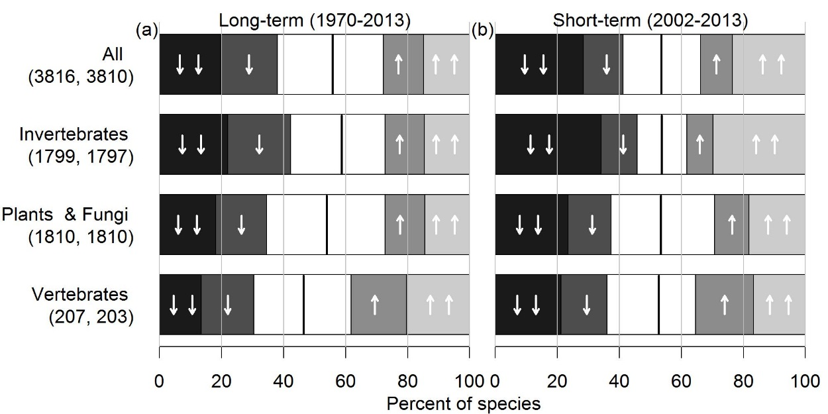
Figure 1: The freshwater and terrestrial Categorical Change metric for all species, and by the three higher taxonomic groups, for the (a) long-term period and (b) the short-term period. The population change categories, from left to right are: Strong decrease ↓↓ , Moderate decrease ↓ , Little change, Moderate increase ↑ and Strong increase ↑↑ . The strong black line shows the divide between negative population changes (where change is below zero) and positive population changes. The number of species is shown in brackets.

The Species Index (SI) declined significantly by 16% in the long-term (∆SI₁₉₇₀₋₂₀₁₃ with CI = -16 (-23,-9)) and non-significantly by 2% (∆SI₂₀₀₂₋₂₀₁₃ = -2% (-5,-2)) in the short-term (Figure 2a; Table A8). We found no evidence that the rate of change of the overall Species Index differed between the prior period (1970-2001) and the short-term period (2002-2013); change model coefficient (CM) with CI = 1.002 (0.998,1.006) (Table A9). There was substantial variation between the Species Indices for the three higher taxonomic groups in the long-term, with vertebrates showing no significant change; ∆SI₁₉₇₀₋₂₀₁₃ = 22 (-5,57), plants and fungi increasing; ∆SI₁₉₇₀₋₂₀₁₃ = 20 (3,39) and invertebrates decreasing; ∆SI₁₉₇₀₋₂₀₁₃ = 71 (-36,-21) (Fig. 2b; Table A8). None of these Species Indices showed a significant change in the short-term. The rate of change was significantly less positive in the recent period than the prior period for vertebrates (CM = 0.987 (0.976,0.999)), and significantly more positive for plants and fungi (CM = 1.011 (1.003,1.018); Table A9).
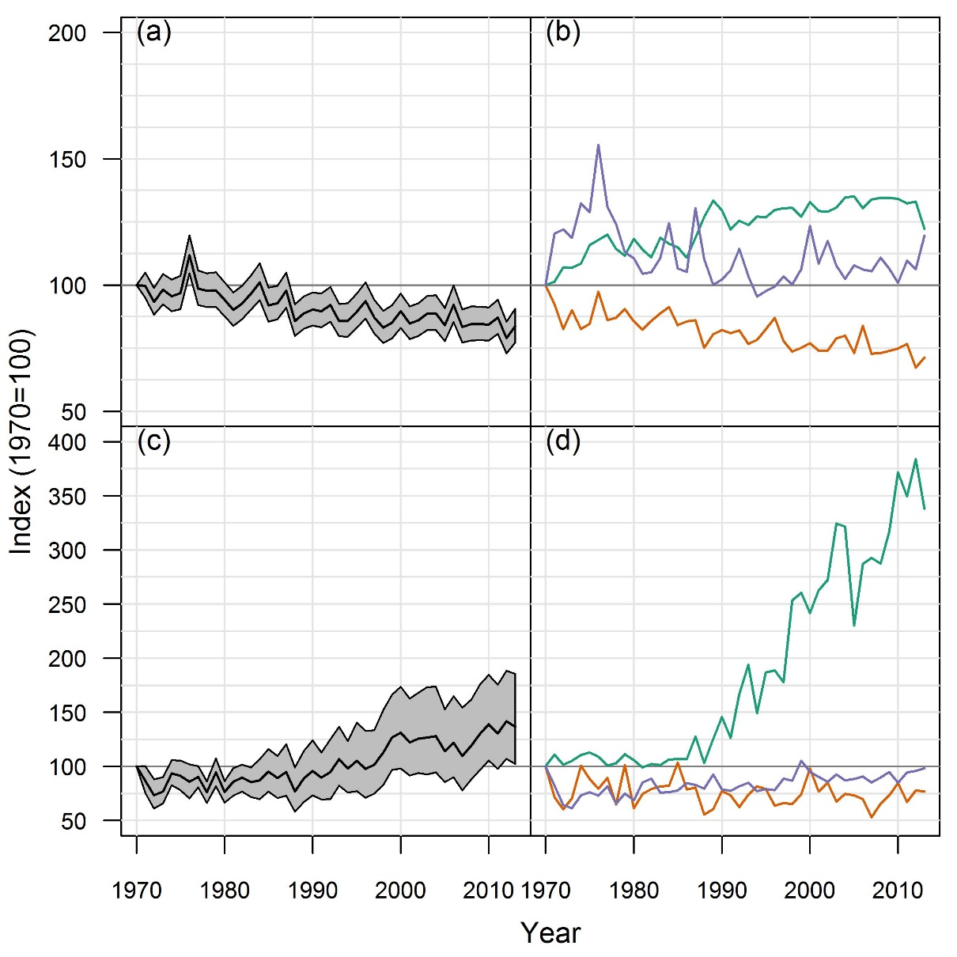
Figure 2: Species Index for UK species. Freshwater and terrestrial species: (a) All species plus 95% CI, N=2501; (b) Vertebrates ( Green , N=207), invertebrates ( Orange , N=1799), plants and fungi ( Purple , N=495). Marine species: (c) All taxa plus 95% CI, N=104; (d) vertebrates ( Green , N=80), invertebrate groups ( Orange , N=8), plants ( Purple , N=16). N.B. the y-axis scale differs between plots (a)/ (b) and plots (c)/ (d).

We were able to determine habitat associations for 83% (N = 3152) of the 3816 species in the Categorical Change metric. The pattern of population change present in the all species metric (Fig. 1a) was similar to that found in each habitat, but with Grassland & Heathland (62%) and Coastal (58%) habitats having slightly higher proportions of species with negative population trends than average and Urban habitats having a slightly lower proportion (47%) (Tables A6 & A7). This could not be tested statistically as the species in each habitat are not independent. Of the 2501 species in the Species Index, we determined habitat associations for 1837 (73%). The Species Indices for five of the seven broad habitat types declined significantly in the long-term, with Grassland and Heathland showing the largest decline, of 29% (∆SI₁₉₇₀₋₂₀₁₃ = -29 (-39,-17); Table A10), whereas those for Coastal and Urban showed no significant change over time. In the short-term, only the Species Indices for two habitats, Woodland and Urban, showed a significant decline. For all habitats apart from Urban and Farmland, we found no evidence that the average rate of population change differed between the prior and the short-term period. The SI_{Urban} was stable in the prior period, but negative in the recent one (CM = 0.98 (0.97,0.99); Table A9). The SI_{Farmland} declined in the prior period and became more negative in the short-term period (CM = 0.993 (0.986,0.9995)).

3.1.2 Marine species
Over the long-term, 38% (N=39) of the marine taxa assessed had negative population trends and 62% (N=65) positive, whilst 26 taxa (25%) were in the decreasing categories and 51 (49%) in the increasing categories (Table A11). The SI_{marine} increased by 37% between 1970 and 2013 (∆SI₁₉₇₀₋₂₀₁₃ = 37 (2,85); Fig. 2c; Table A13). Looking at the trends of marine taxa in more detail, it is apparent that one group was driving the increase. When fish were excluded from the analysis, 48% (N=19) of the remaining marine taxa have negative population trends and the SI_{marine} shows a non-significant decline of 11% since 1970 (∆SI₁₉₇₀₋₂₀₁₃ = -11 (-31,13)), whereas 31% (N=20) of fish have negative population trends, and SI_{fish} shows an increase of 485% (∆SI₁₉₇₀₋₂₀₁₃= 485 (147,1310); Fig. 2d). In the short-term, 44% (N=46) of taxa have negative population trends and the SI_{marine} increased non-significantly by 16% (∆SI₂₀₀₂₋₂₀₁₃ = 16% (-3,41)). There was no evidence that the rate of change in the SI_{marine} differed between the prior and short-term period (Table A12).

3.2 National Red List assessments
We brought together GB Red List assessments for 7966 species, 15% of UK freshwater and terrestrial species (invertebrates: 12%, plants: 52%, fungi: 11%; no comparable assessments were available for vertebrates), of which 13% were considered to be threatened with extinction. A higher proportion of plants were threatened (19%, Figure 3; Table A14) than either fungi or invertebrates (both 11%).
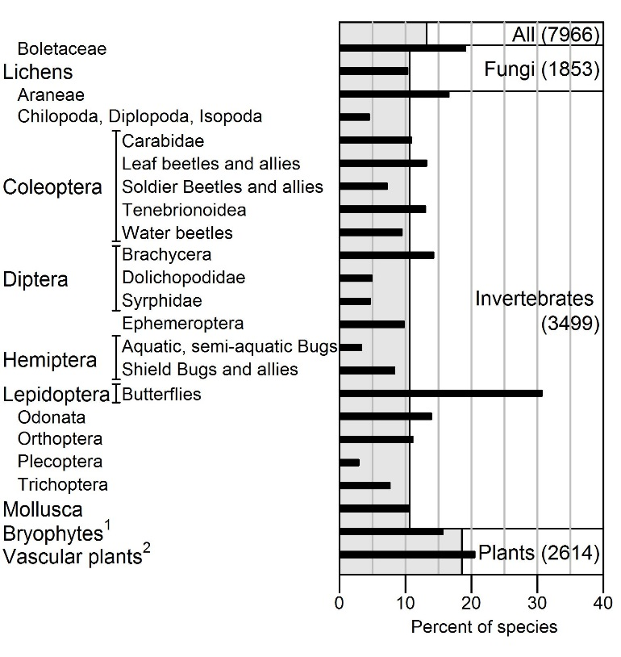
Figure 3: The Red List metric showing the percent of terrestrial and freshwater species threatened with extinction from Great Britain in groups assessed using modern IUCN Red List criteria. Light grey bars show the percent overall and for the three higher taxonomic groups, the black bars show the results of individual group assessments. For paraphyletic groups the families covered are listed in Table A14. 1: Bryophyta, Marchantiophyta, Anthocerophyta; 2: Tracheophyta, Pteridophyta.

3.3 Understanding sources of potential bias in our metrics of species status
Our three species status metrics are populated by a large and diverse number of the UK's ~55k freshwater and terrestrial species from three of the four multicellular eukaryotic kingdoms of life (Tables A2, A14; Figures 4, 5). Nevertheless, the proportion of species sampled from each taxonomic group varied considerably. For example, in the Categorical Change metric data were available for a substantially greater proportion of vertebrate species (57%; Fig. 4), compared to plants (32%), invertebrates (6%), and fungi (1%); although in absolute terms there were fewer vertebrate trends (N=207) compared to the other groups (invertebrates, N=1799; plants, N=1582 and fungi, N=228). We can quantify this taxonomic bias by estimating the number of species or percent by which each group is over or underrepresented in each of the three species status metrics (Fig. 5; Table A15). At a kingdom level fungi and chromists (a diverse group of algae including diatoms and kelps) are strongly underrepresented in all three metrics, whereas plants are overrepresented. There is considerable variation within the plant kingdom however, with only half of phyla represented in the Categorical Change and Red List metrics and only two phyla represented in the Species Index. Taxonomic bias for animals varies between the three metrics, but it is notable that only three phyla are represented (Arthropoda, Chordata and Mollusca). The extent of vertebrate data means that Chordates are overrepresented in the two population change metrics, whereas they are absent from the Red List metric.
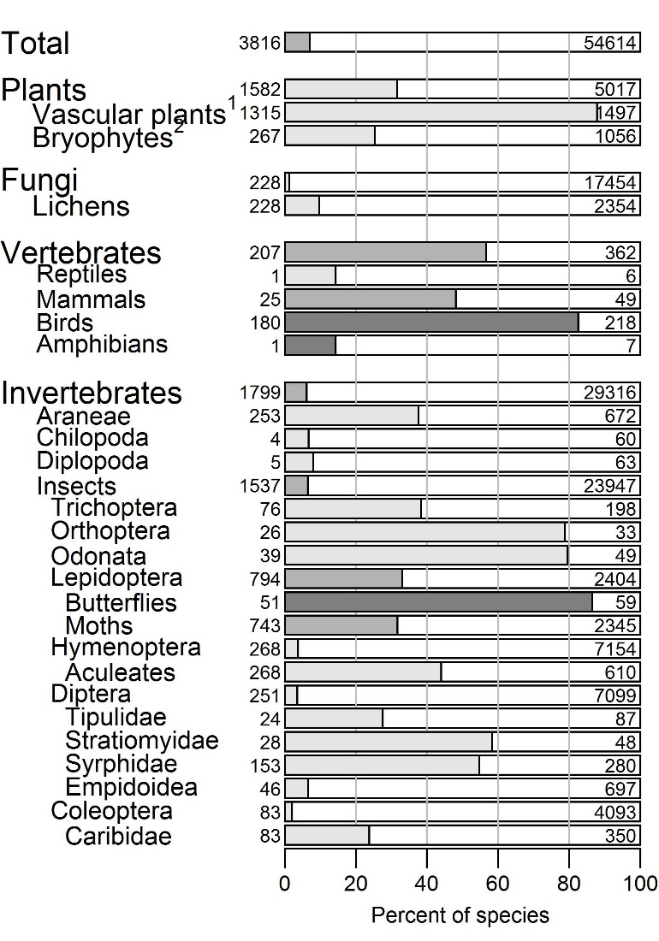
Figure 4: Percentage of freshwater and terrestrial species occurring in the UK that were included in the Categorical Change metric and the Species Index (the latter omits all vascular plants), by taxonomic group. The number of species included is given to the left of each bar and the total number of species in the group is given at the right-hand side. Groups are colour coded by data type, Key: Dark grey: relative abundance, Light-grey: occupancy or distribution, Mid-grey: Both. 1: Tracheophyta, Pteridophyta; 2: Bryophyta, Marchantiophyta.

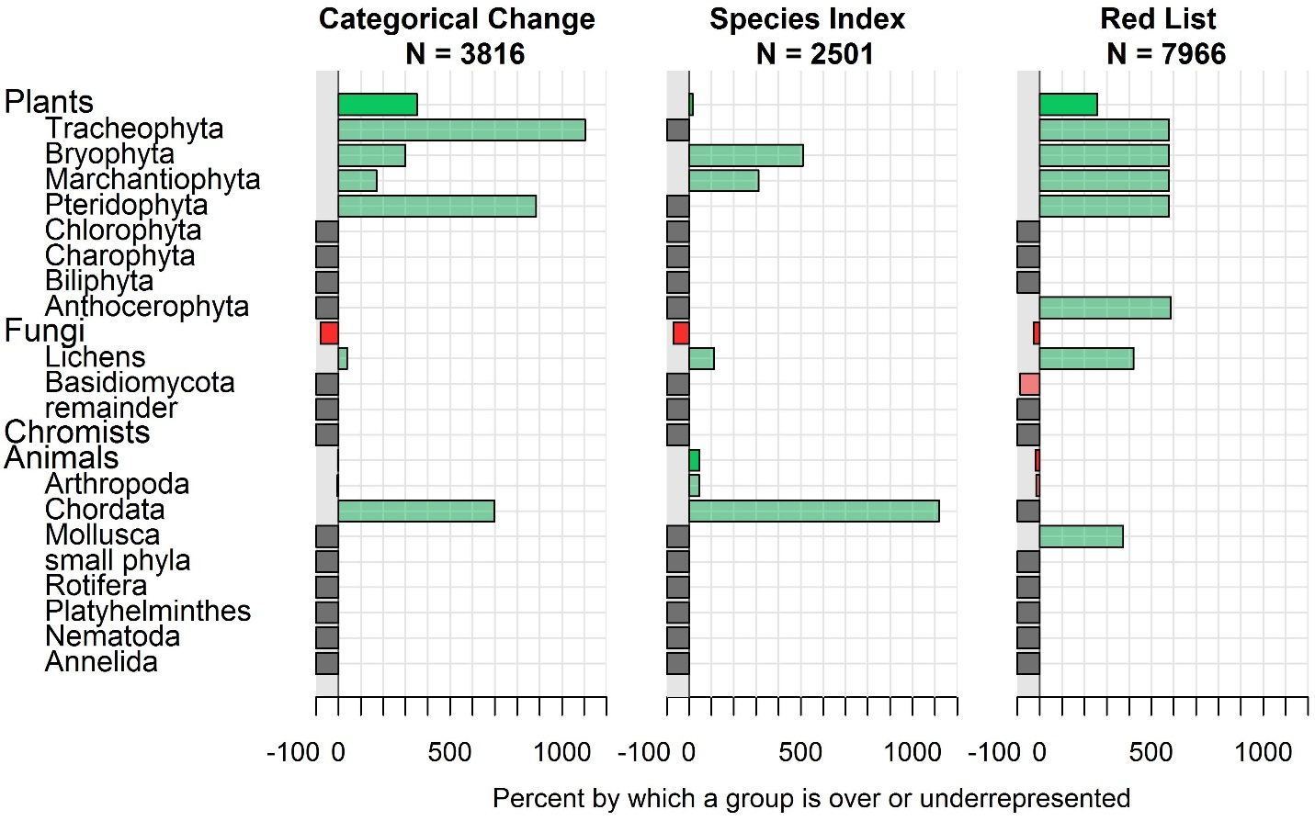
Figure 5: The percentage by which a group is over-represented ( Green), under-represented ( Red ) or not represented ( Dark grey ) in each of the three species status metrics at kingdom (opaque) and phylum (semi-transparent) level.

The proportion of species with negative population trends in the long-term in the weighted version of the Categorical Change metric did not differ markedly from the un-weighted estimate of 56%; weighting by higher taxonomic group (57%), by kingdom (56%) or by phylum (58%) (Table A16). In comparison to the final year value of our unweighted Species Index of ∆SI₁₉₇₀₋₂₀₁₃ = -16 (-23,-9) weighting by higher taxonomic group led to a final value of ∆SI₁₉₇₀₋₂₀₁₃ = -11 (-18,-2), by kingdom ∆SI₁₉₇₀₋₂₀₁₃= -13 (-20,-7) and by phylum ∆SI₁₉₇₀₋₂₀₁₃ = -25 (-31,-19) (Figure 6; Table A16). In both metrics weighting by phylum gave a more negative outcome as the weight of Arthropod species, which have a higher percentage of negative trends, was increased.

The tests for ecological bias (in the sense of ecological specialism) found that bryophyte species included in the species change metrics tended to be associated with a greater number of habitats ($Χ_{6}^{2}= 303.69, P<0.001$) and were more widespread ($Wilcoxon (W)=16245, P<0.001$) than those for which population trends are not yet available. The same pattern, albeit weaker, was observed for vascular plants ($Χ_{2}^{2}=7.70,P=0.021;W=79118,P<0.001)$. However, across all taxonomic groups within our dataset we found no correlation between the number of habitats in which species were found and whether their population trend was positive or negative ($Χ_{7}^{2}=12.28,P=0.09$).
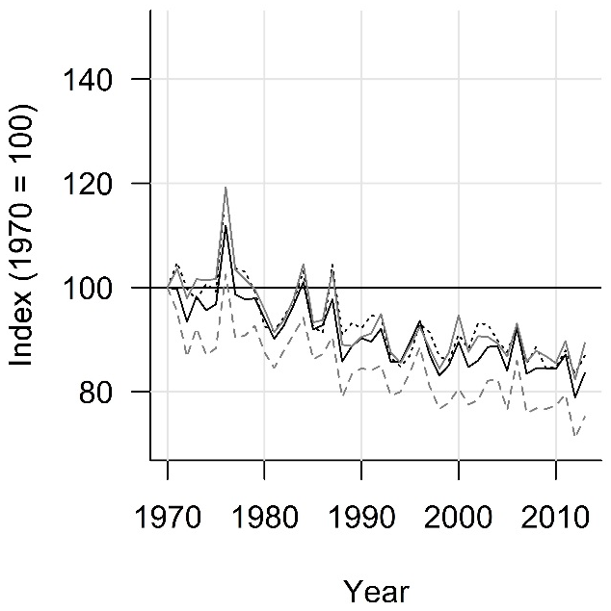
Figure 6: The weighted Species Index where each group’s weight was equal to the proportion of UK freshwater and terrestrial species it represents. Black: Unweighted, Grey: weighted by higher taxonomic group, Black . . . dotted: weighted by kingdom, Grey – – – dashed: weighted by phylum.

Measures of species change were collated for only 104 marine taxa. This included chromists, plants, invertebrates and vertebrates, but was biased towards fish (62%, Table A3). We did not find suitable population change estimates expressed at a species level for marine invertebrates or phytoplankton; although data were often collected at the species level. Given these limitations, we weighted each higher taxonomic group equally in the marine metrics (2.2; Figure 2c, d).

- Discussion
4.1 What is the state of nature in the UK?
The two State of Nature reports (Burns et al., 2013; Hayhow et al., 2016) mark a considerable advance in our knowledge of the status of species in the UK. Previously, national Red Lists were the only assessment of species status available for a comparable number of species, and widely-used biodiversity indicators rely on a far smaller species sample with narrow taxonomic breadth (JNCC, 2017a). In our assessment, more than a third of freshwater and terrestrial species and more than a half of marine species showed changes in abundance, occupancy or range, which we defined as ‘strong’ over the long-term period. For freshwater and terrestrial species the average trend was that of decline, strongly influenced by agricultural management and climate change (Burns et al., 2016). Human activities are also implicated in the 1057 species classified as threatened with extinction from GB (National Red Lists, e.g. Macadam, 2016), despite global (Convention on Biological Diversity, 2010) and national (e.g. Scottish Natural Heritage, 2016) targets to reduce the rate of biodiversity loss.

By contrast, the average trend for marine species was an increase, although this was based on a small sample of taxa, dominated by fish (62%). This average increase in fish populations is thought to have been influenced by two conflicting processes in the long-term. Populations of large-bodied fish species have been negatively impacted by fishing, leading to population declines (Genner et al., 2010; Pinnegar et al., 2010). However, warming sea temperatures have been associated with population increases for a wide range of small-bodied fish (Simpson et al., 2011). In the short-term some commercially fished species have increased due to improved fisheries management (JNCC, 2017b) and previous declines in some deep sea fish have stabilised (Neat and Burns, 2010).

Several studies have observed a recent reduction in the rate of net biodiversity loss compared to earlier in the 20th century. For instance, Carvalheiro et al. (2013) found a reduced rate of species richness loss and homogenisation for insect pollinator groups and plants in the late compared to the mid 20th century and large declines during the 20th century in total nectar provision in GB appeared to stabilise by the late 1970s (Baude et al., 2016). Here, we found no evidence for a difference in the overall rate of species change between the prior and short-term periods. Differences were observed for some groups and habitats, but very few of these related to a reduced rate of decline or elevated rate of increase in the short-term. These different patterns of change between our and other’s studies may be explained by the species sampled or the analytical methods used. However, as each study reported different measures of population change they may be observing different aspects of the same underlying process. A recent simulation study found that although observed trends in population abundance were consistent with simulated population change, observations of species richness showed periods of stability despite changes in the simulated populations (Hill et al., 2016).

We were unable to generate species status metrics for the UK's Overseas Territories (OTs), despite the international significance of the biodiversity found there. Repeated assessments of the state of species, such as those available for the UK, are almost entirely lacking for the OTs. A recent review of their biodiversity identified over 32000 species, but estimated that there may be another 70000 species yet to be documented, with potentially over 3000 single island endemics (Churchyard et al., 2016).

4.2 Do our assessments represent a useful synthesis of the state of UK species and the environment more broadly?
Each of the status metrics was populated by a large number and broad range of taxonomic groups and as such they are likely to provide a reasonable representation of the state of freshwater and terrestrial biodiversity. The species samples underlying the two species change metrics largely overlapped, however the Red List metric was complementary, with half of the species in the Categorical Change metric absent from the Red List metric. Nevertheless, substantial taxonomic bias remained in each, with important groups like fungi underrepresented (Fig. 5) and vascular plants absent from the Species Index. The taxonomic breadth of the sample of marine taxa used was considerably lower than that for freshwater and terrestrial biota, and so we should be very cautious about extrapolating the patterns of change observed. However, we hope that by presenting these interim marine metrics we will stimulate further progress towards a robust assessment of marine species status. Indeed, across all biomes, it is likely that data availability (August et al., 2015) and analytical techniques (Dennis et al., 2017; Edgar et al., 2016; Outhwaite et al., 2018) will continue to increase and improve in coming years, allowing population change to be estimated for additional species and groups, which may reduce bias in the species sample.

In order to control for current taxonomic biases, we explored weighting each taxonomic group in the two species change metrics relative to its contribution to UK biodiversity, such as is used by the Living Planet Index (McRae et al., 2017). This method should be considered for future assessments, however, the taxonomic level at which the weighting is conducted should be chosen carefully or applied hierarchically otherwise the weighting may amplify bias at lower taxonomic levels. Additionally, weighting by taxonomy may not control for other biases, for instance representation across the range of species’ abundances or contributions to ecological processes. For the two taxonomic groups tested, there was some bias in data availability towards generalist, widespread species. It is hard to predict the generality or impact of this pattern, however, given evidence to suggest that specialist species are more likely to have poorer conservation status than generalists (Davey et al., 2012; Le Viol et al., 2012), our assessment of the percent of species in declining categories may be conservative.

In order to maximise taxonomic breadth, the Species Index combined time series’ of both abundance and occupancy (Van Strien et al., 2016). These two measures of population change tend to be correlated (Van Turnhout et al., 2007; Zuckerberg et al., 2009), nevertheless changes in abundance may be more pronounced or easier to detect, in particular for widespread species (Chamberlain and Fuller, 2001). Therefore, this decision may have introduced additional variance to the indices both due to the different measures of change and to differences in the data collection process.

The Red List assessments summarised here cover a modest percentage of UK species (15%) but represent a major step forward in our understanding of national extinction risk. Ecological bias is likely to be lower here, as taxonomic groups are assessed in their entirety, yet significant taxonomic bias remains. Several additional Red List assessments have subsequently been published (e.g. Lane, 2017) and assessments are in progress for the remaining vertebrate classes and several other insect groups, although fungi remain under-represented. Continued support for a programme of Red List assessments will likely further improve taxonomic coverage and allow repeat assessments, as is the case in many countries (Henriksen and Hilmo, 2015; Rassi et al., 2010), in time allowing the calculation of a Red List Index (Butchart et al., 2007).

4.3 Future improvements to the design and communication of the State of Nature and similar assessments?
The aim of the assessment was to create a clear and objective summary of the state of wildlife in the UK and to communicate this in a way that increased awareness and understanding of the state of nature and how and why it is changing. Implicit in this is a requirement for audiences to easily understand the headline metrics and accompanying statements, and appreciate why they are important. Evidence is lacking to say whether the design of the species metrics and how they were communicated facilitated this requirement and whether our aims were met. Here we discuss indirect evidence collated and potential future improvements.

Effective biodiversity indicators should simplify information, be representative, quantitative, responsive, susceptible to analysis, policy relevant and easy to communicate (Gregory et al., 2005); the metrics here meet many of these criteria. Despite this, there remains scope to improve their design to make it easier to communicate their content and meaning. For freshwater and terrestrial species, the results indicate that more species have declined than increased and the average species' trajectory is downwards. We do not explicitly give an interpretation of these patterns, but it is implied that more species decreasing than increasing is undesirable and remedial action should be taken. But what would our interpretation be if we observed a ratio roughly balanced between increasing and decreasing, or with more species increasing, as we do for our sample of marine taxa? An unintended consequence of the current Species Index design is that it implies that population increases for some species balance out decreases for others. However, what is of more concern is the extent of anthropogenic impact on species, with focus upon species in decline. Partitioning the metrics by species’ ecology to show areas of concern could aid interpretation. We investigated whether species' status differs by taxonomic group and habitat, but few strong patterns were seen, although that may be due partly to the simple breakdowns used. It would be useful to explore a range of other traits, such as rarity, specialism or ecosystem function (Powney et al., 2017). Another option would be to link species' status directly to the underlying cause, either by developing metrics that link biodiversity state to an environmental driver (Van Strien et al., 2009) or by developing a linked indicator set (Sparks et al., 2011). Explaining the reasons underpinning changes in species status helps interpretation (Blackmore and Holmes, 2013), although that level of knowledge or certainty is often missing.

We communicated the results of State of Nature 2016 through traditional and social media as well as targeted communications to policy makers, using members of the partnership as spokespeople. We only have indirect measures of whether the report succeeded in increasing the awareness and understanding of target audiences. Over 10000 people responded to the 2016 report by individually tweeting about #StateofNature, and we had >35000 unique page views of an infographic carrying a simplified version of the report’s findings. A stronger indication of increased awareness came from 7500 clicks on the ‘how to help’ options within the infographic, although it is unknown to what extent subsequent action was taken. There is some evidence that the two State of Nature reports have been successfully communicated to policy makers. They have been mentioned 12 times in 10 debates in Hansard, the transcript of the UK parliament, six times in the Scottish Parliament’s, and 12 times in the Welsh Assembly’s equivalent reports. A clear recommendation for similar assessments in the future would be a robust methodology to measure impact on target audiences. Future impact may also be increased by involving a broader range of people in communicating the assessments, for instance a cross-party group of policy makers or other audience groups, as people’s opinion of a messenger can influence their likelihood of acceptance (Kahan, 2010).

Successful communication of a conservation message is, of course, only the first step towards pro-environmental behaviour change (Kollmuss and Ageyman, 2002), however, status reviews such as the State of Nature analyses can form the empirical basis of long-term communication projects whose ultimate aim is behaviour change amongst target audiences.

4.4 Conclusions
The UK has some of the most comprehensive biodiversity monitoring in the world with tens of thousands of people contributing their time and expertise to collect data each year. This gives us an unparalleled ability to chart how nature is changing and to some degree why. The State of Nature analyses have allowed a robust assessment of the changing status of freshwater and terrestrial species with an initial assessment of marine species. The two State of Nature reports were communicated widely and we have some indication that the headline messages reached target audiences.

Clear, comprehensible and objective assessments of the state of nature are critical to informed decision making by policy makers, conservationists and individuals. This is particularly important as we approach 2020, when countries will be assessing their progress towards the Aichi global biodiversity targets (Convention on Biological Diversity, 2010).

The State of Nature partnership hopes to continue to work together towards this goal, with a third report planned for 2019. It is likely the metrics in the 2019 report will have lower levels of taxonomic bias given improvements in data availability and analytical techniques. Equally important is the continued development of the biodiversity metrics in order to facilitate communication of their content and meaning to audiences. Work is ongoing to develop a more rounded assessment of state, pressure and response and to illustrate likely causal links between state and pressure where possible. Finally, we hope to work with audience members to improve our assessment and better measure its impact.

Acknowledgements
Thousands of volunteer recorders collected the majority of the monitoring and recording data underpinning this paper. Our knowledge of the state of nature depends on this and we are very grateful for it. Conservationists and scientists from the State of Nature partnership and elsewhere have provided data, analyses and guidance. The Rothamsted Insect Survey is a BBSRC National Capability and in this role provided data for this study as did the UK Butterfly Monitoring Scheme, operated by the Centre for Ecology & Hydrology and Butterfly Conservation. The government agencies; the Department for Agriculture, Environment and Rural Affairs Northern Ireland, Defra, the Forestry Commission, JNCC, NERC, Natural England, Natural Resources Wales, and Scottish Natural Heritage as well as NGOs have provided funds for wildlife monitoring in the UK.

References
August, T., Harvey, M., Lightfoot, P., et al., 2015. Emerging technologies for biological recording. Biological Journal of the Linnean Society.
Barlow, K., Briggs, P., Haysom, K., et al., 2015. Citizen science reveals trends in bat populations: The national bat monitoring programme in Great Britain. Biological Conservation 182, 14-26.
Baude, M., Kunin, W.E., Boatman, N.D., et al., 2016. Historical nectar assessment reveals the fall and rise of floral resources in Britain. Nature 530, 85-88.
Blackmore, E., Holmes, T. (Eds.), 2013. Common Cause for Nature: Finding values and frames in the conservation sector. Public Interest Research Centre, Machynlleth. From: https://valuesandframes.org/downloads/.
Buckland, S., Johnston, A., 2017. Monitoring the biodiversity of regions: Key principles and possible pitfalls. Biological Conservation 214, 23-34.
Burns, F., Eaton, M.A., Barlow, K.E., et al., 2016. Agricultural management and climatic change are the major drivers of biodiversity change in the UK. PloS one 11, e0151595.
Burns, F., Eaton, M.A., Gregory, R.D., et al., 2013. State of Nature report. the State of Nature partnership. DOI: 10.13140/RG.2.2.28049.02407.
Butchart, S.H., Akçakaya, H.R., Chanson, J., et al., 2007. Improvements to the red list index. PloS one 2, e140.
Carey, P.D., 2008. Results from 2007 Countryside Survey. CEH, Oxford. From: www.countrysidesurvey.org.uk/.
Carvalheiro, L.G., Kunin, W.E., Keil, P., et al., 2013. Species richness declines and biotic homogenisation have slowed down for NW European pollinators and plants. Ecology Letters 16, 870-878.
Chamberlain, D.E., Fuller, R.J., 2001. Contrasting patterns of change in the distribution and abundance of farmland birds in relation to farming system in lowland Britain. Global Ecology and Biogeography 10, 399-409.
Churchyard, T., Eaton, M., Havery, S., et al., 2016. The biodiversity of the United Kingdom’s Overseas Territories: a stock take of species occurrence and assessment of key knowledge gaps. Biodiversity and Conservation 25, 1677-1694.
Collen, B., Loh, J., Whitmee, S., et al., 2008. Monitoring Change in Vertebrate Abundance: the Living Planet Index. Conservation Biology 23, 317-327.
Convention on Biological Diversity, 2010. Convention on Biological Diversity, COP Decision X/2, Strategic Plan for Biodiversity 2011-2020. From: www.cbd.int/decision/cop/?id=12268.
Davey, C.M., Chamberlain, D.E., Newson, S.E., et al., 2012. Rise of the generalists: evidence for climate driven homogenization in avian communities. Global Ecology and Biogeography 21, 568-578.
Dennis, E.B., Freeman, S.N., Brereton, T., et al., 2013. Indexing butterfly abundance whilst accounting for missing counts and variability in seasonal pattern. Methods in Ecology and Evolution 4, 637-645.
Dennis, E.B., Morgan, B.J., Freeman, S.N., et al., 2017. Efficient occupancy model-fitting for extensive citizen-science data. PloS one 12, e0174433.
Eaton, M.A., Noble, D., 2017. Technical background document: The wild bird indicator for the UK and England. This document supports UK Biodiversity Indicators:C5. Birds of the wider countryside and at sea. RSPB, BTO. From: http://jncc.defra.gov.uk/page-4235.
Edgar, G.J., Bates, A.E., Bird, T.J., et al., 2016. New approaches to marine conservation through the scaling up of ecological data. Annual Review of Marine Science 8, 435-461.
Ellis, S., Bourn, N.A.D., Bulman, C.R., 2012. Landscape-scale conservation for butterflies and moths: lessons from the UK. Butterfly Conservation, Wareham, Dorset. From: www.butterfly-conservation.org/3045/landscape-scale-conservation-for-butterflies-and-moths-report.html.
European Union, 2008. Directive 2008/56/EC of the European Parliament and of the Council of 17 June 2008 establishing a framework for community action in the field of marine environmental policy (Marine Strategy Framework Directive), in: THE EUROPEAN PARLIAMENT AND THE COUNCIL OF THE EUROPEAN UNION (Ed.). Official Journal of the European Union, pp. 19-40. From: http://data.europa.eu/eli/dir/2008/56/oj
Fox, R., Oliver, T.H., Harrower, C., et al., 2014. Long-term changes to the frequency of occurrence of British moths are consistent with opposing and synergistic effects of climate and land-use changes. Journal of Applied Ecology 51, 949-957.
Fox, R., Warren, M.S., Brereton, T., 2010. The Butterfly Red List for Great Britain, ISSN 1473-0154. JNCC, Peterborough. From: http://jncc.defra.gov.uk/page-3352.
Freeman, S.N., Baillie, S.R., Gregory, R.D., 2001. Statistical analysis of an indicator of population trends in farmland birds, BTO Research Report no. 251. BTO, Thetford. From: www.bto.org/sites/default/files/shared_documents/publications/research-reports/2001/rr251.pdf.
Genner, M.J., Sims, D.W., Southward, A.J., et al., 2010. Body size dependent responses of a marine fish assemblage to climate change and fishing over a century long scale. Global Change Biology 16, 517-527.
Gregory, R.D., van Strien, A., Vorisek, P., et al., 2005. Developing indicators for European birds. Philos T Roy Soc B 360, 269-288.
Hammond, P.S., Macleod, K., Berggren, P., et al., 2013. Cetacean abundance and distribution in European Atlantic shelf waters to inform conservation and management. Biological Conservation 164, 107-122.
Harris, S.J., Massimino, D., Newson, S.E., et al., 2015. The Breeding Bird Survey 2014. BTO Research Report 673. British Trust for Ornithology, Thetford. From: www.bto.org/volunteer-surveys/bbs/bbs-publications/bbs-reports.
Hayhow, D.B., Burns, F., Eaton, M.A., et al., 2016. State of Nature 2016. the State of Nature Partnership. DOI: 10.13140/RG.2.2.14263.93602.
Henriksen, S., Hilmo, O. (Eds.), 2015. The Norwegian Red List for Species 2015. Artsdatabanken, Norway. From: http://www.biodiversity.no/Pages/135386.
Hill, M.O., 2012. Local frequency as a key to interpreting species occurrence data when recording effort is not known. Methods in Ecology and Evolution 3, 195-205.
Hill, M.O., Preston, C.D., Bosanquet, S.D.S., et al., 2007. BRYOATT - Attributes of British and Irish Mosses, Liverworts and Hornworts With Information on Native Status, Size, Life Form, Life History, Geography and Habitat. CEH, Huntingdon. From: www.brc.ac.uk/resources.
Hill, M.O., Preston, C.D., Roy, D.B., 2004. PLANTATT - Attributes of British and Irish Plants: Status, Size, Life History, Geography and Habitats. CEH, Huntingdon. From: www.brc.ac.uk/resources.
Hill, S.L., Harfoot, M., Purvis, A., et al., 2016. Reconciling biodiversity indicators to guide understanding and action. Conservation Letters 9, 405-412.
Holling, M., 2015. Rare breeding birds in the United Kingdom in 2013. British Birds 108, 373-422.
Holt, C.A., Austin, G.E., Calbrade, N.A., et al., 2015. Waterbirds in the UK 2013/14: The Wetland Bird Survey. BTO, RSPB and JNCC, in association with WWT. British Trust for Ornithology, Thetford. From: www.bto.org/volunteer-surveys/webs/publications/webs-annual-report/waterbirds-in-the-uk.
ICES, 2015. Dataset: NS-IBTS CPUE per length per area. Copenhagen. From: http://www.ices.dk/marine-data/data-portals/Pages/DATRAS.aspx.
Isaac, N.J., Strien, A.J., August, T.A., et al., 2014. Statistics for citizen science: extracting signals of change from noisy ecological data. Methods in Ecology and Evolution 5, 1052-1060.
Isaac, N.J.B., Powney, G.D., August, T.A., et al., 2015. UK Biodiversity Indicators 2015. Technical background document: Deriving indicators from occupancy models. DEFRA, London. From: http://nora.nerc.ac.uk/id/eprint/516564/.
IUCN, 2012. Guidelines for Application of IUCN Red List Criteria at Regional and National Levels: Version 4.0. IUCN, Gland, Switzerland and Cambridge, UK. From: www.iucnredlist.org/technical-documents/red-list-training/red-list-guidance-docs.
IUCN, 2016. Dataset: The IUCN Red List of threatened species. Version 2016-3. IUCN. From: www.iucnredlist.org.
JNCC, 2015. Seabird Population Trends and Causes of Change: 1986-2014 Report. Joint Nature Conservation Committee, Peterborough. From: http://jncc.defra.gov.uk/page-3201.
JNCC, 2017a. UK Biodiversity Indicators. JNCC, Peterborough. From: http://jncc.defra.gov.uk/page-4233.
JNCC, 2017b. Dataset: The UK Biodiversity Indicators 2017: D1a. Fish size classes in the North Sea. Joint Nature Conservation Committee, Peterborough. From: http://jncc.defra.gov.uk/page-4244.
Johns, D., 2015. Monthly averaged data for nine plankton groups plus the phytoplankton colour index (58-62N 0-6E) 1958-2014 as recorded by the Continuous Plankton recorder [01/10/2015]. Sir Alister Hardy Foundation for Ocean Science, Plymouth
Kahan, D., 2010. Fixing the communications failure. Nature 463, 296-297.
Kollmuss, A., Ageyman, J., 2002. Why do people act environmentally and what are the barriers to pro-environmental behaviour. Environmental Education Research 8, 239-260.
Lane, S.A., 2017. A review of the status of the beetles of Great Britain - The clown beetles and false clown beetles - Histeridae and Sphaeritidae. NE Commissioned Reports, Number 235. Natural England, Peterborough. From: http://publications.naturalengland.org.uk/category/4707656804597760.
Le Viol, I., Jiguet, F., Brotons, L., et al., 2012. More and more generalists: two decades of changes in the European avifauna. Biology Letters 8, 780-782.
Loh, J., Green, R.E., Ricketts, T., et al., 2005. The Living Planet Index: using species population time series to track trends in biodiversity. Philisophical Transactions of the Royal Society B 360, 289-295.
Macadam, C.R., 2016. A review of the Mayflies (Ephemeroptera) of Great Britain. Species Status 25. Natural England Commissioned Reports, Number 193. Natural England, Peterborough. From: http://publications.naturalengland.org.uk/publication/4635857668538368?category=4707656804597760.
McRae, L., Deinet, S., Freeman, R., 2017. The Diversity-Weighted Living Planet Index: Controlling for Taxonomic Bias in a Global Biodiversity Indicator. PloS one 12, e0169156.
Neat, F., Burns, F., 2010. Stable abundance, but changing size structure in grenadier fishes (Macrouridae) over a decade (1998–2008) in which deepwater fisheries became regulated. Deep Sea Research Part I: Oceanographic Research Papers 57, 434-440.
Noble, D.G., Newson, S.E., Gregory, R.D., 2004. Approaches to dealing with disappearing and invasive species in the UK’s indicators of wild bird populations. A report by the BTO and RSPB under contract to Defra (Wild Bird Indicators).
Outhwaite, C.L., Chandler, R.E., Powney, G.D., et al., 2018. Prior specification in Bayesian occupancy modelling improves analysis of species occurrence data. Ecological Indicators 93, 333-343.
Pinnegar, J., Blasdale, T., Campbell, N., et al. (Eds.), 2010. Charting Progress 2 Healthy and Biological Diverse Seas Feeder Report: Section 3.4: Fish. Department for Environment Food and Rural Affairs on behalf of UKMMAS. From: http://www.gov.scot/Topics/marine/science/atlas/CP2/hbd/Fish.
Powney, G.D., August, T.A., Harrower, C.A., et al., 2017. UK Biodiversity Indicators 2017, D1c. Status of pollinating Insects: Technical background document. JNCC, Peterborough. From: http://jncc.defra.gov.uk/page-6851.
Preston, C.D., Pearman, D.A., Dines, T.D., 2002. New Atlas of British and Irish flora: An atlas of the vascular plants of Britain, Ireland, isle of man and the channel islands. Oxford University Press, Oxford.
Preston, C.D., Telfer, M.G., Roy, D.B., et al., 2003. The Changing Distribution of the Flora of the United Kingdom: Technical Report. CEH, Cambridgeshire. From: http://randd.defra.gov.uk/Default.aspx?Menu=Menu&Module=More&Location=None&ProjectID=11461&FromSearch=Y&Status=3&Publisher=1&SearchText=plantatlas&SortString=ProjectCode&SortOrder=Asc&Paging=10#Description.
R Core Team, 2016. R: A Language and Environment for Statistical Computing. R Foundation for Statistical Computing, Vienna, Austria. From: https://www.R-project.org.
Rassi, P., Hyvärinen, E., Juslén, A., et al. (Eds.), 2010. Suomen lajien uhanalaisuus—Punainen kirja 2010. The 2010 red list of Finnish species. Ympäristöministeriö ja Suomen ympäristökeskus, Helsinki. From: http://www.environment.fi/redlist.
Redhead, J., Fox, R., Brereton, T., et al., 2016. Assessing species’ habitat associations from occurrence records, standardised monitoring data and expert opinion: a test with British butterflies. Ecological Indicators 62, 271-278.
Scottish Natural Heritage, 2016. Scotland’s Biodiversity Progress to 2020 Aichi Targets. Scottish Natural Heritage, Edinburgh.
Simpson, S.D., Jennings, S., Johnson, M.P., et al., 2011. Continental shelf-wide response of a fish assemblage to rapid warming of the sea. Current Biology 21, 1565-1570.
Sparks, T.H., Butchart, S.H., Balmford, A., et al., 2011. Linked indicator sets for addressing biodiversity loss. Oryx 45, 411-419.
Strachan, R., 2007. National survey of otter Lutra lutra distribution in Scotland 2003-04. Scottish Natural Heritage Commissioned Report No. 211 (ROAME No. F03AC309). Scottish Natural Heritage, Perth. From: http://www.snh.org.uk/pdfs/publications/commissioned_reports/Report%20No211.pdf.
Szabo, J.K., Vesk, P., Baxter, P.W.J., et al., 2010. Regional avian species declines estimated from volunteer-collected long-term data using List Length Analysis. Ecological Applications 20, 2157-2169.
Telfer, M.G., Preston, C., Rothery, P., 2002. A general method for measuring relative change in range size from biological atlas data. Biological conservation 107, 99-109.
UK NEA, 2011. The UK National Ecosystem Assessment. UNEP-WCMC, Cambridge. From: http://uknea.unep-wcmc.org/Resources/tabid/82/Default.aspx.
Van Strien, A., Van Duuren, L., Foppen, R., et al., 2009. A typology of indicators of biodiversity change as a tool to make better indicators. Ecological Indicators 9, 1041-1048.
Van Strien, A.J., Meyling, A.W.G., Herder, J.E., et al., 2016. Modest recovery of biodiversity in a western European country: The Living Planet Index for the Netherlands. Biological Conservation 200, 44-50.
Van Strien, A.J., Van Swaay, C.A.M., Termaat, T., 2013. Opportunistic citizen science data of animal species produce reliable estimates of distribution trends if analysed with occupancy models. Journal of Applied Ecology 50, 1450-1458.
Van Turnhout, C.A.M., Foppen, R.P.B., Leuven, R.S.E.W., et al., 2007. Scale-dependent homogenization: Changes in breeding bird diversity in the Netherlands over a 25-year period. Biological Conservation 134, 505-516.
Yesson, C., Bush, L.E., Davies, A.J., et al., 2015. Large brown seaweeds of the British Isles: evidence of changes in abundance over four decades. Estuarine, coastal and shelf science 155, 167-175.
Zuckerberg, B., Porter, W.F., Corwin, K., 2009. The consistency and stability of abundance-occupancy relationships in large-scale population dynamics. Journal of Animal Ecology 78, 172-181.

